Data Structures
Question Bank – Solved Study Material
SY B.Tech • PCCOE Pune • AY 2026-27 • Summative exam (30 marks)

Unit 1 – Sequential and Linked Data Organization
Unit 2 – Stacks and Queues
Unit 3 – Trees, Symbol Tables and Hashing
Unit 4 – Graphs

How to use this material
Summative exam: 30 marks, 1 hr 15 min, 4 questions (one block per unit), all compulsory, with options inside Q3 and Q4. Questions carry 2, 4 or 5 marks.
Question | Parts | Marks
Q.1 (compulsory) | A: i), ii) B: i), ii) | 5 + 2
Q.2 (compulsory) | A and B | 4 + 4
Q.3 | A: any one of i)/ii) B: compulsory | 5 + 2
Q.4 | Any two of A, B, C | 4 + 4

How long should my answer be?
Marks | Write about | Must include
2 marks | 4–6 lines (≈50–70 words) | Definition + 2 key points or one example
4 marks | ≈ 1 page (≈120–160 words) | Definition, 4–5 points, a diagram or table if it fits
5 marks | 1–1.5 pages (≈160–220 words) | Intro, 5–6 points / steps, labelled diagram, example, short conclusion
6 marks | 1.5 pages (≈220–260 words) | Everything for 5 marks + comparison table or worked example

Exam tips: underline key words, draw neat labelled diagrams (they earn marks even when text is short), use point-wise answers, and end long answers with a one-line conclusion. The green "Remember" boxes give a short trick to recall each answer.

Contents
How to use this material 2
Contents 3
Unit 1: Sequential and Linked Data Organization 9
Q1. Define Data and Data structure with suitable examples. 9
Q2. Explain linear and non-linear data structures with two examples of each. 9
Q3. Distinguish between static and dynamic memory allocation with respect to data structures. 10
Q4. Explain Big-O, Omega and Theta notations with the help of graphs. 10
Q5. Explain how a two-dimensional array is stored in memory using row-major and column-major order. 11
Q6. Explain why a linked list is preferred over an array for dynamic data. Describe the structure of a node in a singly linked list. 11
Q7. Describe a circular linked list. State its advantages over a singly linked list. 12
Q8. Find the time complexity of: for(i=1;i<=n;i++) for(j=1;j<=i;j++) sum++; Show the step count. 13
Q9. Determine the time complexity of: for(i=1;i<n;i=i*2) printf("%d",i); Justify your answer. 13
Q10. For a 2-D array int A[10][10] with base address 2000 and 4 bytes per element, find the address of A[3][4] in row-major order. 13
Q11. An array A[-5..10] has base address 500 and element size 2 bytes. Find the address of A[4]. Also calculate the number of elements. 14
Q12. Write pseudocode to insert an element at a given position in an array. Show the number of shifts required in the worst case. 14
Q13. Write Pseudocode to create a singly linked list of n nodes and display it. 15
Q14. Write a Pseudocode to search for an element in a singly linked list and return its position. 16
Q15. Write Pseucode to insert a node at the beginning, at the end, and after a given node in a singly linked list. 16
Q16. Write Pseucode to delete the first node, last node, and a node with a given key from a singly linked list. 18
Q17. Write a Pseucode to reverse a singly linked list iteratively. Trace it for the list 1 ->2 -> 3-> 4. 19
Q18. Write Pseudocode program to create a doubly linked list and display it in forward and backward directions. 20
Q19. Write pseudocode to insert a node before a given node in a doubly linked list. 21
Q20. Write Pseudocode to delete a given node from a doubly linked list. Handle the first and last node cases. 22
Q21. Write Pseudocode to create and display a circular singly linked list. 23
Q22. Compare arrays, singly linked lists and doubly linked lists for insertion, deletion and search in terms of time complexity. Analyze which is best for frequent insertions in the middle. 24
Q23. Analyze why binary search cannot be applied efficiently on a linked list. Suggest a data structure or technique that overcomes this. 24
Q24. A music streaming application maintains a playlist in which songs are frequently inserted and removed. The number of songs is not known in advance. Explain why linked organization may be preferred over sequential organization for this application. Mention one limitation of using a linked structure. 25
Q25. Consider the 2-D array given below. Assume indexing starts at 0, base address = 502 and each int occupies 2 bytes. Find the address of the element 121 when the array is stored in (a) row-major order and (b) column-major order. int a[3][4] = { { 12, 1, -9, 23 }, { 14, 7, 11, 121 }, { 6, 78, 15, 34 } }; 25
Q26. Complete the following C++ program by filling Blanks 1 to 4 and write the output of main(). (Program: class Node with data and next; class LinkedList with insertAtEnd() and display(); main() inserts 42, 10, 7 and displays.) 26
Q27. The figure shows a singly linked list. The 'next' field holds the address of the following node; the node holding 18 is stored at address 200 and the node holding 24 at address 801. Write pseudocode and draw the list after each operation to: (a) delete the record stored at address 801 (update the tail as well), and (b) insert a new node with data 15 between the nodes holding 11 and 18. 27
Q28. Design an algorithm to add an item to a shopping cart implemented as a singly linked list. Each node stores a unique item number, item name, price and quantity; if the item is already in the cart, only its quantity must be updated. Also explain what happens to the list when an item is sold or removed, and how you would handle it (first node, middle node, last node, empty cart). 28
Quick Revision – Unit 1 29
Unit 2: Stacks and Queues 31
Q1. Explain the queue as an ADT with the FIFO principle. List its basic operations. 31
Q2. Explain why a circular queue is preferred over a linear queue. Illustrate with an example. 31
Q3. Describe a double-ended queue. Explain input-restricted and output-restricted deques. 32
Q4. Explain the priority queue. Differentiate between ascending and descending priority queues. 33
Q5. Write Pseudocode for push, pop and peek on a stack implemented using an array. Handle overflow and underflow. 34
Q6. Implement a stack using a singly linked list. Write the push and pop Pseudocode. 35
Q7. Convert A+B*C-(D/E) to postfix using a stack. Show each step in a table. 35
Q8. Convert (A+B)*(C-D)^E/F to postfix using a stack. Show the stack contents at each step. 36
Q9. Convert the infix expression (A-B/C)*(A/K-L) to prefix. Show the steps. 36
Q10. Evaluate the postfix expression 6 2 3 + - 3 8 2 / + * 2 ^ 3 + showing the stack after each token. 37
Q11. Write an algorithm to check whether parentheses in an expression are balanced. Trace it for {[()]}() and for {[(])}. 38
Q12. Write Pseudocode for enqueue and dequeue on a linear queue implemented using an array. Show the full and empty conditions. 39
Q13. For a circular queue of size 5: insert 10,20,30,40,50; delete two elements; insert 60,70. Show front and rear after each operation. 39
Q14. Implement a queue using a singly linked list. Write the enqueue and dequeue Pseudocode. 40
Q15. Write the algorithm to implement a queue using two stacks. Show enqueue and dequeue for 1,2,3. 41
Q16. Analyz an array-based circular queue for its Queue Full and Queue Empty condition, 42
Q17. A web browser provides back and forward navigation. Evaluate whether an array-based or linked stack is more suitable. Justify your answer. 43
Q18. Compare unsorted array, sorted array, linked list and heap implementations of a priority queue by insert and delete time. Recommend one for hospital triage. 44
Q19. A text editor allows users to undo their most recent editing operations. Explain how a stack can be used to implement the Undo feature and illustrate the process using any three editing operations. 45
Q20. A hospital token system issues tokens to patients and calls patients for consultation in token order. Define a Queue ADT for this system by specifying its basic operations and the conditions for overflow and underflow. 46
Q21. The figure shows a circular queue with 10 positions (0-9), front = 0 and rear = 5. Use a count variable to detect full/empty. (a) Write the Pseucode to insert an element in a circular queue. (b) Insert 21, 23, 25 and 27 one after another and show front, rear, count and the queue contents after every insertion. (c) What happens if 28 is inserted next? 47
Q22. The figure shows a deque of size 7 stored in a circular array (front = 0, rear = 4). Perform the following operations in order and show front, rear and the array after each step: insertFront(10), insertRear(15), insertRear(20), deleteFront(), deleteRear(), insertRear(14), insertFront(2). Identify the operation(s) that cause overflow. 48
Q23. Convert the following infix expression to prefix form using a stack. Show the stack contents and the partial output at each step. (Precedence: ^ highest, then * /, then + -; ^ is right associative.) (A+B*(C^D-E)^(F+G*H)-I) 49
Quick Revision – Unit 2 50
Unit 3: Trees, Symbol Tables and Hashing 51
Q1. Differentiate between full, complete, perfect and skewed binary trees with diagrams. 51
Q2. Explain the binary search tree property. How does a BST differ from a binary tree? 51
Q3. Explain the need for height-balanced trees. Define the balance factor of an AVL node. 52
Q4. Explain the properties of a Red-Black tree. 52
Q5. Explain static and dynamic symbol tables with suitable examples. 53
Q6. Explain hashing, hash function and collision. List the properties of a good hash function. 53
Q7. Convert the general tree (A has children B,C,D; B has children E,F; D has children G,H,I) into a binary tree using the left-child right-sibling method. 54
Q8. Construct the binary tree from Inorder: D B E A F C and Preorder: A B D E C F. Give the postorder traversal. 54
Q9. Construct a BST by inserting 50,30,70,20,40,60,80,35 in the given order. Draw the tree after each insertion. 55
Q10. Write recursive pseudocode for inorder, preorder and postorder traversals. Give all three traversals for the BST built from 50,30,70,20,40,60,80. 56
Q11. Write a non-recursive inorder traversal algorithm using a stack. Trace it on a tree of at least 7 nodes. 56
Q12. Write recursive pseudocode to insert a key into and search a key in a BST. 57
Q13. From the BST with root 50 (left 30 with children 20,40; right 70 with children 60,80), delete 20, then 30, then 50. Show the tree after each deletion. 58
Q14. Construct an AVL tree for the keys 21,26,30,9,4,14,28,18,15,10. Show each rotation performed. 58
Q15. Explain LL, RR, LR and RL rotations with one example each. 60
Q16. In the AVL tree built from 40,20,60,10,30,50,70,5, delete 70 and rebalance if required. Show the balance factors. 62
Q17. Construct a Red-Black tree by inserting 10,18,7,15,16,30,25,40. Show recoloring and rotations. 62
Q18. A hash table has size 10 and h(k)=k mod 10. Insert 25,35,45,55,65,14 using linear probing. Show the table and probes. 63
Q19. For a hash table of size 11 and h(k)=k mod 11, insert 22,33,44,55,11 using quadratic probing. Show the table. 64
Q20. Insert 50,700,76,85,92,73,101 into a table of size 7 using h(k)=k mod 7 with separate chaining. Draw the table. 64
Q21. Compute the hash address of key 123456 for table size 100 using division, mid-square and folding methods. 65
Q22. Construct the expression tree for the postfix expression ab+cde+** and give its inorder, preorder and postorder traversals. 66
Q23. Insert 10,20,30,40,50,60 into a BST and an AVL tree. Analyze the heights and the search cost in each. 66
Q24. Delete the keys 12, 30, 28, 36 and 25, one after another, from the BST shown in the figure (for a node with two children use the inorder successor). Draw the tree after each deletion. 67
Q25. Which traversal displays the nodes of the BST shown in the figure in sorted order? Write the non-recursive algorithm for this traversal and trace the stack contents for the given tree. 68
Q26. Write the preorder, inorder and postorder traversals of the binary tree shown in the figure. Also write the recursive pseudocode for the postorder traversal. 69
Q27. Recursive and non-recursive traversals. A file-explorer tool keeps folder IDs in the BST: 40, 20, 60, 10, 30, 50, 70, 5, 15. (a) Write the inorder, preorder and postorder traversals. (b) Write recursive pseudocode for inorder traversal. (c) Write a non-recursive inorder using an explicit stack, and trace the stack contents at every step. (d) Which traversal displays the IDs in sorted order, and why? 70
Q28. Which of the binary trees (A)-(D) shown has inorder traversal B C A D and preorder traversal A B C D? Justify by constructing the tree from the two traversals and also write its postorder traversal. 71
Q29. The postorder traversal of a binary tree is 8, 9, 6, 7, 4, 5, 2, 3, 1 and its inorder traversal is 8, 6, 9, 4, 7, 2, 5, 1, 3. Construct the tree and find its height. Explain why the inorder traversal is required to reconstruct a tree uniquely. 71
Q30. Construct a hash table of size 10 using linear probing for the keys {31, 3, 4, 21, 61, 6, 71, 8, 9, 25} with h(k) = k mod 10 (one record per slot). Count the collisions and the total number of probes, evaluate the suitability of this hash function for the given keys, and propose an improvement with justification. 72
Quick Revision – Unit 3 73
Unit 4: Graphs 74
Q1. Explain depth first search with a suitable example. 74
Q2. Explain breadth first search with a suitable example. 74
Q3. Define a spanning tree and a minimum cost spanning tree with an example. 75
Q4. Differentiate between a tree and a graph. 75
Q5. Represent the undirected graph with V={A,B,C,D,E,F} and E={AB,AC,BD,CD,CE,DF,EF} using an adjacency matrix & an adjacency list. 76
Q6. Draw the adjacency matrix and adjacency list for the directed graph with edges A->B(4), A->C(2), B->D(5), C->B(1), C->D(8), D->E(3). 77
Q7. Write pseudocode to create a graph using an adjacency matrix, adjacency list and display it. 78
Q8. Write a recursive DFS algorithm. Apply it to the graph V={1..6}, E={12,13,24,25,36,56} starting at 1. 79
Q9. Write a non-recursive DFS using a stack and trace it on the graph of the previous question. 79
Q10. Write the BFS algorithm using a queue. State its time complexity. 80
Q11. Apply BFS to the graph with edges AB,AC,BD,BE,CF,EF,FG starting from A. Show the queue and visited order. 81
Q12. For the graph with 8 vertices and edges 12,13,24,25,36,37,48,58,67, give the DFS and BFS orders from vertex 1 and draw the spanning trees. 81
Q13. Apply Prim's algorithm to the graph with edges AB(4),AC(3),BC(1),BD(2),CD(4),DE(2),CE(5) starting at A. Show each step and total cost. 82
Q14. Write Prim's algorithm using an adjacency (cost) matrix and trace it for a 5-vertex graph. 83
Q15. Write the find and union functions used by Kruskal's algorithm for cycle detection. Trace for edges AB, BC, AC. 83
Q16. Apply Dijkstra's algorithm on the graph with edges AB(7),AC(9),AF(14),BC(10),BD(15),CD(11),CF(2),DE(6),EF(9) from A. 84
Q17. Write a DFS-based algorithm to print all paths between two vertices. Apply it for A to D in edges AB,AC,BD,CD,BC. 85
Q18. Design a graph model for a city road network. Choose the representation, and explain how you would find the shortest route and the cheapest cable layout. 85
Q19. Evaluate whether Dijkstra's algorithm works with negative edge weights. Give a counter example and suggest an alternative. 86
Q20. Define the following with a small example graph (drawing) for each: (a) Directed Acyclic Graph (DAG), (b) Spanning tree, (c) Degree of a vertex in an undirected graph and in-degree / out-degree in a directed graph. 87
Q21. Find the minimum cost spanning tree of the graph shown using Kruskal's algorithm. The graph contains a self-loop and parallel edges; explain how the algorithm handles them. Show the sorted edge list with accept/reject decisions and the total cost. 88
Q22. Find a minimum cost spanning tree of the graph shown using Prim's algorithm, starting from vertex 1. Show the selected edge and the set of visited vertices at each step and give the total cost. 89
Q23. A telecom company must connect 6 towns (P, Q, R, S, T, U) with fibre cable at minimum cost. The possible links and their costs (in lakhs) are P–Q 4, P–R 3, Q–R 5, Q–S 2, R–S 7, R–T 8, S–T 6, S–U 9, T–U 3. (a) Apply Prim's algorithm from P. Show the edge selected and the set of visited towns at each step. (b) Apply Kruskal's algorithm and show the sorted edge list with accept or reject for each edge. (c) Show that both give the same total cost, and state that cost. (d) The link T–U is damaged and unavailable. Find the new minimum cost network, and say whether the spanning tree is still unique. 89
Q24. A delivery company models 8 warehouses (W1 to W8) as a graph. The roads are W1–W2, W1–W3, W2–W4, W2–W5, W3–W6, W3–W7, W5–W8 and W6–W8. (a) Starting at W1, and visiting neighbours in ascending order, write the BFS and DFS visiting sequences. (b) Show the queue contents for BFS and the stack contents for DFS at each step. (c) Write pseudocode for BFS using an adjacency list. (d) The company wants the route with the fewest road segments from W1 to W8. Say which traversal to use and give the route it finds, with a reason. 91
Q25. List all possible spanning trees of the graph shown in the figure and state how many there are. Justify, by reasoning on the cycles of the graph, that no spanning tree has been missed. 92
Q26. A social network is a graph in which each node is a person and each edge means that two people are friends. A friendship circle is a connected group of people who are directly or indirectly friends. Write an algorithm to find all friendship circles. Justify the graph representation you choose and analyze the time complexity. 93
Quick Revision – Unit 4 94

Unit 1: Sequential and Linked Data Organization

Q1. Define Data and Data structure with suitable examples.
Understand • Low • CO1
Data is a raw fact or value, such as a number, a character or a name, that has no meaning until it is processed. Examples: 25, 'A', "Pune", a student's marks.
Data structure is a way of organising and storing data in memory so that it can be used efficiently (searched, inserted, deleted, sorted).
1. Array: marks of 60 students stored in consecutive locations, int marks[60].
2. Linked list: songs in a playlist joined by pointers.
3. Stack: the Undo history in a text editor (last in, first out).
4. Tree: folders and files on a computer.
Data structure = data + relationship between data + operations on it.
Remember: Data is the raw material; a data structure is the shelf that holds it in order.

Q2. Explain linear and non-linear data structures with two examples of each.
Understand • Low • CO1
1. Linear data structure: elements are arranged one after another in a sequence. Each element has one predecessor and one successor (except the first and last). It can be traversed in a single run.
- Examples: Array, Linked list (also stack and queue).
2. Non-linear data structure: elements are arranged in a hierarchy or network. One element can be connected to many elements, so a single run cannot visit all of them.
- Examples: Tree (parent → children), Graph (cities joined by roads).
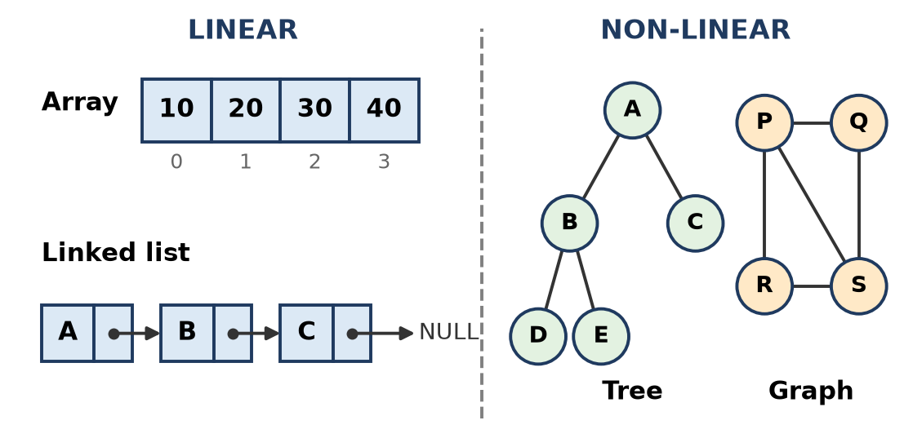
Figure: Linear vs non-linear data structures
Point | Linear | Non-linear
Arrangement | Sequential, single level | Hierarchical or network, many levels
Traversal | One run visits all | Needs special traversals (DFS, BFS, inorder)
Memory use | Simple | More complex
Examples | Array, linked list, stack, queue | Tree, graph

Remember: Linear = a train (one coach after another); non-linear = a family tree or a road map.

Q3. Distinguish between static and dynamic memory allocation with respect to data structures.
Understand • Low • CO1
Static allocation reserves memory at compile time; dynamic allocation reserves memory at run time from the heap (in C++ with new and delete).
Point | Static allocation | Dynamic allocation
When memory is given | Compile time | Run time (new, malloc)
Size | Fixed, cannot change | Can grow or shrink as needed
Memory area | Stack / data segment | Heap
Freeing memory | Automatic | Programmer must delete / free
Wastage | Possible (unused space) or overflow | Little wastage, extra space for pointers
Access | Fast, direct by index | Through pointers
Data structure | Array int a[10]; | Linked list Node* p = new Node;

Conclusion: arrays use static memory and suit a fixed amount of data; linked lists use dynamic memory and suit data whose size is not known in advance.
Remember: Static = booking a fixed hall in advance; dynamic = adding chairs as guests arrive.

Q4. Explain Big-O, Omega and Theta notations with the help of graphs.
Understand • Low • CO1
Asymptotic notations describe how the running time f(n) of an algorithm grows as the input size n becomes large, ignoring constants.
1. Big-O (upper bound): f(n) = O(g(n)) if there are positive constants c and n0 such that 0 ≤ f(n) ≤ c·g(n) for all n ≥ n0. It gives the worst case: the algorithm never takes longer than this.
2. Omega Ω (lower bound): f(n) = Ω(g(n)) if f(n) ≥ c·g(n) for all n ≥ n0. It gives the best case: the algorithm takes at least this much time.
3. Theta Θ (tight bound): f(n) = Θ(g(n)) if c1·g(n) ≤ f(n) ≤ c2·g(n) for all n ≥ n0. f(n) grows exactly like g(n).
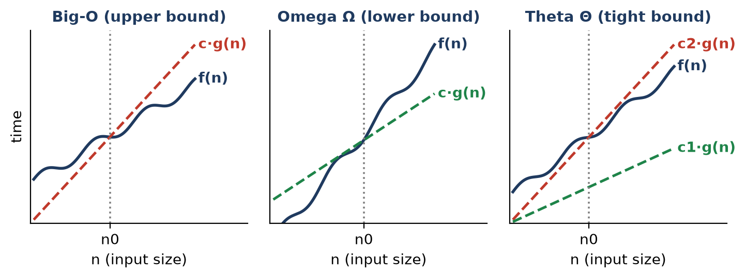
Figure: Big-O, Omega and Theta: after n0 the curve f(n) stays below, above, or between the bounds
Example: f(n) = 3n + 2
- 3n + 2 ≤ 4n for n ≥ 2 → O(n) (c = 4, n0 = 2)
- 3n + 2 ≥ 3n for n ≥ 1 → Ω(n) (c = 3)
- Both hold → Θ(n)
Remember: O = ceiling (at most), Ω = floor (at least), Θ = sandwich (exactly).

Q5. Explain how a two-dimensional array is stored in memory using row-major and column-major order.
Understand • Low • CO1
Memory is one-dimensional, so a 2-D array A[M][N] (M rows, N columns) must be laid out in a single line. There are two ways.
1. Row-major order (used by C/C++): all elements of row 0, then row 1, and so on.
- Address of A[i][j] = B + w × [(i − LR) × N + (j − LC)]
2. Column-major order (used by FORTRAN, MATLAB): all elements of column 0, then column 1, and so on.
- Address of A[i][j] = B + w × [(j − LC) × M + (i − LR)]
Here B = base address, w = size of one element, LR and LC = lower bounds of row and column (0 in C++).
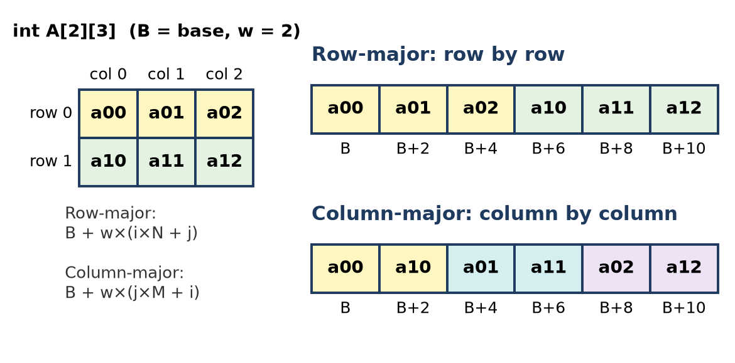
Figure: Row-major and column-major layout of a 2 × 3 array
Example: int A[2][3], B = 100, w = 2. Find A[0][1].
- Row-major: 100 + 2 × (0 × 3 + 1) = 102
- Column-major: 100 + 2 × (1 × 2 + 0) = 104
Remember: Row-major: "finish the row first" (read like a book); column-major: "finish the column first".

Q6. Explain why a linked list is preferred over an array for dynamic data. Describe the structure of a node in a singly linked list.
Understand • Low • CO1
Why a linked list for dynamic data:
1. Dynamic size: nodes are created with new at run time, so the list grows or shrinks; an array has a fixed size.
2. No wastage / no overflow: memory is used only for existing elements.
3. Easy insertion and deletion: only pointers change; no shifting of elements as in an array.
4. Non-contiguous memory: nodes can be anywhere in memory, so a large free block is not needed.
Structure of a node: each node has two fields.
- data: the value stored.
- next: a pointer holding the address of the next node; the last node's next is NULL. A pointer head stores the address of the first node.
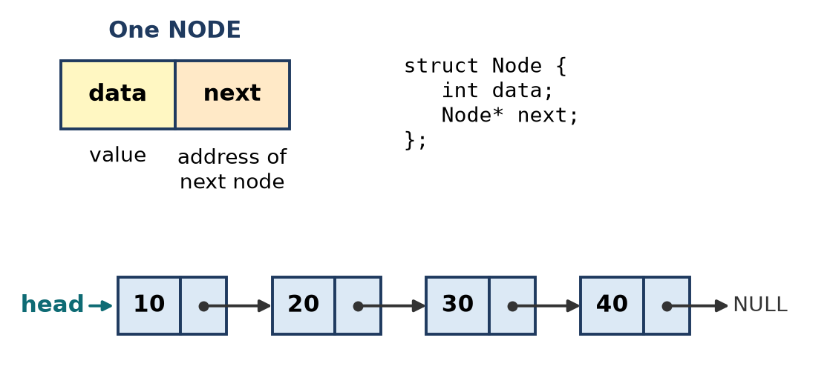
Figure: Node structure and a singly linked list
struct Node {
int data; // value
Node* next; // address of next node
};
Remember: Array = seats in a row (fixed); linked list = people holding hands (anyone can join or leave).

Q7. Describe a circular linked list. State its advantages over a singly linked list.
Understand • Low • CO1
A circular linked list is a linked list in which the last node's next pointer points back to the first node instead of NULL, so the nodes form a circle. Often a pointer to the last node is kept, because last→next gives the first node.
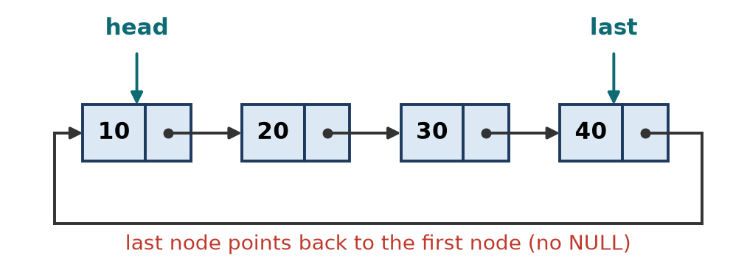
Figure: Circular singly linked list
Advantages over a singly linked list:
1. Any node can be a starting point; the whole list can be traversed from any node.
2. No NULL pointers, so the end is never "lost"; traversal can go round and round.
3. With a pointer to the last node, insertion at both the beginning and the end is O(1).
4. Useful for round-robin CPU scheduling, multiplayer turns, music "repeat all" and circular queues.
Care needed: traversal must stop when we return to the start node, otherwise it becomes an infinite loop.
Remember: Circular list = a merry-go-round: no last seat, you always come back to where you started.

Q8. Find the time complexity of: for(i=1;i<=n;i++) for(j=1;j<=i;j++) sum++; Show the step count.
Apply • Moderate • CO1
The inner loop runs i times for each value of i, so sum++ runs 1 + 2 + 3 + … + n times.
Step count (frequency of each statement):
Statement | Frequency
i = 1 | 1
i <= n | n + 1
i++ | n
j = 1 | n
j <= i | Σ(i + 1) = n(n+1)/2 + n
j++ | n(n+1)/2
sum++ | n(n+1)/2

Total = 1 + (n + 1) + n + n + [n(n+1)/2 + n] + n(n+1)/2 + n(n+1)/2 = 3n(n+1)/2 + 4n + 2 = 1.5n² + 5.5n + 2
Check for n = 3: sum++ runs 1 + 2 + 3 = 6 = 3 × 4 / 2. Total = 1.5(9) + 5.5(3) + 2 = 13.5 + 16.5 + 2 = 32.
Keeping only the highest-order term and dropping the constant:
Time complexity = O(n²)
Remember: 1 + 2 + … + n = n(n+1)/2, which is "half of n²", and that is still O(n²).

Q9. Determine the time complexity of: for(i=1;i<n;i=i*2) printf("%d",i); Justify your answer.
Apply • Moderate • CO1
The loop variable is doubled each time: i = 1, 2, 4, 8, …, 2^k.
Justification:
1. After k iterations, i = 2^k.
2. The loop stops when i ≥ n, that is when 2^k ≥ n.
3. Taking log: k ≥ log₂ n.
4. So the loop runs ⌈log₂ n⌉ times.
n | Values of i printed | Iterations | ⌈log₂ n⌉
8 | 1, 2, 4 | 3 | 3
10 | 1, 2, 4, 8 | 4 | 4
16 | 1, 2, 4, 8 | 4 | 4

Time complexity = O(log n)
Remember: When the loop variable is multiplied (or divided) by 2, think "log n" — like binary search halving the list.

Q10. For a 2-D array int A[10][10] with base address 2000 and 4 bytes per element, find the address of A[3][4] in row-major order.
Apply • Moderate • CO1
Formula (row-major, index from 0): Address of A[i][j] = B + w × (i × N + j)
Given: B = 2000, w = 4 bytes, N (columns) = 10, i = 3, j = 4
Working:
1. i × N + j = 3 × 10 + 4 = 34 (34 elements come before A[3][4])
2. w × 34 = 4 × 34 = 136
3. Address = 2000 + 136 = 2136
Address of A[3][4] = 2136
Remember: Count how many elements come before it (full rows × N + j), multiply by size, add the base.

Q11. An array A[-5..10] has base address 500 and element size 2 bytes. Find the address of A[4]. Also calculate the number of elements.
Apply • Moderate • CO1
Formulas:
- Number of elements = UB − LB + 1
- Address of A[i] = B + w × (i − LB)
Given: LB = −5, UB = 10, B = 500, w = 2, i = 4
Number of elements: = 10 − (−5) + 1 = 10 + 5 + 1 = 16
Address of A[4]:
1. i − LB = 4 − (−5) = 9 (A[4] is the 10th element; 9 elements come before it)
2. w × 9 = 2 × 9 = 18
3. Address = 500 + 18 = 518
Address of A[4] = 518; number of elements = 16
Remember: With a negative lower bound, "minus a minus" becomes plus: i − (−5) = i + 5.

Q12. Write pseudocode to insert an element at a given position in an array. Show the number of shifts required in the worst case.
Apply • Moderate • CO1
To insert at position pos (1-based), every element from the last one down to position pos is moved one place right, then the new element is placed.
// Insert x at position pos (1..n+1) in A[0..n-1]; MAX = capacity
bool insertAt(int A[], int &n, int MAX, int pos, int x) {
if (n == MAX) return false; // array full (overflow)
if (pos < 1 || pos > n + 1) return false; // invalid position
for (int i = n - 1; i >= pos - 1; i--) // shift right, from the end
A[i + 1] = A[i];
A[pos - 1] = x; // place new element
n++; // one more element
return true;
}
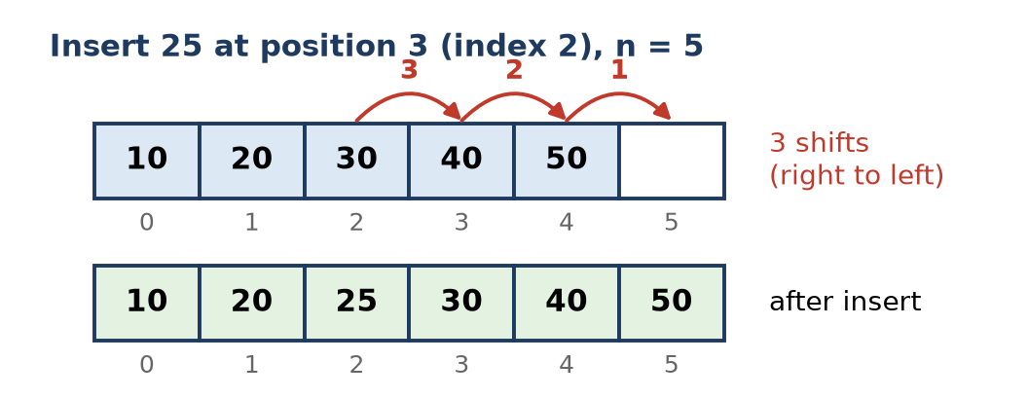
Figure: Inserting 25 at position 3 needs 3 shifts
Number of shifts = n − pos + 1
- Worst case: insert at position 1 → n shifts → O(n)
- Best case: insert at the end (pos = n + 1) → 0 shifts → O(1)
- Average case: about n/2 shifts → O(n)
Remember: Shift from the back, or you overwrite your own data.

Q13. Write Pseudocode to create a singly linked list of n nodes and display it.
Apply • Moderate • CO1
Create: read a value, make a node with new, and attach it at the end using a tail pointer. Display: start at head and follow next until NULL.
struct Node { int data; Node* next; };
Node* create(int n) {
Node *head = nullptr, *tail = nullptr;
for (int i = 0; i < n; i++) {
int x; cin >> x;
Node* t = new Node{x, nullptr}; // new node, next = NULL
if (head == nullptr) head = tail = t; // first node
else { tail->next = t; tail = t; } // link at end
}
return head;
}
void display(Node* head) {
Node* p = head;
while (p != nullptr) { // till end of list
cout << p->data << " -> ";
p = p->next; // move to next node
}
cout << "NULL\n";
}
Example: n = 4, input 10 20 30 40 → output 10 -> 20 -> 30 -> 40 -> NULL
Figure: List created by create(4)
Time: create O(n) (tail pointer avoids re-traversal), display O(n).
Remember: Keep a tail pointer while creating, otherwise each insert at the end costs a full walk.

Q14. Write a Pseudocode to search for an element in a singly linked list and return its position.
Apply • Moderate • CO1
Linear search: walk from head, counting positions, until the key is found or the list ends.
// returns 1-based position of key, or -1 if not found
int search(Node* head, int key) {
int pos = 1;
Node* p = head;
while (p != nullptr) {
if (p->data == key) return pos; // found
p = p->next; // go to next node
pos++;
}
return -1; // reached NULL: not found
}
Trace: list 10 → 20 → 30 → 40, key = 30
Step | p→data | pos | Match?
1 | 10 | 1 | No
2 | 20 | 2 | No
3 | 30 | 3 | Yes → return 3

- Best case O(1) (key at head), worst case O(n) (last node or absent).
- Binary search is not useful here because there is no direct access to the middle node.
Remember: Linked list search = asking each person in the queue one by one.

Q15. Write Pseucode to insert a node at the beginning, at the end, and after a given node in a singly linked list.
Apply • Moderate • CO1
Rule: always set the new node's next first, then change the old link, so the rest of the list is never lost.
// (a) at beginning: O(1)
void insertBegin(Node* &head, int x) {
Node* t = new Node{x, head}; // 1. new->next = head
head = t; // 2. head = new
}
// (b) at end: O(n)
void insertEnd(Node* &head, int x) {
Node* t = new Node{x, nullptr};
if (head == nullptr) { head = t; return; } // empty list
Node* p = head;
while (p->next != nullptr) p = p->next; // go to last node
p->next = t; // last->next = new
}
// (c) after a given node p: O(1)
void insertAfter(Node* p, int x) {
if (p == nullptr) return;
Node* t = new Node{x, p->next}; // 1. new->next = p->next
p->next = t; // 2. p->next = new
}
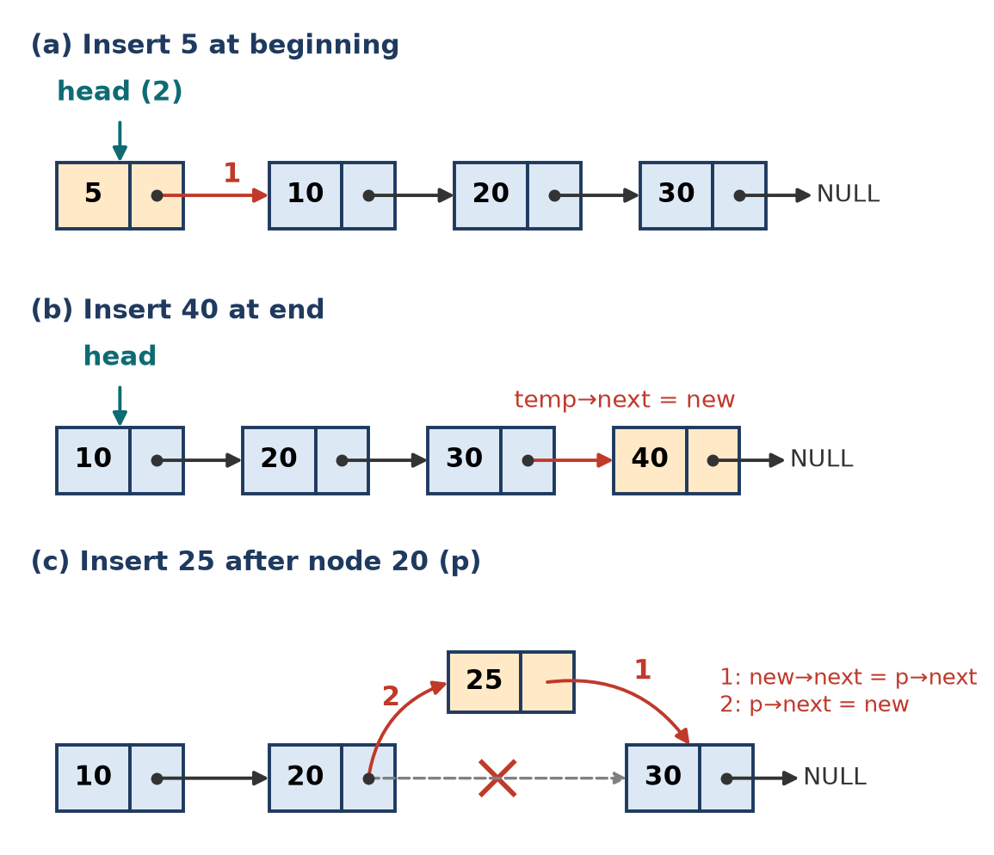
Figure: Insertion at beginning, end and after a node
Remember: "New node grabs the next one first, then the old one lets go."

Q16. Write Pseucode to delete the first node, last node, and a node with a given key from a singly linked list.
Apply • Moderate • CO1
// (a) delete first: O(1)
void deleteFirst(Node* &head) {
if (head == nullptr) return; // empty list
Node* t = head;
head = head->next; // head moves to 2nd node
delete t;
}
// (b) delete last: O(n)
void deleteLast(Node* &head) {
if (head == nullptr) return;
if (head->next == nullptr) { delete head; head = nullptr; return; } // one node
Node* p = head;
while (p->next->next != nullptr) p = p->next; // stop at second-last
delete p->next;
p->next = nullptr; // second-last becomes last
}
// (c) delete node with key: O(n)
void deleteKey(Node* &head, int key) {
if (head == nullptr) return;
if (head->data == key) { deleteFirst(head); return; } // key at head
Node* prev = head;
while (prev->next != nullptr && prev->next->data != key) prev = prev->next;
if (prev->next == nullptr) return; // key not found
Node* curr = prev->next;
prev->next = curr->next; // bypass the node
delete curr;
}
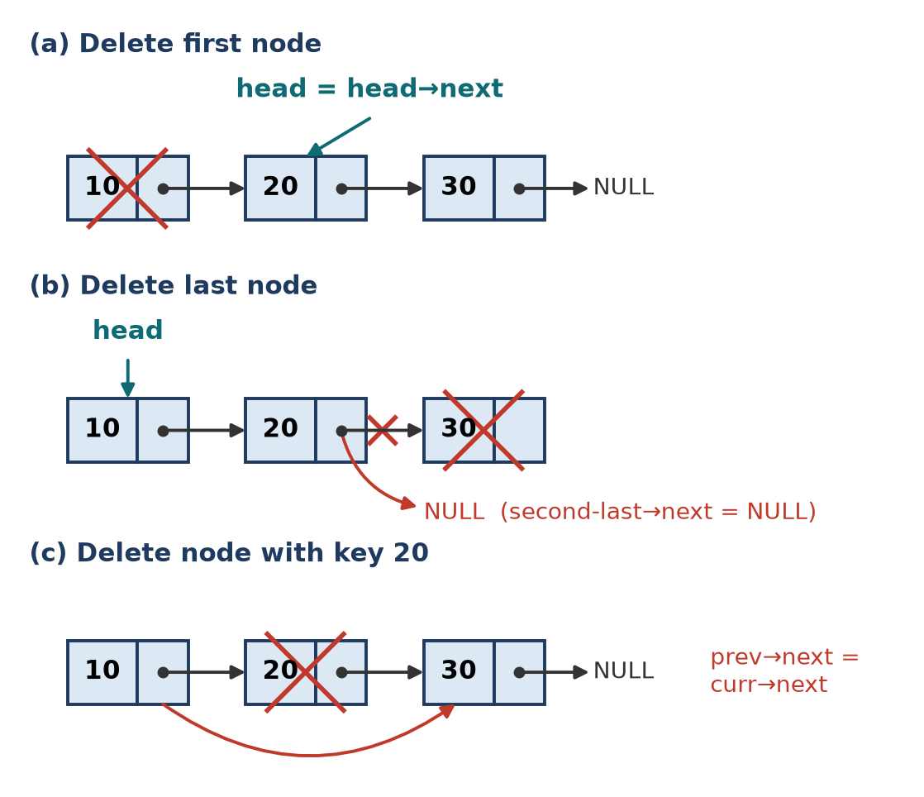
Figure: Deletion of first, last and key node
Cases handled: empty list, single node, key at head, key not found.
Remember: To delete a node you must stand on the node before it.

Q17. Write a Pseucode to reverse a singly linked list iteratively. Trace it for the list 1 ->2 -> 3-> 4.
Apply • Moderate • CO1
Use three pointers prev, curr, next. At each step, turn curr's arrow backwards.
Node* reverse(Node* head) {
Node *prev = nullptr, *curr = head, *next = nullptr;
while (curr != nullptr) {
next = curr->next; // 1. save the rest of the list
curr->next = prev; // 2. reverse the link
prev = curr; // 3. move prev forward
curr = next; // 4. move curr forward
}
return prev; // prev is the new head
}
Trace for 1 → 2 → 3 → 4 → NULL
Pass | next | Link changed | prev | curr
Start | – | – | NULL | 1
1 | 2 | 1→NULL | 1 | 2
2 | 3 | 2→1 | 2 | 3
3 | 4 | 3→2 | 3 | 4
4 | NULL | 4→3 | 4 | NULL (stop)

New head = prev = 4. Result: 4 → 3 → 2 → 1 → NULL
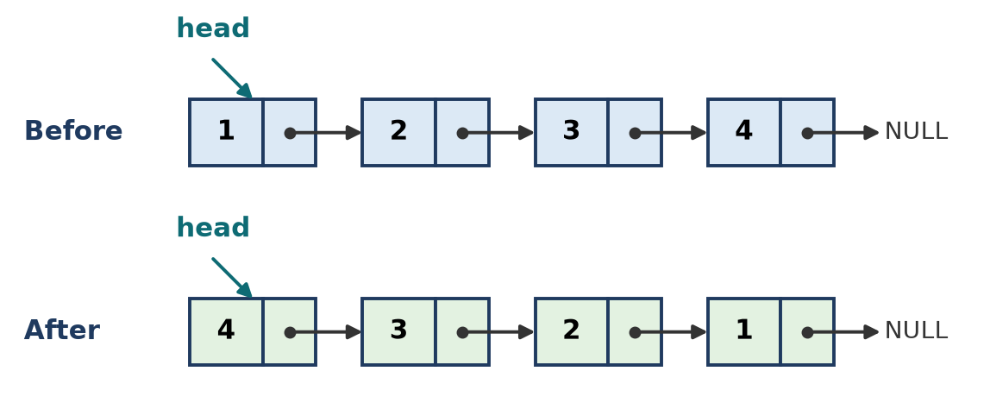
Figure: List before and after reversal
Time O(n), extra space O(1).
Remember: Save, Reverse, Move, Move — "next = curr→next" always comes first.

Q18. Write Pseudocode program to create a doubly linked list and display it in forward and backward directions.
Apply • Moderate • CO1
In a doubly linked list (DLL) each node has prev, data and next, so we can move both ways. We keep head and tail.
struct DNode { int data; DNode *prev, *next; };
void create(DNode* &head, DNode* &tail, int n) {
head = tail = nullptr;
for (int i = 0; i < n; i++) {
int x; cin >> x;
DNode* t = new DNode{x, tail, nullptr}; // prev = old tail
if (head == nullptr) head = t; // first node
else tail->next = t; // old tail -> new
tail = t;
}
}
void displayForward(DNode* head) {
for (DNode* p = head; p != nullptr; p = p->next) cout << p->data << " ";
cout << "\n";
}
void displayBackward(DNode* tail) {
for (DNode* p = tail; p != nullptr; p = p->prev) cout << p->data << " ";
cout << "\n";
}
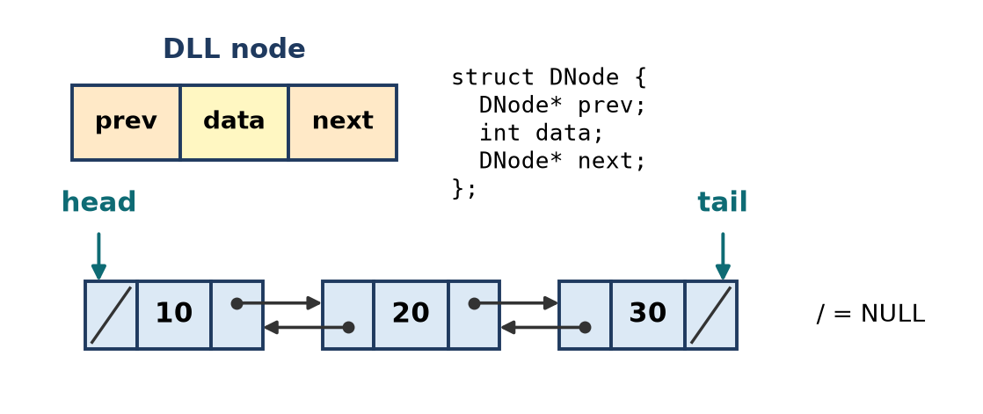
Figure: Doubly linked list: node and list
Example: input 10 20 30
- Forward: 10 20 30
- Backward: 30 20 10
Remember: DLL = a two-way road: next to go ahead, prev to come back.

Q19. Write pseudocode to insert a node before a given node in a doubly linked list.
Apply • Moderate • CO1
Let p be the given node. Because p has a prev pointer, we can insert before it in O(1) without searching for the previous node.
void insertBefore(DNode* &head, DNode* p, int x) {
if (p == nullptr) return;
DNode* t = new DNode{x, nullptr, nullptr};
t->prev = p->prev; // 1. new->prev = p->prev
t->next = p; // 2. new->next = p
if (p->prev != nullptr)
p->prev->next = t; // 3. old previous -> new
else
head = t; // p was head: new node is head
p->prev = t; // 4. p->prev = new
}
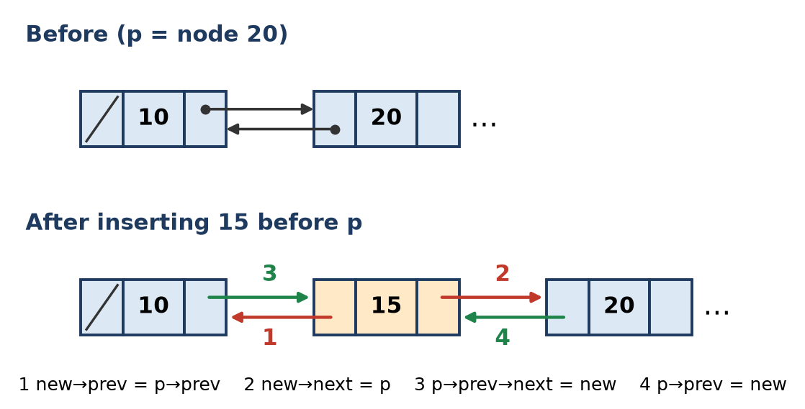
Figure: Insert 15 before node 20: four pointer changes
Steps in words: set both pointers of the new node first (1, 2), then make the neighbours point to it (3, 4). Step 4 must come after step 3, because step 3 uses p->prev.
Remember: First fix the newcomer's two hands, then let the neighbours hold them.

Q20. Write Pseudocode to delete a given node from a doubly linked list. Handle the first and last node cases.
Apply • Moderate • CO1
To delete node p, link its previous node to its next node and vice versa, then free p.
void deleteNode(DNode* &head, DNode* &tail, DNode* p) {
if (head == nullptr || p == nullptr) return; // empty list
if (p == head) head = p->next; // first node case
if (p == tail) tail = p->prev; // last node case
if (p->prev != nullptr) p->prev->next = p->next; // skip p forward
if (p->next != nullptr) p->next->prev = p->prev; // skip p backward
delete p;
}
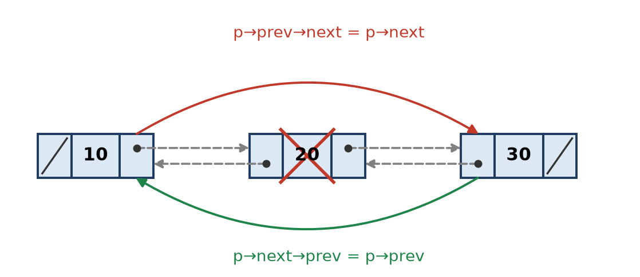
Figure: Deleting node 20 from a DLL
Case | What changes
First node | head = p→next; new head's prev = NULL
Last node | tail = p→prev; new tail's next = NULL
Middle node | p→prev→next = p→next and p→next→prev = p→prev
Only node | head = tail = NULL

Time O(1) when p is known (no search for the previous node, unlike a singly list).
Remember: Delete in a DLL = the left neighbour and the right neighbour shake hands over p's head.

Q21. Write Pseudocode to create and display a circular singly linked list.
Apply • Moderate • CO1
Same as a singly list, but the last node points to the first node. Display uses a do-while loop and stops when it comes back to head.
Node* createCircular(int n) {
Node *head = nullptr, *tail = nullptr;
for (int i = 0; i < n; i++) {
int x; cin >> x;
Node* t = new Node{x, nullptr};
if (head == nullptr) head = tail = t;
else { tail->next = t; tail = t; }
tail->next = head; // close the circle
}
return head;
}
void displayCircular(Node* head) {
if (head == nullptr) { cout << "Empty\n"; return; }
Node* p = head;
do {
cout << p->data << " -> ";
p = p->next;
} while (p != head); // stop when back at start
cout << "(back to " << head->data << ")\n";
}
Example: input 10 20 30 40 → 10 -> 20 -> 30 -> 40 -> (back to 10)
Figure: Circular singly linked list
Remember: Circular display: "do first, check later" — use do-while with p != head.

Q22. Compare arrays, singly linked lists and doubly linked lists for insertion, deletion and search in terms of time complexity. Analyze which is best for frequent insertions in the middle.
Analyze • HOTS • CO1
Operation | Array | Singly linked list | Doubly linked list
Access k-th element | O(1) | O(n) | O(n)
Insert at beginning | O(n) (shift all) | O(1) | O(1)
Insert at end | O(1) if space | O(n), O(1) with tail | O(1) with tail
Insert in middle (position known) | O(n) shifting | O(1) after p, but O(n) to find p | O(1) before or after p
Delete a given node | O(n) shifting | O(n) (must find previous node) | O(1) (has prev pointer)
Search (unsorted) | O(n) | O(n) | O(n)
Search (sorted) | O(log n) binary search | O(n) | O(n)
Extra memory | None | 1 pointer per node | 2 pointers per node

Analysis for frequent insertions in the middle:
1. An array must shift on average n/2 elements for every insertion, and may overflow. Worst choice.
2. A singly linked list needs only two pointer changes, but can insert only after a node, and deleting needs the previous node.
3. A doubly linked list can insert before or after a known node and delete it in O(1), and can move in both directions to reach the position.
Conclusion: for frequent middle insertions (and deletions), the doubly linked list is best; the price is one extra pointer per node. Arrays are best only when access by index or binary search dominates.
Remember: Arrays shift, singly lists search for the previous node, doubly lists just relink.

Q23. Analyze why binary search cannot be applied efficiently on a linked list. Suggest a data structure or technique that overcomes this.
Analyze • HOTS • CO1
Binary search needs to jump to the middle element in O(1), compare, and discard half. This works on a sorted array because A[mid] is found directly from its address.
Why it fails on a linked list:
1. No random access: to reach the middle node we must walk from head, which costs n/2 steps.
2. Each later step again walks to the middle of the remaining half: n/2 + n/4 + n/8 + … ≈ n steps.
3. So comparisons are only log n, but traversal is O(n); there is no gain over linear search.
4. Extra pointer movement makes it even slower than a simple linear scan in practice.
Solutions:
- Skip list: a sorted linked list with extra "express" levels that skip many nodes; search, insert and delete in O(log n) on average.
- Binary search tree / balanced BST (AVL, Red-Black): a linked structure where each comparison discards half the data; O(log n) for balanced trees.
- Sorted array (or copy the list into an array) when data rarely changes, then use binary search.
- Hash table for O(1) average lookup when ordering is not needed.
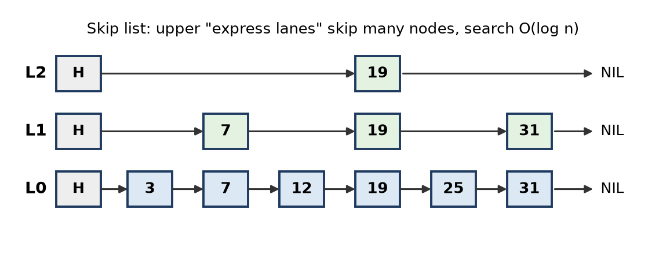
Figure: Skip list: upper levels act as express lanes
Conclusion: binary search needs random access; for linked data, use a skip list or a balanced BST to get O(log n).
Remember: Binary search needs to "jump to the middle"; a linked list can only "walk", so give it express lanes (skip list) or branches (BST).

Q24. A music streaming application maintains a playlist in which songs are frequently inserted and removed. The number of songs is not known in advance. Explain why linked organization may be preferred over sequential organization for this application. Mention one limitation of using a linked structure.
Apply • HOTS
Situation: a playlist with frequent add/remove of songs and an unknown, changing number of songs.
Why linked organization (linked list) is preferred:
1. Unknown size: songs (nodes) are created at run time with new; no need to fix the size in advance, so no overflow and no wasted slots. An array must be declared with a fixed size or resized by copying.
2. Fast insertion and deletion: adding a song "play next" or removing a song only changes two pointers (O(1)) once the position is known; an array must shift all later songs (O(n)).
3. Next / Previous buttons: a doubly linked list gives natural next and previous movement.
4. Repeat-all mode: a circular (doubly) linked list loops back from the last song to the first.
5. Memory need not be contiguous: large playlists fit even if memory is fragmented.
Limitations of a linked structure (any one):
- No random access: jumping directly to song number 50 or "shuffle to position k" takes O(n) traversal; an array does it in O(1).
- Extra memory for pointers in every node and poorer cache performance.
Recommendation: use a circular doubly linked list of songs, with a pointer to the currently playing song.
Remember: Playlist = a chain of songs: easy to clip in or out, but you must walk the chain to reach the 50th.

Q25. Consider the 2-D array given below. Assume indexing starts at 0, base address = 502 and each int occupies 2 bytes. Find the address of the element 121 when the array is stored in (a) row-major order and (b) column-major order. int a[3][4] = { { 12, 1, -9, 23 }, { 14, 7, 11, 121 }, { 6, 78, 15, 34 } };
Apply • Moderate • CO1
Locate 121: it is in row 1 (second row), column 3 (fourth column) → a[1][3].
Given: B = 502, w = 2, M (rows) = 3, N (columns) = 4, i = 1, j = 3
(a) Row-major: Address = B + w × (i × N + j)
1. i × N + j = 1 × 4 + 3 = 7
2. 2 × 7 = 14
3. Address = 502 + 14 = 516
Check: memory order is 12, 1, −9, 23, 14, 7, 11, 121 → 121 is the 8th element (offset 7). 502 + 7 × 2 = 516. ✓
(b) Column-major: Address = B + w × (j × M + i)
1. j × M + i = 3 × 3 + 1 = 10
2. 2 × 10 = 20
3. Address = 502 + 20 = 522
Check: memory order is 12, 14, 6, 1, 7, 78, −9, 11, 15, 23, 121 → 121 is the 11th element (offset 10). 502 + 10 × 2 = 522. ✓
Answer: row-major = 516, column-major = 522
Remember: Row-major uses N (number of columns) in the formula; column-major uses M (number of rows).

Q26. Complete the following C++ program by filling Blanks 1 to 4 and write the output of main(). (Program: class Node with data and next; class LinkedList with insertAtEnd() and display(); main() inserts 42, 10, 7 and displays.)
Apply • Moderate • CO1
Blank | Answer | Reason
Blank 1 | nullptr | A new node points to nothing yet
Blank 2 | newNode | In an empty list the new node becomes head
Blank 3 | newNode | Last node's next is linked to the new node
Blank 4 | current->next | Move to the next node while displaying

Completed program:
#include <iostream>
using namespace std;
class Node {
public:
int data;
Node* next;
Node(int data) { this->data = data; this->next = nullptr; } // Blank 1
};
class LinkedList {
public:
Node* head;
LinkedList() { head = nullptr; }
void insertAtEnd(int value) {
Node* newNode = new Node(value);
if (head == nullptr) {
head = newNode; // Blank 2
} else {
Node* current = head;
while (current->next != nullptr) current = current->next;
current->next = newNode; // Blank 3
}
}
void display() {
Node* current = head;
while (current != nullptr) {
cout << current->data << " -> ";
current = current->next; // Blank 4
}
cout << "NULL" << endl;
}
};
int main() {
LinkedList LL;
LL.insertAtEnd(42); LL.insertAtEnd(10); LL.insertAtEnd(7);
LL.display();
return 0;
}
Output:
42 -> 10 -> 7 -> NULL
Insertion is at the end, so the order of insertion (42, 10, 7) is kept.
Remember: New node → nullptr; empty list → head = newNode; otherwise last→next = newNode; walk with current = current→next.

Q27. The figure shows a singly linked list. The 'next' field holds the address of the following node; the node holding 18 is stored at address 200 and the node holding 24 at address 801. Write pseudocode and draw the list after each operation to: (a) delete the record stored at address 801 (update the tail as well), and (b) insert a new node with data 15 between the nodes holding 11 and 18.
Apply • Moderate • CO1
Given list: head → [11 | 200] → [18 | 801] (at 200) → [24 | null] (at 801) ← tail
(a) Delete the node at 801 (node 24, which is the tail):
// target = 801 (the tail node)
Node* p = head;
while (p->next != target) p = p->next; // p = node 18 (at 200)
p->next = nullptr; // 18->next = null
tail = p; // tail now = 18
delete target; // free memory at 801
(b) Insert 15 between 11 and 18:
Node* t = new Node; // say memory at address 350
t->data = 15;
Node* p = head; // node 11
t->next = p->next; // 15->next = 200 (address of 18)
p->next = t; // 11->next = 350
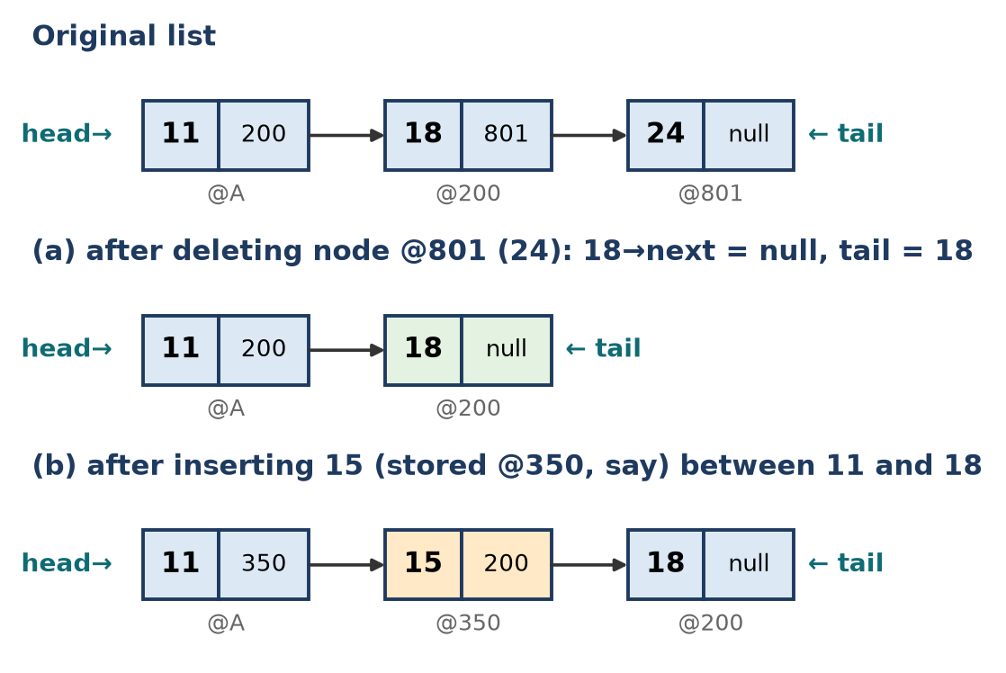
Figure: List after operation (a) and after operation (b)
Stage | List (data with next address) | tail
Original | 11(200) → 18(801) → 24(null) | 24
After (a) | 11(200) → 18(null) | 18
After (b) | 11(350) → 15(200) → 18(null) | 18

(Address 350 for the new node is assumed; any free address returned by new works.)
Remember: Deleting the tail: stop at the second-last node, make it null, move tail. Inserting: new→next first, then old→next.

Q28. Design an algorithm to add an item to a shopping cart implemented as a singly linked list. Each node stores a unique item number, item name, price and quantity; if the item is already in the cart, only its quantity must be updated. Also explain what happens to the list when an item is sold or removed, and how you would handle it (first node, middle node, last node, empty cart).
Create • HOTS • CO1
Node design: itemNo (unique key), name, price, qty, next.
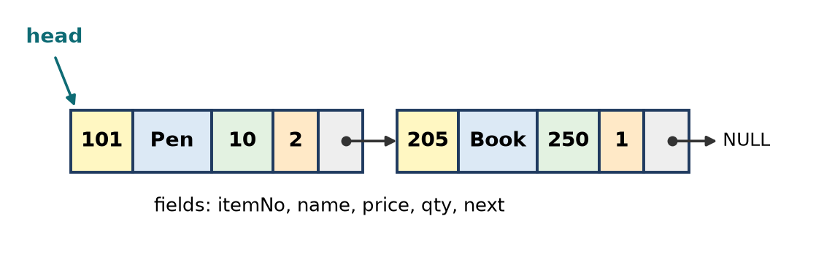
Figure: Shopping cart as a singly linked list
Algorithm: addItem
1. Traverse the cart from head comparing itemNo.
2. If found, qty = qty + q and stop (no new node).
3. If not found, create a node and insert at the end (the cart keeps the order of adding).
struct Item { int no; string name; double price; int qty; Item* next; };
void addItem(Item* &head, int no, string name, double price, int q) {
Item* p = head; Item* last = nullptr;
while (p != nullptr) {
if (p->no == no) { p->qty += q; return; } // already in cart
last = p; p = p->next;
}
Item* t = new Item{no, name, price, q, nullptr};
if (head == nullptr) head = t; // empty cart
else last->next = t; // add at end
}
void removeItem(Item* &head, int no, int q) { // q = quantity sold/removed
if (head == nullptr) { cout << "Cart empty\n"; return; }
Item *p = head, *prev = nullptr;
while (p != nullptr && p->no != no) { prev = p; p = p->next; }
if (p == nullptr) { cout << "Not in cart\n"; return; }
if (p->qty > q) { p->qty -= q; return; } // only reduce quantity
if (prev == nullptr) head = p->next; // first node
else prev->next = p->next; // middle or last node
delete p;
}
When an item is sold or removed:
Case | Handling
Empty cart | head == NULL → report "cart empty" (underflow)
Quantity left after sale | Only reduce qty; links unchanged
First node | head = head→next, free old node
Middle node | prev→next = p→next, free p
Last node | prev→next = NULL (p→next is NULL), free p
Only node | head becomes NULL → cart empty

Time: add and remove O(n) because of the search for itemNo.
Remember: Search first: found → change qty; not found → add node. Remove: qty left → reduce, else unlink with prev.

Quick Revision – Unit 1
Term | Key fact
Data structure | Way of organising data in memory for efficient use
Linear vs non-linear | Sequence (array, list) vs hierarchy/network (tree, graph)
Static allocation | Compile time, fixed size, e.g. array
Dynamic allocation | Run time from heap with new/delete, e.g. linked list
Big-O / Ω / Θ | Upper bound / lower bound / tight bound
Row-major address | B + w × [(i − LR) × N + (j − LC)]
Column-major address | B + w × [(j − LC) × M + (i − LR)]
1-D address | B + w × (i − LB); elements = UB − LB + 1
Nested loop j ≤ i | n(n+1)/2 → O(n²)
Loop i = i × 2 | ⌈log₂ n⌉ times → O(log n)
Array insert worst case | n shifts → O(n)
SLL node | data + next; last next = NULL
DLL node | prev + data + next; delete given node in O(1)
Circular list | last→next = first; display with do-while
Reverse SLL | prev, curr, next; O(n) time, O(1) space
Binary search on list | Not efficient (no random access); use skip list / BST

Unit 2: Stacks and Queues

Q1. Explain the queue as an ADT with the FIFO principle. List its basic operations.
Understand • Low • CO1, CO2
A queue is a linear data structure in which insertion is done at one end (REAR) and deletion at the other end (FRONT). It follows FIFO – First In, First Out: the element that comes first is served first, like people in a ticket line.
Queue as an ADT (Abstract Data Type): an ADT describes what data is stored and what operations are allowed, not how they are coded (array or linked list).
- Data: an ordered list of elements with two ends, front and rear.
- Operations:
1. createQueue(): make an empty queue.
2. enqueue(x): insert x at the rear (error overflow if full).
3. dequeue(): remove and return the front element (error underflow if empty).
4. peek() / front(): return the front element without removing it.
5. isEmpty(), isFull(): test the state.
6. size(): number of elements.
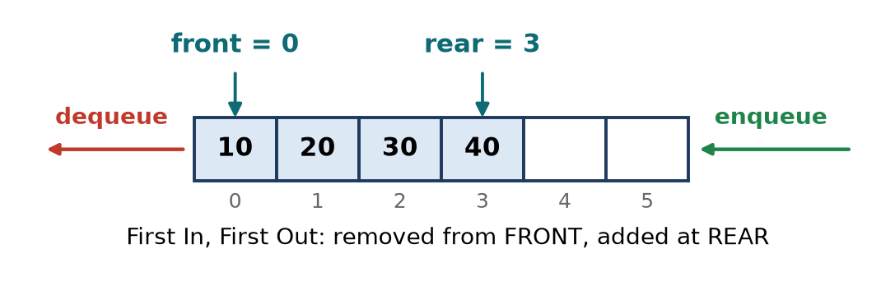
Figure: Queue: delete at front, insert at rear
Applications: printer jobs, CPU scheduling, BFS in graphs, call-centre waiting lines.
Remember: Queue = bus stop line: join at the back (rear), leave from the front.

Q2. Explain why a circular queue is preferred over a linear queue. Illustrate with an example.
Understand • Low • CO1, CO2
Problem with a linear queue: in an array queue, rear only moves forward. After some deletions, the front slots become empty but cannot be reused; when rear = MAX − 1 the queue reports "full" even though space exists. This is wastage of memory.
Circular queue: the last position is connected back to the first, so after MAX − 1 the next position is 0. Indexes move with modulo:
- rear = (rear + 1) % MAX, front = (front + 1) % MAX
Example (size 5):
1. Insert 10, 20, 30, 40, 50 → rear = 4 (full).
2. Delete 10, 20, 30 → front = 3; slots 0, 1, 2 are now empty.
3. Insert 60:
- Linear queue: rear = 4 = MAX − 1 → "Queue Full" (overflow) although 3 slots are free.
- Circular queue: rear = (4 + 1) % 5 = 0 → 60 is stored in slot 0. ✓
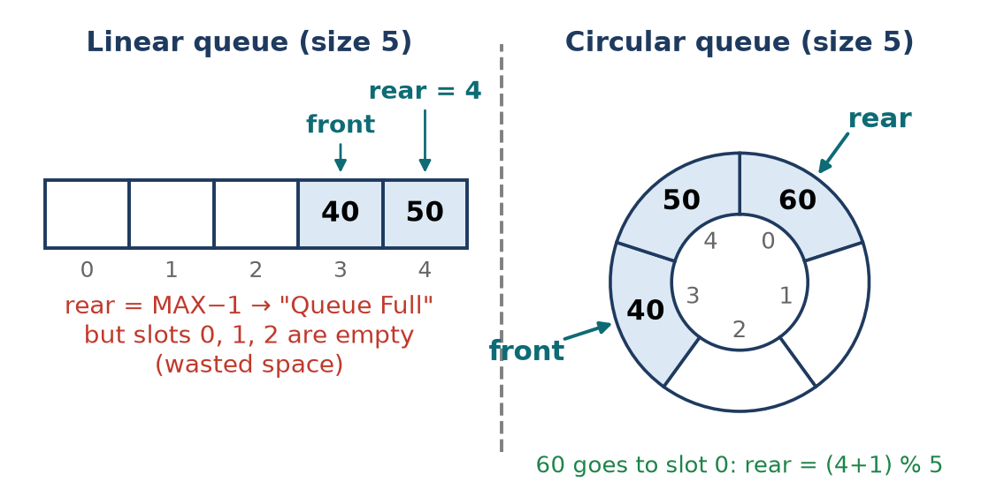
Figure: Linear queue wastes freed slots; circular queue reuses them
Advantages: full use of the array, no shifting of elements, O(1) enqueue and dequeue. Used in CPU round-robin scheduling, keyboard and network buffers.
Remember: Circular queue = a round table: when you reach the last chair, the next chair is chair 0.

Q3. Describe a double-ended queue. Explain input-restricted and output-restricted deques.
Understand • Low • CO1, CO2
A deque (double-ended queue) is a linear list in which insertion and deletion can be done at both ends – front and rear. It can work as both a stack and a queue.
Operations: insertFront(x), insertRear(x), deleteFront(), deleteRear(), getFront(), getRear(), isEmpty(), isFull().
Types:
1. Input-restricted deque: insertion at only one end (rear), but deletion at both ends.
2. Output-restricted deque: deletion at only one end (front), but insertion at both ends.
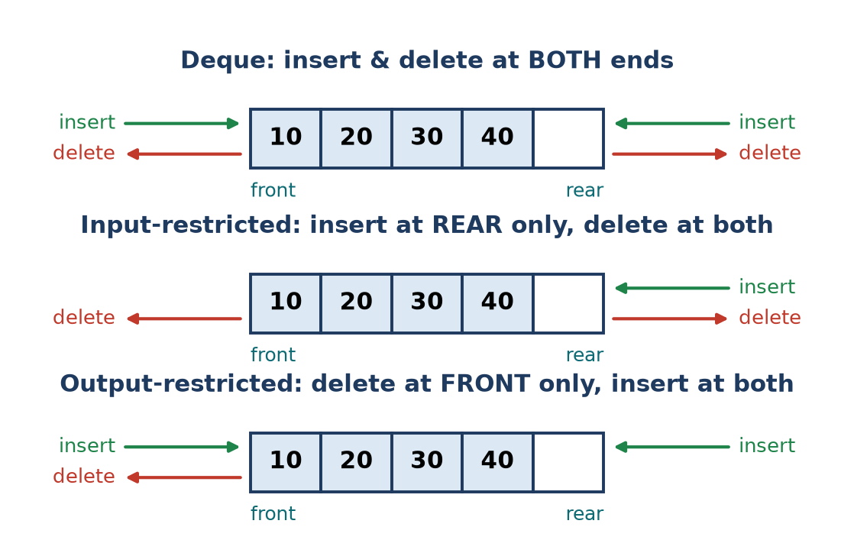
Figure: Deque, input-restricted deque and output-restricted deque
Type | Insert at | Delete at
Deque | Front and rear | Front and rear
Input-restricted | Rear only | Front and rear
Output-restricted | Front and rear | Front only

Applications: browser history with a size limit, undo-redo, sliding-window maximum, job-stealing schedulers.
Remember: Input-restricted = one entry door, two exit doors; output-restricted = two entry doors, one exit door.

Q4. Explain the priority queue. Differentiate between ascending and descending priority queues.
Understand • Low • CO1, CO2
A priority queue is a queue in which every element has a priority, and the element with the highest priority is removed first, regardless of arrival order. Elements with the same priority are served in FIFO order.
Operations: insert(x, priority), deleteHighest(), peek(), isEmpty().
Example: elements (A, 3), (B, 1), (C, 5) where the number is the priority value.
- Ascending PQ deletes in order B(1), A(3), C(5).
- Descending PQ deletes in order C(5), A(3), B(1).
Point | Ascending priority queue | Descending priority queue
Element removed first | Smallest priority value | Largest priority value
Also called | Min-priority queue | Max-priority queue
Heap used | Min-heap | Max-heap
Insertion | Any order | Any order
Example use | Shortest job first, Dijkstra's algorithm | Emergency room (most serious first), highest bid

Applications: CPU scheduling, Dijkstra/Prim algorithms, hospital triage, event simulation.
Remember: Ascending = "smallest number first", descending = "biggest number first".

Q5. Write Pseudocode for push, pop and peek on a stack implemented using an array. Handle overflow and underflow.
Apply • Moderate • CO1, CO2
A stack is a LIFO (Last In, First Out) list where insertion (push) and deletion (pop) happen at one end called top. In an array, top = -1 means empty.
const int MAX = 5;
int st[MAX];
int top = -1; // empty stack
void push(int x) {
if (top == MAX - 1) { // no space left
cout << "Stack Overflow\n"; return;
}
st[++top] = x; // increase top, then store
}
int pop() {
if (top == -1) { // nothing to remove
cout << "Stack Underflow\n"; return -1;
}
return st[top--]; // return top, then decrease
}
int peek() {
if (top == -1) { cout << "Stack Empty\n"; return -1; }
return st[top]; // read without removing
}
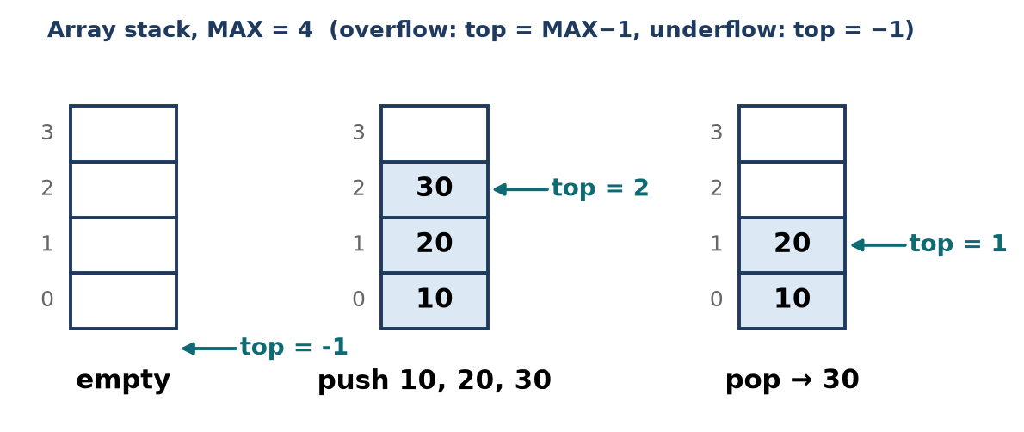
Figure: Array stack: empty, after three pushes, after one pop
Condition | Test
Overflow (full) | top == MAX − 1
Underflow (empty) | top == −1

All three operations take O(1) time.
Remember: Push: check full, ++top, store. Pop: check empty, read, top−−.

Q6. Implement a stack using a singly linked list. Write the push and pop Pseudocode.
Apply • Moderate • CO1, CO2
In a linked stack, the head of the list is the top. Push = insert at beginning, pop = delete from beginning, both O(1). There is no fixed size, so overflow happens only when memory (heap) is exhausted.
struct Node { int data; Node* next; };
Node* top = nullptr; // empty stack
void push(int x) {
Node* t = new (nothrow) Node; // get memory
if (t == nullptr) { cout << "Overflow: memory full\n"; return; }
t->data = x;
t->next = top; // new node points to old top
top = t; // new node becomes top
}
int pop() {
if (top == nullptr) { // empty stack
cout << "Stack Underflow\n"; return -1;
}
Node* t = top;
int x = t->data;
top = top->next; // second node becomes top
delete t; // free memory
return x;
}
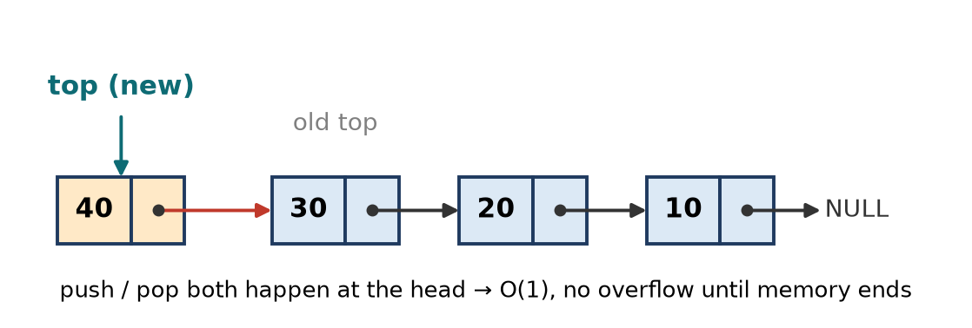
Figure: Linked stack: push adds a node before the old top
Trace: push 10, push 20, push 30 → top → 30 → 20 → 10 → NULL. pop() returns 30; top → 20.
Remember: Linked stack = insert and delete at the head; top is just another name for head.

Q7. Convert A+B*C-(D/E) to postfix using a stack. Show each step in a table.
Apply • Moderate • CO1, CO2
Rules: operand → output; ( → push; ) → pop to output until (; operator → pop operators of higher or equal precedence (left-associative), then push. At the end pop everything. Precedence: ^ > * / > + -.
Step | Symbol | Stack (bottom → top) | Postfix output
1 | A | empty | A
2 | + | + | A
3 | B | + | AB
4 | * | + * | AB
5 | C | + * | ABC
6 | − | − | ABC*+ (pop *, pop +, push −)
7 | ( | − ( | ABC*+
8 | D | − ( | ABC*+D
9 | / | − ( / | ABC*+D
10 | E | − ( / | ABC*+DE
11 | ) | − | ABC*+DE/
12 | end | empty | ABC*+DE/-

Postfix = ABC*+DE/-
Check: (A + (B × C)) − (D ÷ E) → A BC* + then DE/ then −. ✓
Remember: In postfix the operands keep their order (A B C D E); only the operators move.

Q8. Convert (A+B)*(C-D)^E/F to postfix using a stack. Show the stack contents at each step.
Apply • Moderate • CO1, CO2
Precedence: ^ (highest, right-associative) > * / > + -. For * / with equal precedence on the stack, pop first (left-associative).
Step | Symbol | Stack (bottom → top) | Postfix output
1 | ( | ( | –
2 | A | ( | A
3 | + | ( + | A
4 | B | ( + | AB
5 | ) | empty | AB+
6 | * | * | AB+
7 | ( | * ( | AB+
8 | C | * ( | AB+C
9 | − | * ( − | AB+C
10 | D | * ( − | AB+CD
11 | ) | * | AB+CD-
12 | ^ | * ^ | AB+CD- (^ higher than *, push)
13 | E | * ^ | AB+CD-E
14 | / | / | AB+CD-E^* (pop ^, pop * of equal precedence, push /)
15 | F | / | AB+CD-E^*F
16 | end | empty | AB+CD-E^*F/

Postfix = AB+CD-E^*F/
Check: ((A + B) × ((C − D)^E)) ÷ F. ✓
Remember: Incoming / meets ^ and * on the stack: both are "at least as strong", so both leave first.

Q9. Convert the infix expression (A-B/C)*(A/K-L) to prefix. Show the steps.
Apply • Moderate • CO1, CO2
Method (stack, scan right to left):
1. Scan the infix expression from right to left.
2. Operand → output. ) → push. ( → pop to output until ).
3. Operator → pop operators of strictly higher precedence, then push (equal precedence stays, because left-associative operators reverse).
4. At the end pop all, then reverse the output.
Right-to-left symbols: ) L - K / A ( * ) C / B - A (
Step | Symbol | Stack (bottom → top) | Output (reversed prefix)
1 | ) | ) | –
2 | L | ) | L
3 | − | ) − | L
4 | K | ) − | LK
5 | / | ) − / | LK
6 | A | ) − / | LKA
7 | ( | empty | LKA/-
8 | * | * | LKA/-
9 | ) | * ) | LKA/-
10 | C | * ) | LKA/-C
11 | / | * ) / | LKA/-C
12 | B | * ) / | LKA/-CB
13 | − | * ) − | LKA/-CB/ (pop / , higher)
14 | A | * ) − | LKA/-CB/A
15 | ( | * | LKA/-CB/A-
16 | end | empty | LKA/-CB/A-*

Reverse LKA/-CB/A-* → Prefix = *-A/BC-/AKL
Check by brackets: (A − (B/C)) → -A/BC; ((A/K) − L) → -/AKL; join with * → *-A/BC-/AKL. ✓
Remember: Prefix = reverse, convert (right to left), reverse again.

Q10. Evaluate the postfix expression 6 2 3 + - 3 8 2 / + * 2 ^ 3 + showing the stack after each token.
Apply • Moderate • CO1, CO2
Rule: operand → push. Operator → pop op2 (top) then op1, compute op1 operator op2, push the result.
Token | Action | Stack (bottom → top)
6 | push | 6
2 | push | 6, 2
3 | push | 6, 2, 3
+ | 2 + 3 = 5 | 6, 5
− | 6 − 5 = 1 | 1
3 | push | 1, 3
8 | push | 1, 3, 8
2 | push | 1, 3, 8, 2
/ | 8 ÷ 2 = 4 | 1, 3, 4
+ | 3 + 4 = 7 | 1, 7
* | 1 × 7 = 7 | 7
2 | push | 7, 2
^ | 7² = 49 | 49
3 | push | 49, 3
+ | 49 + 3 = 52 | 52

Result = 52
Check (infix): ((6 − (2 + 3)) × (3 + 8 ÷ 2))² + 3 = (1 × 7)² + 3 = 49 + 3 = 52. ✓
Remember: The first value popped is the RIGHT operand: 6 2 − means 6 − 2, not 2 − 6.

Q11. Write an algorithm to check whether parentheses in an expression are balanced. Trace it for {[()]}() and for {[(])}.
Apply • Moderate • CO1, CO2
Algorithm:
1. Scan the expression left to right.
2. Opening bracket ( [ { → push.
3. Closing bracket → if stack empty → unbalanced; else pop and check it is the matching opening bracket; if not → unbalanced.
4. At the end, stack empty → balanced, otherwise unbalanced.
bool isBalanced(string e) {
stack<char> s;
for (char c : e) {
if (c == '(' || c == '[' || c == '{') s.push(c);
else if (c == ')' || c == ']' || c == '}') {
if (s.empty()) return false; // extra closing
char t = s.top(); s.pop();
if ((c == ')' && t != '(') || (c == ']' && t != '[') ||
(c == '}' && t != '{')) return false; // mismatch
}
}
return s.empty(); // leftover opening?
}
Trace 1: {[()]}()
Symbol | Action | Stack
{ | push | {
[ | push | { [
( | push | { [ (
) | pop ( – match | { [
] | pop [ – match | {
} | pop { – match | empty
( | push | (
) | pop ( – match | empty
end | stack empty | Balanced

Trace 2: {[(])}
Symbol | Action | Stack
{ | push | {
[ | push | { [
( | push | { [ (
] | pop ( – does not match ] | Not balanced (stop)

Remember: Last opened must be first closed – that is exactly LIFO.

Q12. Write Pseudocode for enqueue and dequeue on a linear queue implemented using an array. Show the full and empty conditions.
Apply • Moderate • CO1, CO2
Use front = rear = -1 for an empty queue. Insert at rear, delete from front.
const int MAX = 5;
int Q[MAX];
int front = -1, rear = -1;
void enqueue(int x) {
if (rear == MAX - 1) { cout << "Queue Full (overflow)\n"; return; }
if (front == -1) front = 0; // first element
Q[++rear] = x; // move rear, store
}
int dequeue() {
if (front == -1 || front > rear) { cout << "Queue Empty (underflow)\n"; return -1; }
int x = Q[front++]; // take from front
if (front > rear) front = rear = -1; // queue became empty: reset
return x;
}
Condition | Test
Full | rear == MAX − 1
Empty | front == −1 (or front > rear)
Number of elements | rear − front + 1

Figure: Linear queue with front and rear
Trace (MAX = 5): enqueue 10, 20, 30 → front = 0, rear = 2. dequeue → 10, front = 1.
Drawback: after deletions the freed front slots are not reused (rear can only grow); the circular queue solves this.
Remember: Linear queue: full when rear hits the wall (MAX − 1), even if the front is empty.

Q13. For a circular queue of size 5: insert 10,20,30,40,50; delete two elements; insert 60,70. Show front and rear after each operation.
Apply • Moderate • CO1, CO2
Rules: start with front = rear = −1.
- Insert: if (rear + 1) % 5 == front → full; if front == −1 then front = 0; rear = (rear + 1) % 5.
- Delete: take Q[front]; front = (front + 1) % 5.
Operation | front | rear | Q[0] … Q[4] | Remark
Initial | −1 | −1 | – – – – – | Empty
Insert 10 | 0 | 0 | 10 – – – –
Insert 20 | 0 | 1 | 10 20 – – –
Insert 30 | 0 | 2 | 10 20 30 – –
Insert 40 | 0 | 3 | 10 20 30 40 –
Insert 50 | 0 | 4 | 10 20 30 40 50 | Full: (4+1) % 5 = 0 = front
Delete → 10 | 1 | 4 | – 20 30 40 50
Delete → 20 | 2 | 4 | – – 30 40 50
Insert 60 | 2 | 0 | 60 – 30 40 50 | rear = (4+1) % 5 = 0 (wraps)
Insert 70 | 2 | 1 | 60 70 30 40 50 | Full again: (1+1) % 5 = 2 = front

Final: front = 2, rear = 1; queue order from front: 30, 40, 50, 60, 70.
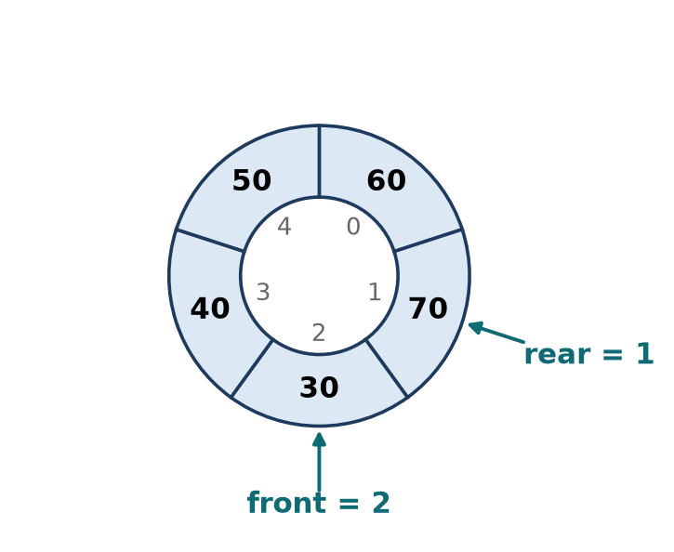
Figure: Final state of the circular queue
Remember: In a circular queue rear can be "behind" front – that just means it has wrapped round.

Q14. Implement a queue using a singly linked list. Write the enqueue and dequeue Pseudocode.
Apply • Moderate • CO1, CO2
Keep two pointers: front (first node, for deletion) and rear (last node, for insertion). Both operations are O(1) and there is no fixed size.
struct Node { int data; Node* next; };
Node *front = nullptr, *rear = nullptr; // empty queue
void enqueue(int x) {
Node* t = new Node{x, nullptr};
if (rear == nullptr) front = rear = t; // first node
else { rear->next = t; rear = t; } // link at end
}
int dequeue() {
if (front == nullptr) { cout << "Queue Underflow\n"; return -1; }
Node* t = front;
int x = t->data;
front = front->next; // move front ahead
if (front == nullptr) rear = nullptr; // queue became empty
delete t;
return x;
}
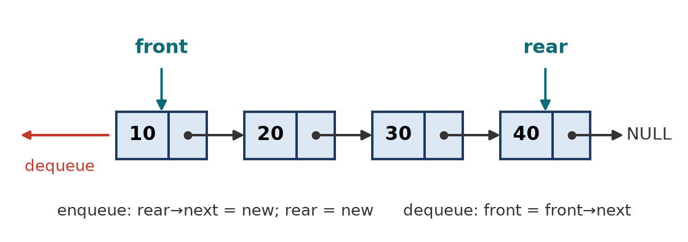
Figure: Linked queue with front and rear pointers
Trace: enqueue 10, 20, 30 → front → 10 → 20 → 30 ← rear. dequeue() → 10; front → 20.
Important: when the last node is deleted, set rear = NULL too, or rear would point to freed memory.
Remember: Linked queue: add behind rear, remove at front; if front becomes NULL, rear must too.

Q15. Write the algorithm to implement a queue using two stacks. Show enqueue and dequeue for 1,2,3.
Apply • Moderate • CO1, CO2
Idea: stack S1 receives new elements; stack S2 gives elements out. Moving all of S1 into S2 reverses the order, so the oldest element comes to the top of S2.
Algorithm:
- enqueue(x): push x on S1.
- dequeue(): if S2 is empty, pop every element of S1 and push it on S2. Then pop S2. (If both are empty → underflow.)
stack<int> s1, s2;
void enqueue(int x) { s1.push(x); }
int dequeue() {
if (s2.empty()) {
if (s1.empty()) { cout << "Queue Underflow\n"; return -1; }
while (!s1.empty()) { s2.push(s1.top()); s1.pop(); } // reverse
}
int x = s2.top(); s2.pop();
return x;
}
Operation | S1 (bottom → top) | S2 (bottom → top) | Returned
enqueue 1 | 1 | empty | –
enqueue 2 | 1, 2 | empty | –
enqueue 3 | 1, 2, 3 | empty | –
dequeue | empty | 3, 2, 1 (moved) → pop | 1
dequeue | empty | 3, 2 → pop | 2
dequeue | empty | 3 → pop | 3

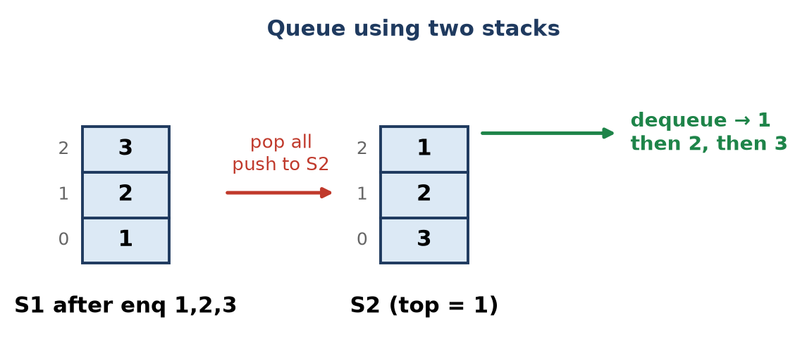
Figure: Queue using two stacks
Output order 1, 2, 3 = FIFO ✓. enqueue O(1); dequeue O(n) worst case but O(1) amortised (each element moves only once).
Remember: Two LIFOs make a FIFO: reversing twice gives the original order.

Q16. Analyz an array-based circular queue for its Queue Full and Queue Empty condition,
Analyze • HOTS • CO1, CO2
In a circular queue of size N, front and rear move with % N. The difficulty is that in both "empty" and "full" states, front and rear can be in the same relative position, so a clear rule is needed.
Method 1: front = rear = −1 for empty (common in syllabus)
- Empty: front == −1
- Full: (rear + 1) % N == front (same as: front == 0 and rear == N − 1, or front == rear + 1)
- When the last element is deleted, reset front = rear = −1.
Method 2: front = rear = 0, keep one slot empty
- Empty: front == rear
- Full: (rear + 1) % N == front
- Only N − 1 slots can be used. Reason: if all N were used, rear would again equal front and full would look the same as empty.
Method 3: count variable
- Empty: count == 0, Full: count == N; all N slots used, at the cost of one extra variable.
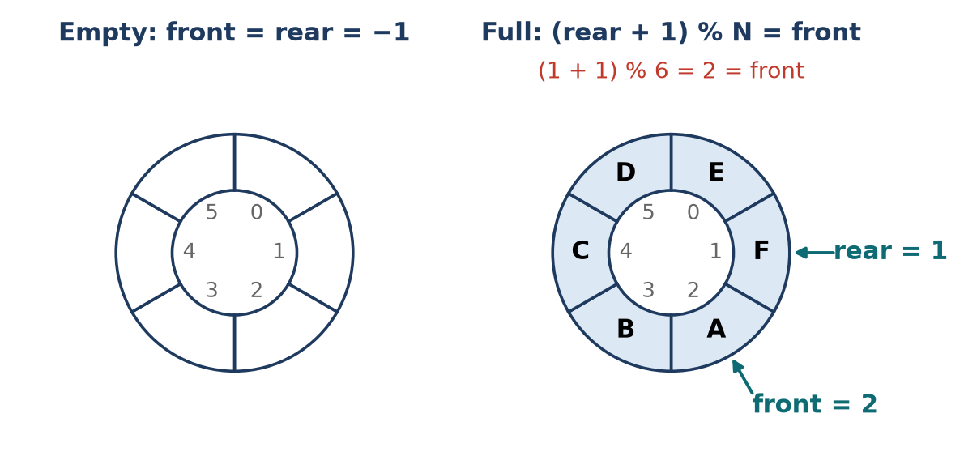
Figure: Empty and full states of a circular queue (N = 6)
Method | Empty test | Full test | Usable slots
front/rear = −1 | front == −1 | (rear+1) % N == front | N
One slot empty | front == rear | (rear+1) % N == front | N − 1
Count | count == 0 | count == N | N

Example (N = 6): front = 2, rear = 1 → (1 + 1) % 6 = 2 = front → full.
Conclusion: the test front == rear alone is ambiguous; use the −1 flag, sacrifice one slot, or keep a count.
Remember: Full = "rear's next is front"; empty = "nobody here" (front = −1 or count = 0).

Q17. A web browser provides back and forward navigation. Evaluate whether an array-based or linked stack is more suitable. Justify your answer.
Evaluating • HOTS • CO1, CO2
Situation: a browser keeps a Back stack and a Forward stack.
- Visit a new page: push the current page on Back, clear Forward.
- Back: push current on Forward, pop Back.
- Forward: push current on Back, pop Forward.
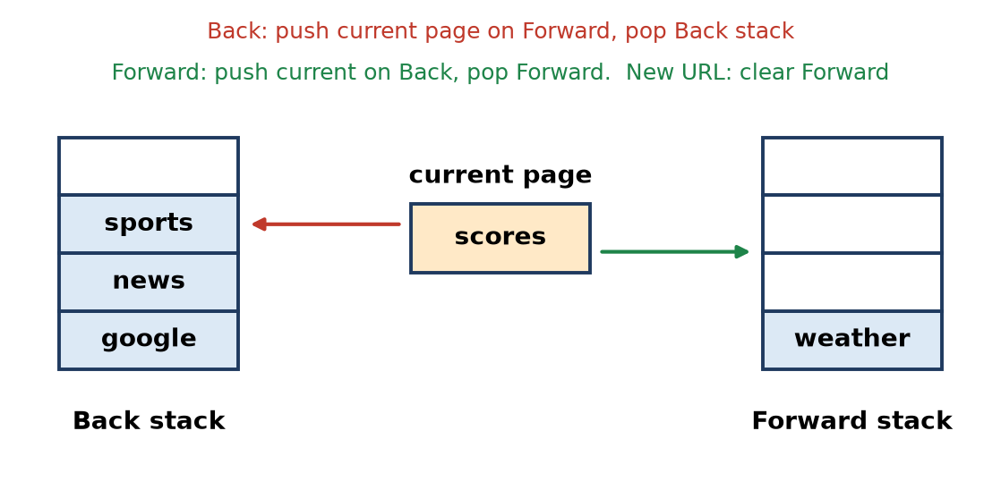
Figure: Back and forward navigation with two stacks
Evaluation:
Point | Array-based stack | Linked stack
Size | Fixed MAX, must guess | Grows with history
Overflow | When MAX pages visited | Only when memory is full
Memory use | Unused slots wasted | Exactly as many nodes as pages, plus pointers
Push / pop time | O(1) | O(1)
Clear Forward stack | O(1) (top = −1) | O(n) to free nodes
Cache speed | Better (contiguous) | Slightly slower

Justification:
1. The number of pages a user visits in a session is unknown and can be large, so a fixed array either wastes space or overflows.
2. Push and pop are O(1) in both, so the linked stack loses nothing in speed for the main operations.
3. Each page entry holds a URL and page state of different sizes, which fits naturally in dynamically created nodes.
Verdict: a linked stack is more suitable. An array stack is acceptable only if the browser deliberately limits history to a fixed number of pages (then a circular array that drops the oldest entry works well).
Remember: Unknown size → linked; fixed limit → array.

Q18. Compare unsorted array, sorted array, linked list and heap implementations of a priority queue by insert and delete time. Recommend one for hospital triage.
Evaluating • HOTS • CO1, CO2
A priority queue needs two main operations: insert (a new patient) and delete-highest (call the most critical patient).
Implementation | Insert | Delete highest priority | Remark
Unsorted array | O(1) (add at end) | O(n) (search + shift) | Fast insert, slow delete; fixed size
Sorted array | O(n) (find place + shift) | O(1) (highest at one end) | Slow insert; fixed size
Sorted linked list | O(n) (find place) | O(1) (remove head) | Dynamic size; unsorted list is O(1) / O(n)
Binary heap | O(log n) | O(log n) | Peek O(1); balanced for both operations

Hospital triage analysis:
1. Patients arrive all the time (many inserts) and the most serious is treated first (many deletes), so both operations must be fast.
2. Arrays and lists make one of the two operations O(n); with hundreds of patients this becomes slow.
3. A max-heap keyed on severity keeps the most critical patient at the root: both insert and delete are O(log n); for 1,000 patients that is about 10 steps instead of 1,000.
4. To keep arrival order among equal severity, store (severity, arrival time) as the key.
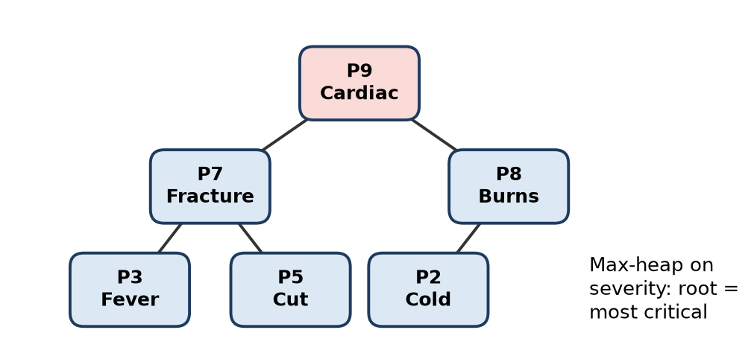
Figure: Max-heap of patients by severity
Recommendation: use a binary max-heap priority queue for hospital triage.
Remember: Heap = the fair balance: log n for both joining and leaving.

Q19. A text editor allows users to undo their most recent editing operations. Explain how a stack can be used to implement the Undo feature and illustrate the process using any three editing operations.
Apply • HOTS • CO1, CO2
Why a stack: Undo always reverses the most recent action first – that is LIFO, exactly a stack.
Working:
1. Every edit (type, delete, format) is recorded as an operation object (what was done, where, old text) and pushed on the Undo stack.
2. On Undo, the top operation is popped and its inverse is applied (insert ↔ delete, bold ↔ un-bold).
3. The popped operation is pushed on a Redo stack; any new edit clears the Redo stack.
Illustration with three operations:
Step | Action | Document | Undo stack (bottom → top)
1 | Type "Hi" | Hi | type "Hi"
2 | Make "Hi" bold | Hi | type "Hi", bold "Hi"
3 | Delete "i" | H | type "Hi", bold "Hi", delete "i"
4 | Undo | Hi (i restored) | type "Hi", bold "Hi"
5 | Undo | Hi (bold removed) | type "Hi"

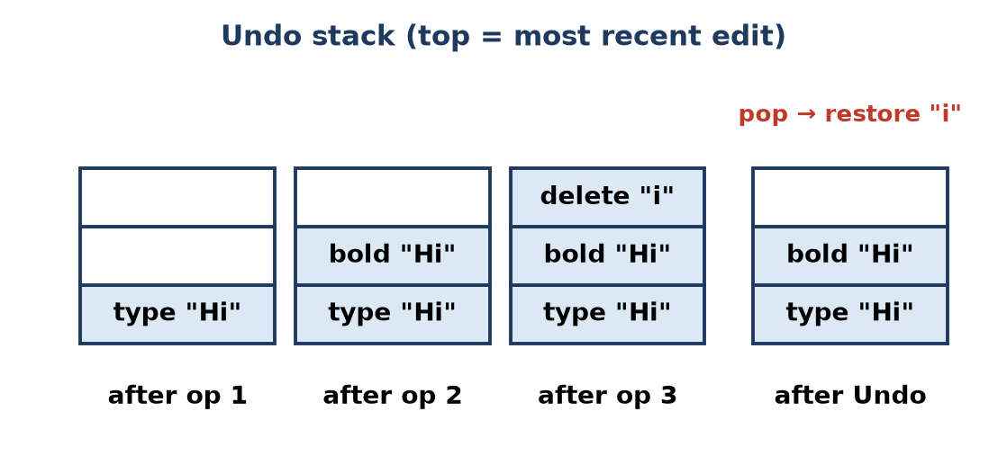
Figure: Undo stack after each operation
All push and pop operations are O(1). Editors often cap the stack (for example, last 100 actions) to save memory.
Remember: Undo = pop the latest edit and do its opposite; Redo = keep what you popped on a second stack.

Q20. A hospital token system issues tokens to patients and calls patients for consultation in token order. Define a Queue ADT for this system by specifying its basic operations and the conditions for overflow and underflow.
Apply • HOTS • CO1, CO2
Situation: tokens are issued in increasing order and patients are called in the same order → FIFO queue.
ADT TokenQueue
- Data: circular array Q[MAX] of tokens (token number, patient name); front, rear, count.
- Operations:
1. createQueue(): front = 0, rear = −1, count = 0.
2. issueToken(t) (enqueue): if isFull → overflow; else rear = (rear + 1) % MAX, Q[rear] = t, count++.
3. callNext() (dequeue): if isEmpty → underflow; else t = Q[front], front = (front + 1) % MAX, count−−, return t.
4. nextToken() (peek): return Q[front] without removing.
5. isEmpty(): count == 0. isFull(): count == MAX.
6. waiting(): return count.
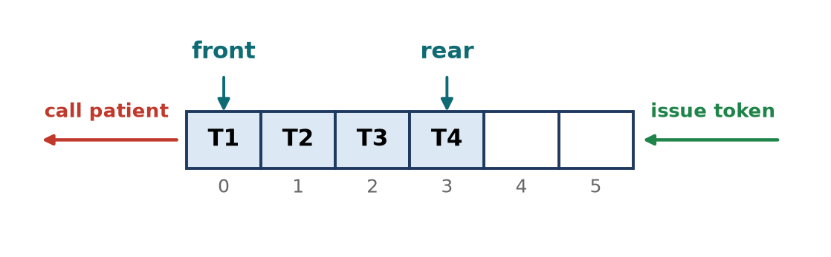
Figure: Token queue: issue at rear, call from front
Condition | When it happens | Test | Action
Overflow | All MAX token slots are waiting (waiting area or daily limit full) | count == MAX | Refuse new token, show "No more tokens"
Underflow | Doctor calls but nobody is waiting | count == 0 | Show "No patient waiting"

Example (MAX = 50): issue T1, T2, T3 → callNext() returns T1, then T2. A circular array reuses slots of called patients; a linked queue can be used if there is no daily limit.
Remember: Token system = first come, first called: issue at rear, call at front.

Q21. The figure shows a circular queue with 10 positions (0-9), front = 0 and rear = 5. Use a count variable to detect full/empty. (a) Write the Pseucode to insert an element in a circular queue. (b) Insert 21, 23, 25 and 27 one after another and show front, rear, count and the queue contents after every insertion. (c) What happens if 28 is inserted next?
Apply • Moderate • CO1, CO2
Initial state (from figure): positions 0–5 hold 1, 3, 5, 7, 9, 11; front = 0, rear = 5, count = 6, N = 10.
(a) Insert using count:
void insertCQ(int Q[], int N, int &front, int &rear, int &count, int x) {
if (count == N) { // all positions used
cout << "Queue Overflow\n";
return;
}
rear = (rear + 1) % N; // next position, wraps after N-1
Q[rear] = x;
count++;
}
(b) Insertions:
Operation | front | rear | count | Q[0] … Q[9]
Initial | 0 | 5 | 6 | 1 3 5 7 9 11 – – – –
Insert 21 | 0 | 6 | 7 | 1 3 5 7 9 11 21 – – –
Insert 23 | 0 | 7 | 8 | 1 3 5 7 9 11 21 23 – –
Insert 25 | 0 | 8 | 9 | 1 3 5 7 9 11 21 23 25 –
Insert 27 | 0 | 9 | 10 | 1 3 5 7 9 11 21 23 25 27

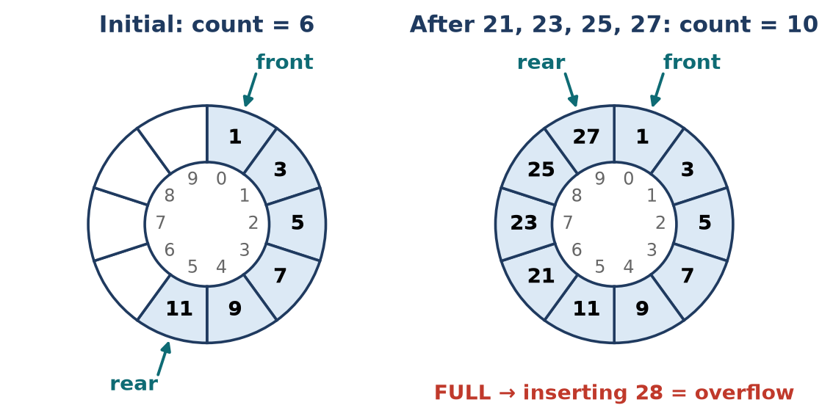
Figure: Circular queue before and after the four insertions
(c) Insert 28: count = 10 = N, so the queue is full → Queue Overflow; 28 is not inserted and front, rear, count stay 0, 9, 10. (Also (9 + 1) % 10 = 0 = front.) Space becomes available only after a deletion moves front.
Remember: With a count variable: full when count == N, empty when count == 0 — no confusion between them.

Q22. The figure shows a deque of size 7 stored in a circular array (front = 0, rear = 4). Perform the following operations in order and show front, rear and the array after each step: insertFront(10), insertRear(15), insertRear(20), deleteFront(), deleteRear(), insertRear(14), insertFront(2). Identify the operation(s) that cause overflow.
Apply • Moderate • CO1, CO2
Initial (from figure): DQ = [5, 11, 3, 9, 4, –, –], front = 0, rear = 4, count = 5, N = 7.
Rules (circular):
- insertFront: front = (front − 1 + N) % N; insertRear: rear = (rear + 1) % N
- deleteFront: front = (front + 1) % N; deleteRear: rear = (rear − 1 + N) % N
- Overflow when count == N (equivalently (rear + 1) % N == front)
Operation | front | rear | count | DQ[0] … DQ[6] | Remark
Initial | 0 | 4 | 5 | 5 11 3 9 4 – –
insertFront(10) | 6 | 4 | 6 | 5 11 3 9 4 – 10 | front = (0 − 1 + 7) % 7 = 6
insertRear(15) | 6 | 5 | 7 | 5 11 3 9 4 15 10 | Now full
insertRear(20) | 6 | 5 | 7 | 5 11 3 9 4 15 10 | OVERFLOW – (5+1) % 7 = 6 = front
deleteFront() → 10 | 0 | 5 | 6 | 5 11 3 9 4 15 – | front = (6 + 1) % 7 = 0
deleteRear() → 15 | 0 | 4 | 5 | 5 11 3 9 4 – – | rear = 4
insertRear(14) | 0 | 5 | 6 | 5 11 3 9 4 14 –
insertFront(2) | 6 | 5 | 7 | 5 11 3 9 4 14 2 | Full again (no overflow)

Final: front = 6, rear = 5; deque order from front to rear: 2, 5, 11, 3, 9, 4, 14.
Operation causing overflow: only insertRear(20). insertFront(2) fills the last free slot, so the deque is full but no overflow occurs.
(Note: if the array were treated as a non-circular deque, insertFront(10) at front = 0 would also overflow; the question states a circular array, so it wraps to index 6.)
Remember: In a circular deque, front moves left with (front − 1 + N) % N — index 0 wraps to N − 1.

Q23. Convert the following infix expression to prefix form using a stack. Show the stack contents and the partial output at each step. (Precedence: ^ highest, then * /, then + -; ^ is right associative.) (A+B*(C^D-E)^(F+G*H)-I)
Apply • Moderate • CO1, CO2
Method: scan right to left. Operand → output; ) → push; ( → pop to output until ). For an operator, pop while the stack top has higher precedence, or equal precedence when the incoming operator is ^ (right-associative); then push. At the end, reverse the output.
Right-to-left symbols: ) I - ) H * G + F ( ^ ) E - D ^ C ( * B + A (
Step | Symbol | Stack (bottom → top) | Partial output
1 | ) | ) | –
2 | I | ) | I
3 | − | ) − | I
4 | ) | ) − ) | I
5 | H | ) − ) | IH
6 | * | ) − ) * | IH
7 | G | ) − ) * | IHG
8 | + | ) − ) + | IHG* (pop *, higher)
9 | F | ) − ) + | IHG*F
10 | ( | ) − | IHG*F+
11 | ^ | ) − ^ | IHG*F+
12 | ) | ) − ^ ) | IHG*F+
13 | E | ) − ^ ) | IHG*F+E
14 | − | ) − ^ ) − | IHG*F+E
15 | D | ) − ^ ) − | IHG*F+ED
16 | ^ | ) − ^ ) − ^ | IHG*F+ED
17 | C | ) − ^ ) − ^ | IHG*F+EDC
18 | ( | ) − ^ | IHG*F+EDC^-
19 | * | ) − * | IHG*F+EDC^-^ (pop ^, higher)
20 | B | ) − * | IHG*F+EDC^-^B
21 | + | ) − + | IHG*F+EDC^-^B* (pop *; − equal, stays)
22 | A | ) − + | IHG*F+EDC^-^B*A
23 | ( | empty | IHG*F+EDC^-^B*A+-

Reverse IHG*F+EDC^-^B*A+- → Prefix = -+A*B^-^CDE+F*GHI
Check by grouping: ((A + (B × ((C^D − E) ^ (F + G × H)))) − I)
- C^D − E → -^CDE; F + G × H → +F*GH
- their power → ^-^CDE+F*GH; B × that → *B^-^CDE+F*GH
- A + that → +A*B^-^CDE+F*GH; minus I → -+A*B^-^CDE+F*GHI ✓
Remember: Right-to-left scan flips associativity: for + − * / an equal operator stays on the stack; for ^ it is popped.

Quick Revision – Unit 2
Term | Key fact
Stack | LIFO; push/pop at top; O(1)
Array stack conditions | Overflow: top == MAX − 1; underflow: top == −1
Linked stack | Push/pop at head; overflow only when memory is full
Queue | FIFO; insert at rear, delete at front
Linear queue conditions | Full: rear == MAX − 1; empty: front == −1 or front > rear
Circular queue | rear = (rear + 1) % N; full: (rear + 1) % N == front
Count method | Empty: count == 0; full: count == N
Deque | Insert/delete at both ends
Input-restricted deque | Insert at rear only, delete at both ends
Output-restricted deque | Delete at front only, insert at both ends
Priority queue | Highest priority first; heap gives O(log n) insert and delete
Infix → postfix | Pop operators of higher or equal precedence (not for ^)
Infix → prefix | Scan right to left (or reverse), convert, reverse output
Postfix evaluation | Pop op2 then op1; push op1 operator op2
Queue using two stacks | Enqueue on S1; dequeue from S2, refilling from S1 when empty
Applications of stack | Undo, browser back, recursion, bracket matching, expression evaluation

Unit 3: Trees, Symbol Tables and Hashing

Q1. Differentiate between full, complete, perfect and skewed binary trees with diagrams.
Understand • Low • CO1, CO3
A binary tree is a tree in which every node has at most two children (left and right).
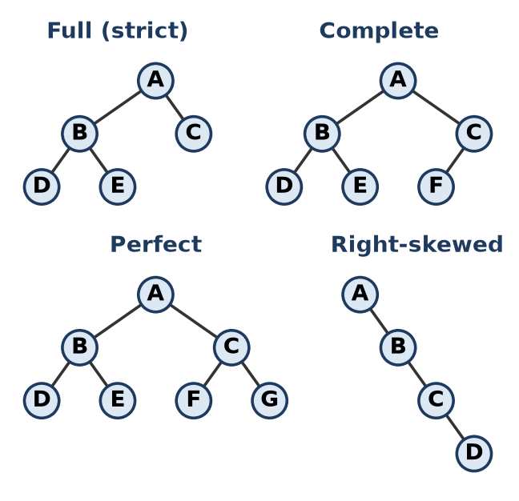
Figure: Types of binary trees
Type | Rule | Example property
Full (strict) | Every node has 0 or 2 children | Leaves = internal nodes + 1
Complete | All levels full except the last; last level filled left to right | Used for heaps (array storage)
Perfect | All internal nodes have 2 children and all leaves at the same level | Nodes = 2^(h+1) − 1
Skewed | Every node has only one child (all left or all right) | Height = n − 1, behaves like a linked list

Every perfect tree is both full and complete, but not the other way round.
Remember: F-C-P-S: Full = 0 or 2, Complete = left-filled, Perfect = all leaves level, Skewed = one-sided.

Q2. Explain the binary search tree property. How does a BST differ from a binary tree?
Understand • Low • CO1, CO3
BST property: for every node, all keys in its left subtree are smaller and all keys in its right subtree are larger than the node's key; both subtrees are also BSTs.
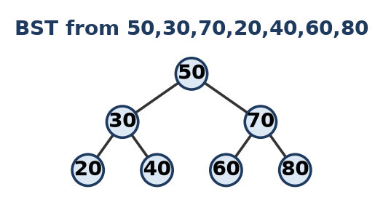
Figure: BST example
Point | Binary tree | Binary search tree
Ordering | No order between keys | Left < root < right
Search | Visit all nodes, O(n) | Follow one path, O(h) (O(log n) if balanced)
Inorder output | Any order | Sorted (ascending) order
Duplicates | Allowed anywhere | Usually not allowed

Remember: BST = "Binary Sorted Tree": smaller go left, bigger go right.

Q3. Explain the need for height-balanced trees. Define the balance factor of an AVL node.
Understand • Low • CO1, CO3
Need: a BST built from sorted data becomes skewed, so its height is n − 1 and search, insert and delete become O(n). A height-balanced tree (AVL) keeps the height about log2 n, so all operations stay O(log n).
Balance factor (BF) of a node: BF = height(left subtree) − height(right subtree)
- In an AVL tree, every node must have BF = −1, 0 or +1.
- If any node gets BF = +2 or −2 after an insertion or deletion, rotations (LL, RR, LR, RL) restore balance.
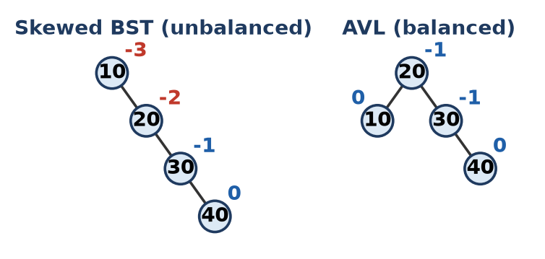
Figure: Skewed BST vs AVL tree (balance factors shown)
Remember: AVL rule: left height and right height may differ by at most one.

Q4. Explain the properties of a Red-Black tree.
Understand • Low • CO1, CO3
A Red-Black tree is a self-balancing BST in which each node stores an extra colour bit (red or black).
1. Every node is either red or black.
2. The root is black.
3. Every leaf (NIL / null pointer) is black.
4. A red node cannot have a red child (no two reds in a row).
5. Every path from a node to its descendant NIL leaves has the same number of black nodes (black height).
Result: the longest path is at most twice the shortest, so height ≤ 2 log2(n + 1) and search, insert, delete are O(log n), with fewer rotations than AVL.
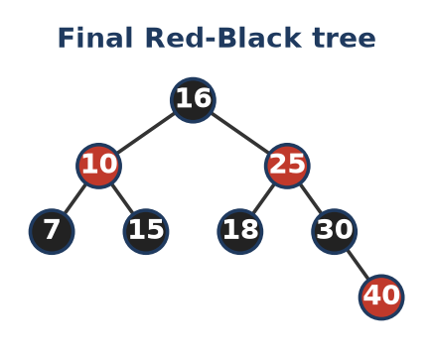
Figure: A valid Red-Black tree
Remember: "Root black, no red-red, same black count."

Q5. Explain static and dynamic symbol tables with suitable examples.
Understand • Low • CO1, CO3
A symbol table is a data structure that stores (name, attributes) pairs, for example a compiler stores each identifier with its type, scope and address.
Point | Static symbol table | Dynamic symbol table
Contents | Fixed, known in advance | Changes while the program runs
Operations | Only search | Search, insert, delete
Structure | Sorted array, optimal BST | Hash table, AVL / Red-Black tree
Example | Table of C++ keywords (int, for, while) | Compiler's table of user identifiers (sum, i, count)

Remember: Static = read-only list; dynamic = grows and shrinks.

Q6. Explain hashing, hash function and collision. List the properties of a good hash function.
Understand • Low • CO1, CO3
- Hashing: storing and finding a record directly at a computed address, giving O(1) average search.
- Hash function: a function h(k) that maps a key to a table index, e.g. h(k) = k mod 10.
- Collision: two different keys get the same address, e.g. 25 and 35 both give 5. It is handled by open addressing (linear, quadratic probing, double hashing) or chaining.
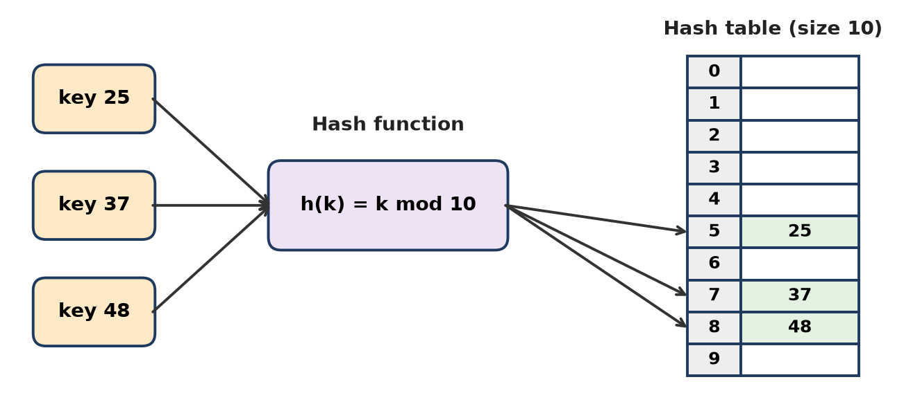
Figure: Hashing
Good hash function:
1. Easy and fast to compute.
2. Spreads keys uniformly over the table.
3. Gives few collisions.
4. Uses all parts of the key.
5. Always gives the same address for the same key.
Remember: Hash = "address calculator"; collision = two keys, one slot.

Q7. Convert the general tree (A has children B,C,D; B has children E,F; D has children G,H,I) into a binary tree using the left-child right-sibling method.
Apply • Moderate • CO1, CO3
Left-child right-sibling rule: in the binary tree, the left pointer points to the node's first child and the right pointer points to its next sibling.
Steps:
1. A's first child is B, so A.left = B (A has no sibling, A.right = NULL).
2. B's first child is E, so B.left = E; B's next sibling is C, so B.right = C.
3. E's sibling is F, so E.right = F.
4. C has no child; C's sibling is D, so C.right = D.
5. D's first child is G, so D.left = G; G.right = H, H.right = I.
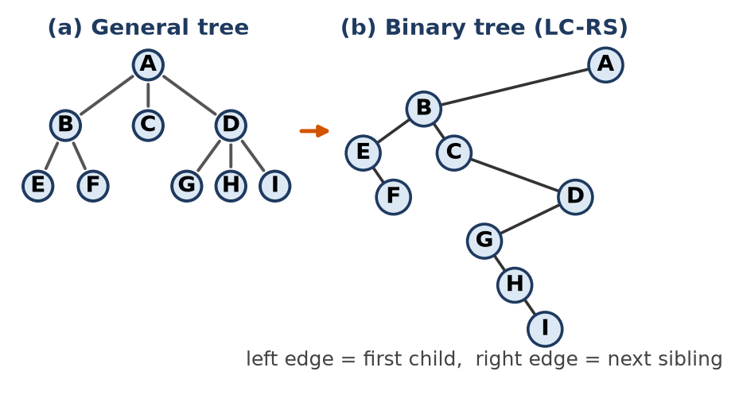
Figure: General tree to binary tree
Check: preorder of the binary tree = A B E F C D G H I, which equals the preorder of the general tree.
Remember: Left = first child, Right = next brother.

Q8. Construct the binary tree from Inorder: D B E A F C and Preorder: A B D E C F. Give the postorder traversal.
Apply • Moderate • CO1, CO3
Rule: the first node of preorder is the root; its position in inorder splits the left and right subtrees.
1. Preorder first = A is the root. Inorder: (D B E) A (F C).
2. Left part, preorder B D E: root B; inorder D B E, so D is left and E is right of B.
3. Right part, preorder C F: root C; inorder F C, so F is the left child of C.
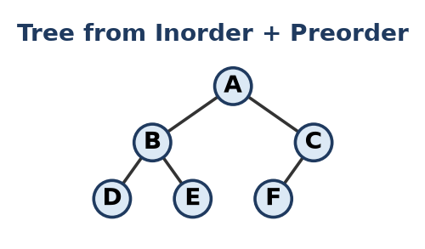
Figure: Constructed tree
Postorder (Left, Right, Root) = D E B F C A
Remember: Preorder picks the root, inorder splits left and right.

Q9. Construct a BST by inserting 50,30,70,20,40,60,80,35 in the given order. Draw the tree after each insertion.
Apply • Moderate • CO1, CO3
Insert rule: start at the root; go left if key < node, right if key > node, until an empty place is found.
1. 50 → becomes root.
2. 30 < 50 → left of 50.
3. 70 > 50 → right of 50.
4. 20 < 50, < 30 → left of 30.
5. 40 < 50, > 30 → right of 30.
6. 60 > 50, < 70 → left of 70.
7. 80 > 50, > 70 → right of 70.
8. 35 < 50, > 30, < 40 → left of 40.
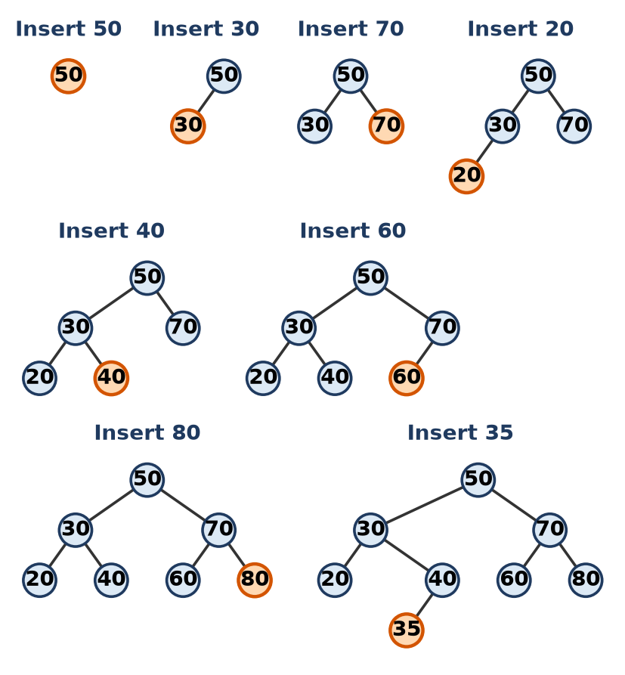
Figure: BST after each insertion (new node highlighted)
Check: inorder = 20 30 35 40 50 60 70 80 (sorted), height = 3.
Remember: Compare and turn: smaller left, larger right, stop at NULL.

Q10. Write recursive pseudocode for inorder, preorder and postorder traversals. Give all three traversals for the BST built from 50,30,70,20,40,60,80.
Apply • Moderate • CO1, CO3
struct Node { int data; Node *left, *right; };
void inorder(Node* r) { // Left, Root, Right
if (r == nullptr) return;
inorder(r->left);
cout << r->data << " ";
inorder(r->right);
}
void preorder(Node* r) { // Root, Left, Right
if (r == nullptr) return;
cout << r->data << " ";
preorder(r->left);
preorder(r->right);
}
void postorder(Node* r) { // Left, Right, Root
if (r == nullptr) return;
postorder(r->left);
postorder(r->right);
cout << r->data << " ";
}
Figure: BST from 50,30,70,20,40,60,80
Traversal | Output
Inorder | 20 30 40 50 60 70 80
Preorder | 50 30 20 40 70 60 80
Postorder | 20 40 30 60 80 70 50

Remember: The name tells where the Root goes: PRE = first, IN = middle, POST = last.

Q11. Write a non-recursive inorder traversal algorithm using a stack. Trace it on a tree of at least 7 nodes.
Apply • Moderate • CO1, CO3
Idea: push nodes while moving left; when you cannot go left, pop, print, then move to the right child.
void inorderIter(Node* root) {
stack<Node*> s;
Node* cur = root;
while (cur != nullptr || !s.empty()) {
while (cur != nullptr) { // go left as far as possible
s.push(cur);
cur = cur->left;
}
cur = s.top(); s.pop(); // visit the node
cout << cur->data << " ";
cur = cur->right; // then its right subtree
}
}
Trace on the BST of 50, 30, 70, 20, 40, 60, 80 (see Q10 figure):
Step | Action | Stack (top at right) | Output
1 | push 50, 30, 20 | 50 30 20 | –
2 | pop 20, print | 50 30 | 20
3 | pop 30, print; push 40 | 50 40 | 20 30
4 | pop 40, print | 50 | 20 30 40
5 | pop 50, print; push 70, 60 | 70 60 | … 50
6 | pop 60, print | 70 | … 60
7 | pop 70, print; push 80 | 80 | … 70
8 | pop 80, print; stack empty → stop | empty | 20 30 40 50 60 70 80

Remember: "Go left and push, pop and print, then turn right."

Q12. Write recursive pseudocode to insert a key into and search a key in a BST.
Apply • Moderate • CO1, CO3
Insert: if the tree is empty, create the node there; otherwise go left (smaller) or right (larger) recursively. Search: if the node is NULL or holds the key, return it; otherwise search only one side.
struct Node { int data; Node *left, *right; };
Node* insert(Node* r, int key) {
if (r == nullptr) // empty place found
return new Node{key, nullptr, nullptr};
if (key < r->data)
r->left = insert(r->left, key); // go left
else if (key > r->data)
r->right = insert(r->right, key); // go right
return r; // duplicates ignored
}
Node* search(Node* r, int key) {
if (r == nullptr || r->data == key) // not found or found
return r;
if (key < r->data)
return search(r->left, key);
return search(r->right, key);
}
- Example: searching 40 in the Q10 tree: 50 → 30 → 40 found (3 comparisons).
- Time: O(h), i.e. O(log n) for a balanced tree, O(n) for a skewed tree.
Remember: Both follow one root-to-leaf path: smaller left, larger right.

Q13. From the BST with root 50 (left 30 with children 20,40; right 70 with children 60,80), delete 20, then 30, then 50. Show the tree after each deletion.
Apply • Moderate • CO1, CO3
Three deletion cases: (1) leaf – just remove; (2) one child – link the child to the parent; (3) two children – replace with the inorder successor (smallest in right subtree), then delete the successor.
1. Delete 20: leaf → remove it. 30 now has only right child 40.
2. Delete 30: one child (40) → 40 takes 30's place as left child of 50.
3. Delete 50: two children → inorder successor = 60 (leftmost of right subtree). Copy 60 into the root and delete the old 60 (a leaf).
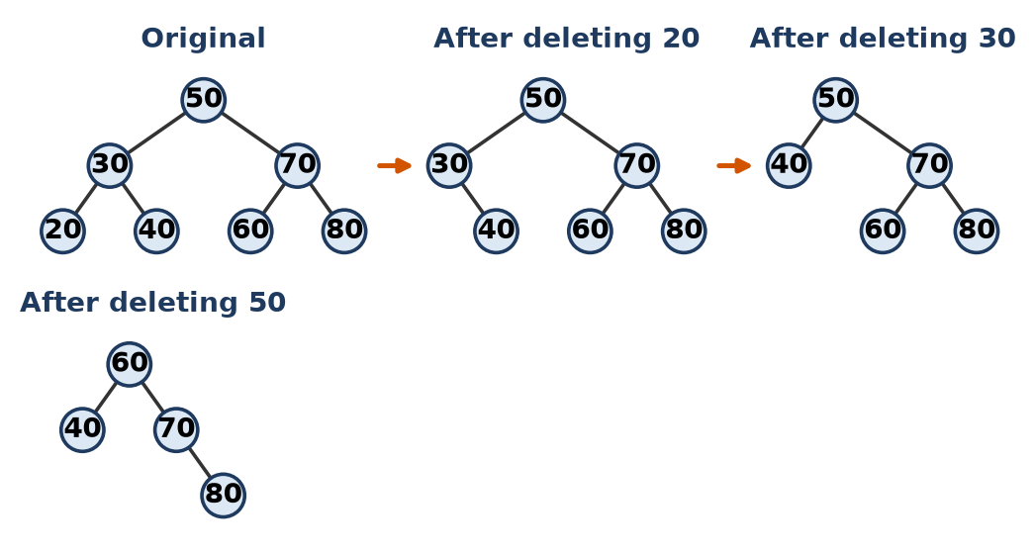
Figure: BST deletions
Final tree: root 60, left 40, right 70 (with right child 80). Inorder 40 60 70 80 is still sorted.
Remember: Leaf: cut; one child: bypass; two children: borrow the successor.

Q14. Construct an AVL tree for the keys 21,26,30,9,4,14,28,18,15,10. Show each rotation performed.
Apply • Moderate • CO1, CO3
Insert as in a BST, then recompute BF = h(left) − h(right) up the path; at the first node with BF = ±2, rotate.
Insert | Unbalanced node (BF) | Case | Rotation | Root after
21, 26 | – | – | none | 21
30 | 21 (−2) | RR | left rotate at 21 | 26
9 | – | – | none | 26
4 | 21 (+2) | LL | right rotate at 21 | 26
14 | 26 (+2) | LR | left at 9, right at 26 | 21
28 | 26 (−2) | RL | right at 30, left at 26 | 21
18 | – | – | none | 21
15 | 14 (−2) | RL | right at 18, left at 14 | 21
10 | 9 (−2) | RL | right at 15, left at 9 | 21

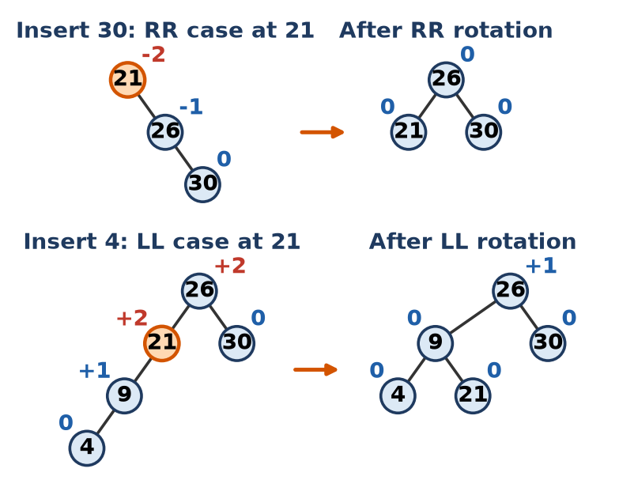
Figure: Rotations for 30 (RR) and 4 (LL)
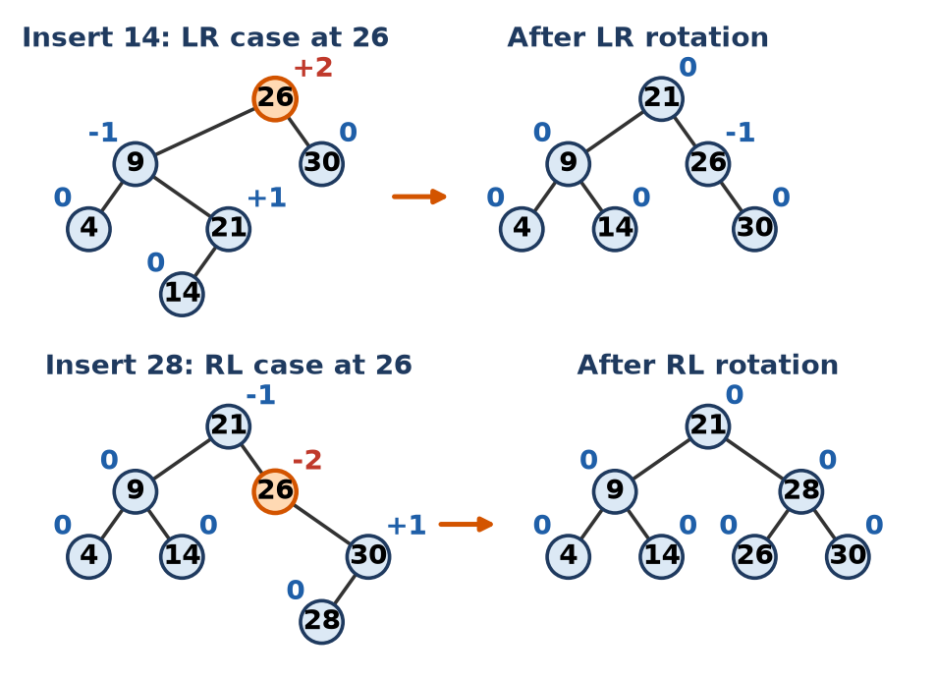
Figure: Rotations for 14 (LR) and 28 (RL)
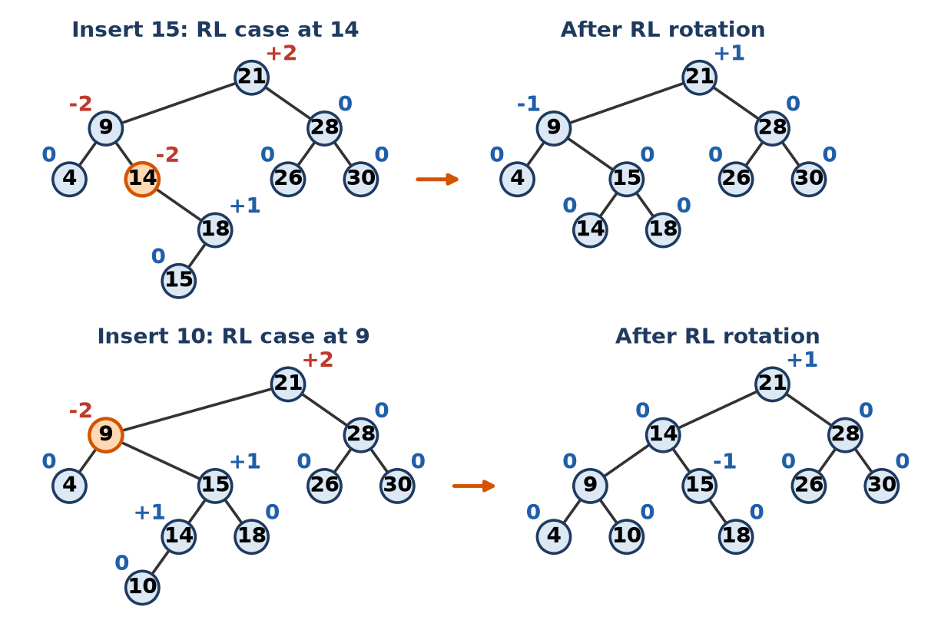
Figure: Rotations for 15 (RL) and 10 (RL)
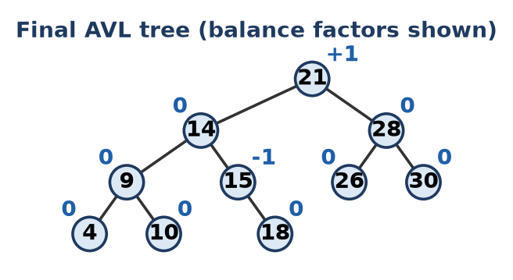
Figure: Final AVL tree
Final AVL tree: root 21; left subtree 14 (9 with children 4, 10; 15 with right child 18); right subtree 28 (26, 30). Height = 3, all BF in {−1, 0, +1}.
Remember: Name the case by the path from the unbalanced node to the new key: Left-Left, Right-Right, Left-Right, Right-Left.

Q15. Explain LL, RR, LR and RL rotations with one example each.
Apply • Moderate • CO1, CO3
Rotations restore balance in an AVL tree when a node's BF becomes ±2. The case is named by the path from the unbalanced node to the newly inserted node.
1. LL (Left-Left): new node in the left subtree of the left child (BF +2). Fix: single right rotation. Example: insert 30, 20, 10.
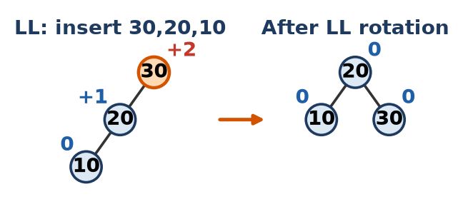
Figure: LL rotation
2. RR (Right-Right): new node in the right subtree of the right child (BF −2). Fix: single left rotation. Example: insert 10, 20, 30.
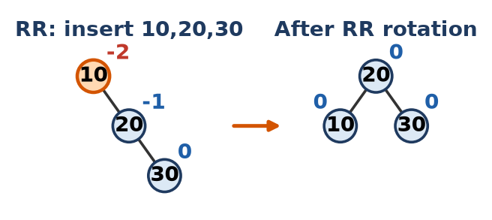
Figure: RR rotation
3. LR (Left-Right): new node in the right subtree of the left child. Fix: left rotate the child, then right rotate the node. Example: 30, 10, 20.
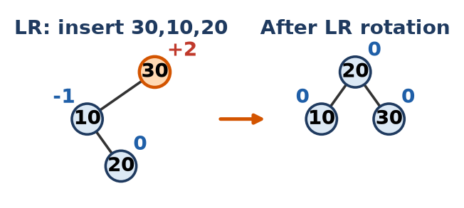
Figure: LR rotation
4. RL (Right-Left): new node in the left subtree of the right child. Fix: right rotate the child, then left rotate the node. Example: 10, 30, 20.
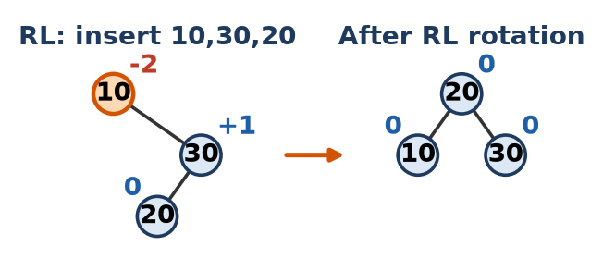
Figure: RL rotation
Node* rotateRight(Node* y) { // fixes LL
Node* x = y->left;
y->left = x->right;
x->right = y;
return x; // x is the new subtree root
}
Node* rotateLeft(Node* x) { // fixes RR
Node* y = x->right;
x->right = y->left;
y->left = x;
return y;
}
// LR: n->left = rotateLeft(n->left); return rotateRight(n);
// RL: n->right = rotateRight(n->right); return rotateLeft(n);
In all four examples the result is the balanced tree 20 (10, 30).
Remember: Single letter repeated (LL, RR) = single rotation; mixed letters (LR, RL) = double rotation.

Q16. In the AVL tree built from 40,20,60,10,30,50,70,5, delete 70 and rebalance if required. Show the balance factors.
Apply • Moderate • CO1, CO3
1. Build: inserting 40, 20, 60, 10, 30, 50, 70, 5 causes no rotation (every BF stays within ±1). Tree: 40 (20 (10 (5), 30), 60 (50, 70)).
2. Delete 70: it is a leaf, so simply remove it.
3. Recompute BF from 60 up to the root (heights counted in edges, empty = −1):
Node | BF before | BF after deleting 70
5 | 0 | 0
10 | +1 | +1
30 | 0 | 0
20 | +1 | +1
50 | 0 | 0
60 | 0 | +1 (left 50, right empty)
40 | +1 | +1 (h left = 2, h right = 1)

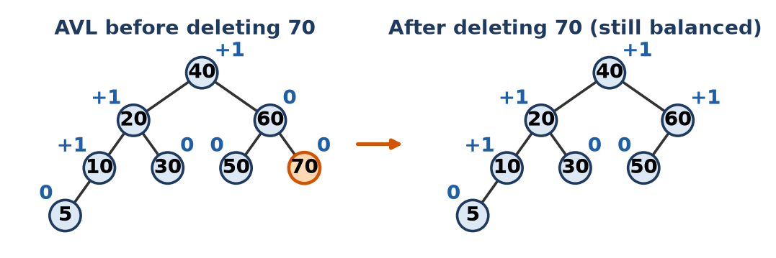
Figure: AVL before and after deleting 70
4. Every BF is still −1, 0 or +1, so no rotation is required. If the root had become +2, we would check the left child's BF (≥ 0 → LL right rotation, < 0 → LR).
Remember: After a delete, walk up to the root and check every BF; rotate only at ±2.

Q17. Construct a Red-Black tree by inserting 10,18,7,15,16,30,25,40. Show recoloring and rotations.
Apply • Moderate • CO1, CO3
Rules for insertion: insert as in a BST and colour the new node red. If its parent is also red: (a) uncle red → recolour parent and uncle black, grandparent red, and repeat at the grandparent; (b) uncle black → rotate (LL/RR single, LR/RL double) and recolour. Root is always made black.
Insert | Problem | Action
10 | root is red | colour 10 black
18 | parent 10 black | none (18 red)
7 | parent 10 black | none (7 red)
15 | parent 18 red, uncle 7 red | recolour 18, 7 black, 10 red → root back to black
16 | parent 15 red, uncle NIL (black), LR shape | left rotate at 15, right rotate at 18; 16 black, 18 red
30 | parent 18 red, uncle 15 red | recolour 15, 18 black, 16 red
25 | parent 30 red, uncle NIL, RL shape | right rotate at 30, left rotate at 18; 25 black, 18 red
40 | parent 30 red, uncle 18 red | recolour 18, 30 black, 25 red; now 25 and 16 both red, uncle 7 black, RR shape → left rotate at 10; 16 black, 10 red

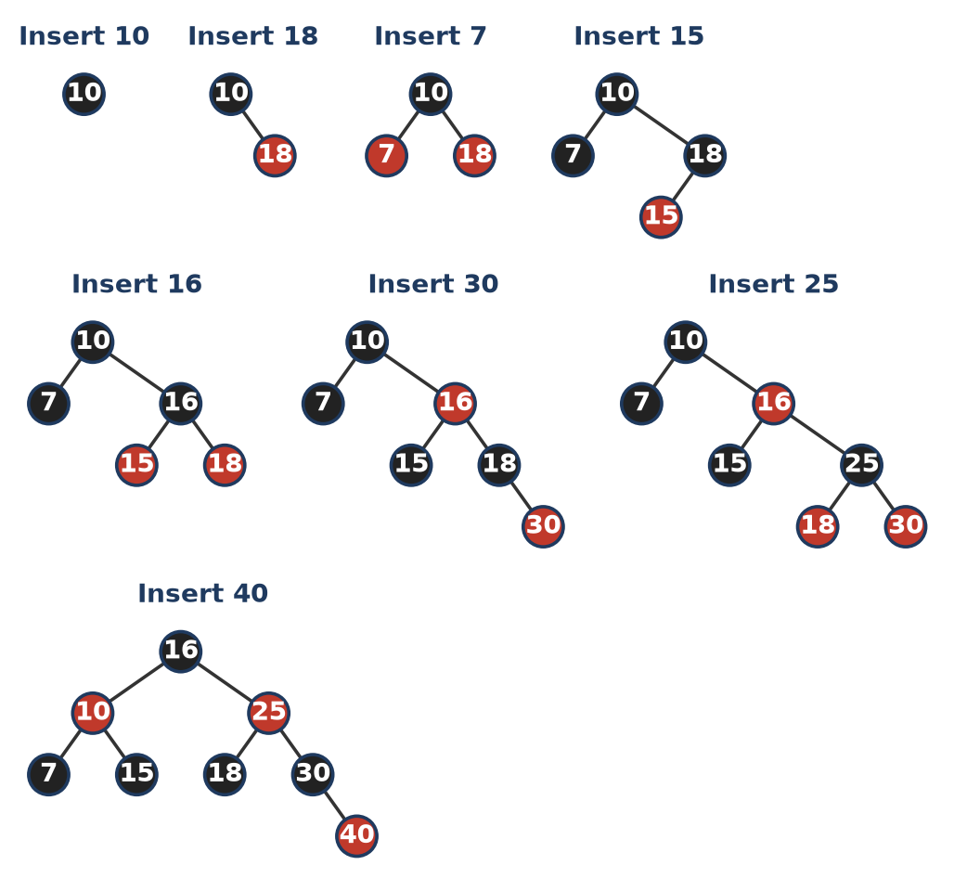
Figure: Red-Black tree after each insertion (dark = black, red = red)
Final tree: root 16 (B); left 10 (R) with children 7 (B), 15 (B); right 25 (R) with children 18 (B), 30 (B); 40 (R) is the right child of 30. Black height = 2 on every path.
Remember: Red uncle → recolour; black uncle → rotate.

Q18. A hash table has size 10 and h(k)=k mod 10. Insert 25,35,45,55,65,14 using linear probing. Show the table and probes.
Apply • Moderate • CO1, CO3
Linear probing: h(k, i) = (h(k) + i) mod 10, i = 0, 1, 2 … (try the next slot until an empty one is found).
Key | h(k) | Slots tried | Placed at | Probes
25 | 5 | 5 | 5 | 1
35 | 5 | 5, 6 | 6 | 2
45 | 5 | 5, 6, 7 | 7 | 3
55 | 5 | 5, 6, 7, 8 | 8 | 4
65 | 5 | 5, 6, 7, 8, 9 | 9 | 5
14 | 4 | 4 | 4 | 1

Index | 0 | 1 | 2 | 3 | 4 | 5 | 6 | 7 | 8 | 9
Key | – | – | – | – | 14 | 25 | 35 | 45 | 55 | 65

Total probes = 1 + 2 + 3 + 4 + 5 + 1 = 16; 4 keys collided. All keys ending in 5 form a primary cluster at slots 5–9.
Remember: Linear probing = "next seat please"; same last digit → long cluster.

Q19. For a hash table of size 11 and h(k)=k mod 11, insert 22,33,44,55,11 using quadratic probing. Show the table.
Apply • Moderate • CO1, CO3
Quadratic probing: h(k, i) = (h(k) + i²) mod 11, i = 0, 1, 2 … (jumps of +0, +1, +4, +9, +16 …). All five keys give h(k) = 0.
Key | h(k) | i = 0 | i = 1 | i = 2 | i = 3 | i = 4 | Placed at
22 | 0 | 0 free |  |  |  |  | 0
33 | 0 | 0 full | 1 free |  |  |  | 1
44 | 0 | 0 full | 1 full | 4 free |  |  | 4
55 | 0 | 0 full | 1 full | 4 full | 9 free |  | 9
11 | 0 | 0 full | 1 full | 4 full | 9 full | 16 mod 11 = 5 free | 5

Index | 0 | 1 | 2 | 3 | 4 | 5 | 6 | 7 | 8 | 9 | 10
Key | 22 | 33 | – | – | 44 | 11 | – | – | – | 55 | –

Quadratic probing spreads the keys out and avoids the primary clustering of linear probing.
Remember: Jumps grow as squares: 0, 1, 4, 9, 16.

Q20. Insert 50,700,76,85,92,73,101 into a table of size 7 using h(k)=k mod 7 with separate chaining. Draw the table.
Apply • Moderate • CO1, CO3
Separate chaining: each slot holds a linked list; a colliding key is simply added to the list of that slot.
Key | Calculation | h(k)
50 | 50 = 7 × 7 + 1 | 1
700 | 700 = 7 × 100 + 0 | 0
76 | 76 = 7 × 10 + 6 | 6
85 | 85 = 7 × 12 + 1 | 1
92 | 92 = 7 × 13 + 1 | 1
73 | 73 = 7 × 10 + 3 | 3
101 | 101 = 7 × 14 + 3 | 3

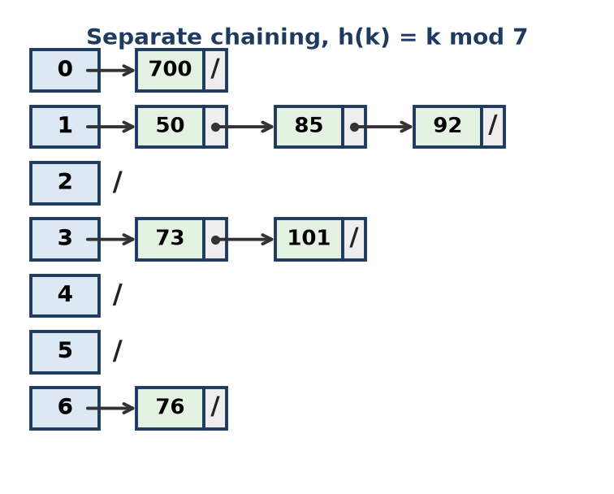
Figure: Separate chaining table
- Slot 1 has the chain 50 → 85 → 92, slot 3 has 73 → 101.
- Load factor = 7 ÷ 7 = 1; the table never "fills up" with chaining.
Remember: Chaining = every slot is a bucket (linked list).

Q21. Compute the hash address of key 123456 for table size 100 using division, mid-square and folding methods.
Apply • Moderate • CO1, CO3
Table size 100 → the address must have 2 digits (00–99).
1. Division method: h(k) = k mod m
- 123456 mod 100 = 56
2. Mid-square method: square the key and take the middle 2 digits.
- 123456² = 15241383936 (11 digits)
- Middle digits (drop 5 on the left, 4 on the right): 15241 38 3936 → 38
3. Folding method (shift folding): split into 2-digit parts and add, dropping the carry.
- 12 + 34 + 56 = 102 → keep last 2 digits → 02
- (Boundary folding reverses alternate parts: 21 + 34 + 65 = 120 → 20.)
Method | Address
Division | 56
Mid-square | 38
Folding (shift) | 02

Remember: Divide-take remainder, Square-take middle, Fold-add the pieces.

Q22. Construct the expression tree for the postfix expression ab+cde+** and give its inorder, preorder and postorder traversals.
Apply • Moderate • CO1, CO3
Method: scan left to right; push an operand as a one-node tree; for an operator, pop two trees (first pop = right child), make the operator their parent and push it.
Symbol | Action | Stack (trees)
a, b | push | a, b
+ | pop b, a → (a+b) | (a+b)
c, d, e | push | (a+b), c, d, e
+ | pop e, d → (d+e) | (a+b), c, (d+e)
* | pop (d+e), c → c*(d+e) | (a+b), c*(d+e)
* | pop both → root * | (a+b)(c(d+e))

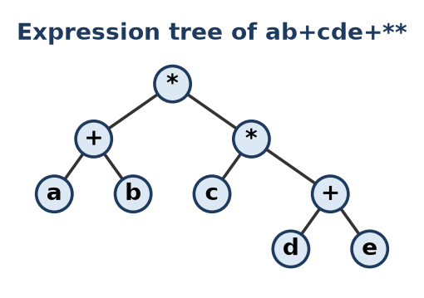
Figure: Expression tree
Traversal | Output
Inorder | a + b * c * d + e, i.e. (a + b) * (c * (d + e))
Preorder (prefix) | * + a b * c + d e
Postorder (postfix) | a b + c d e + * *

Remember: Operands are leaves, operators are internal nodes; postorder gives back the postfix.

Q23. Insert 10,20,30,40,50,60 into a BST and an AVL tree. Analyze the heights and the search cost in each.
Analyze • HOTS • CO1, CO3
BST: each key is larger than all previous keys, so every key goes to the right → a right-skewed tree (a linked list).
AVL: rotations keep it balanced:
- Insert 30 → BF(10) = −2, RR → root 20.
- Insert 50 → BF(30) = −2, RR at 30 → 40 becomes right child of 20.
- Insert 60 → BF(20) = −2, RR at 20 → root 40.
Final AVL: 40 (20 (10, 30), 50 (–, 60)).
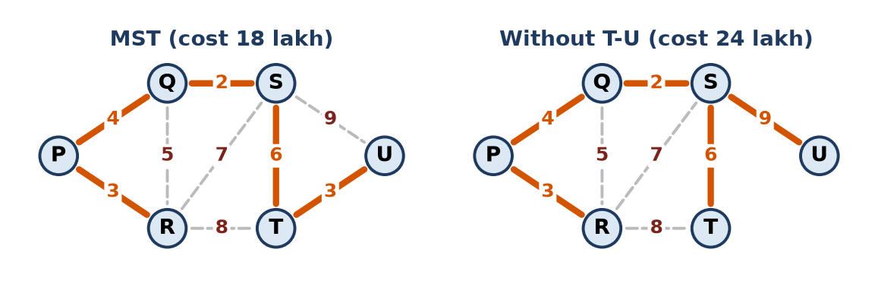
Figure: Skewed BST vs AVL for sorted input
Measure | BST | AVL tree
Height (edges) | 5 (n − 1) | 2 (about log2 n)
Levels | 6 | 3
Worst-case search | 6 comparisons | 3 comparisons
Average successful search | (1+2+3+4+5+6) ÷ 6 = 3.5 | (1 + 2×2 + 3×3) ÷ 6 = 14 ÷ 6 ≈ 2.33
Order of search | O(n) | O(log n)

Conclusion: for sorted input a plain BST degrades to O(n); the AVL tree pays a few rotations at insertion time but guarantees O(log n) search.
Remember: Sorted input kills a BST; AVL rotations save it.

Q24. Delete the keys 12, 30, 28, 36 and 25, one after another, from the BST shown in the figure (for a node with two children use the inorder successor). Draw the tree after each deletion.
Apply • Moderate • CO1, CO3
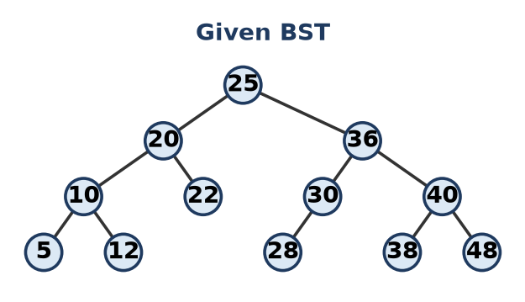
Figure: Given BST
1. Delete 12: leaf → remove; 10 keeps only left child 5.
2. Delete 30: one child (28) → 28 replaces 30 as left child of 36.
3. Delete 28: leaf → remove; 36 now has only right child 40.
4. Delete 36: one child (40) → 40 becomes right child of 25.
5. Delete 25 (root): two children → inorder successor = leftmost node of right subtree = 38. Copy 38 to the root, then delete the old 38 (leaf).
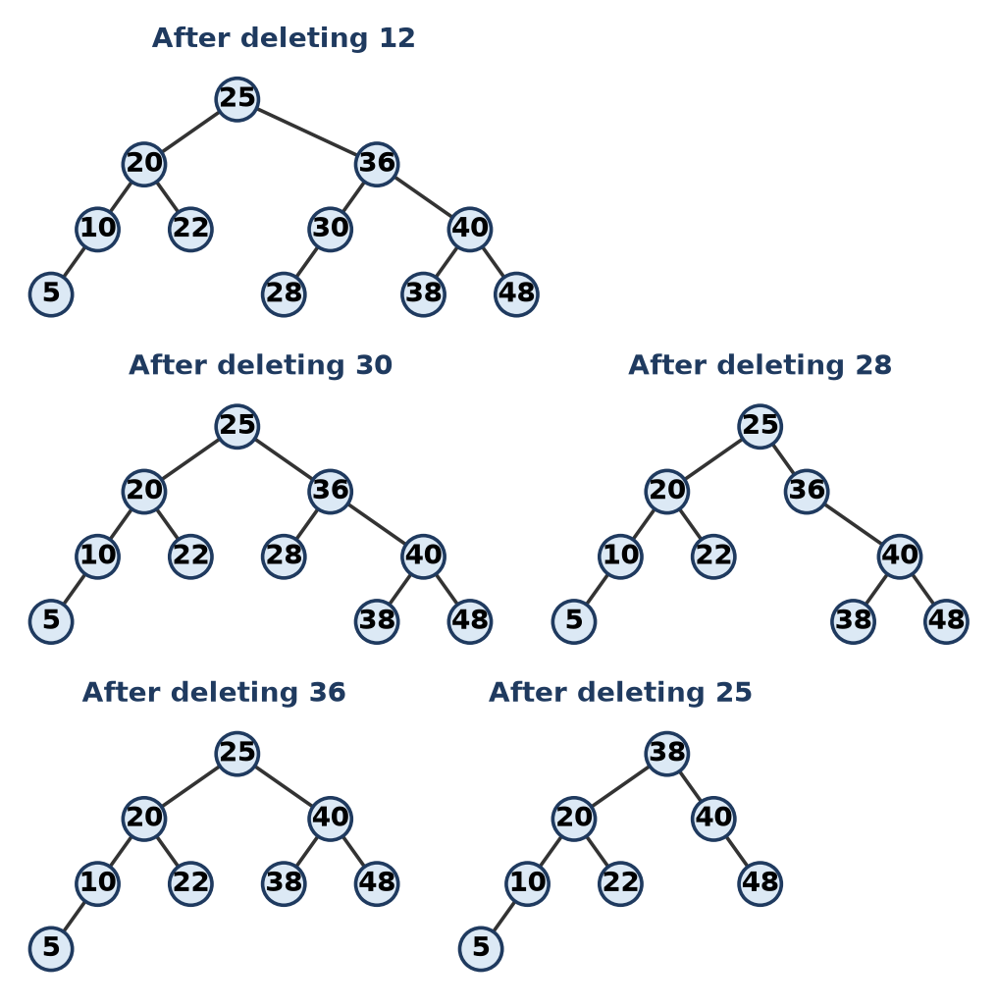
Figure: Tree after each deletion
Final tree: root 38; left 20 (10 (5), 22); right 40 (–, 48). Inorder 5 10 20 22 38 40 48 is still sorted.
Remember: Successor = one step right, then all the way left.

Q25. Which traversal displays the nodes of the BST shown in the figure in sorted order? Write the non-recursive algorithm for this traversal and trace the stack contents for the given tree.
Apply • Moderate • CO1, CO3
Inorder (Left, Root, Right) prints a BST in ascending order, because every left subtree holds smaller keys and every right subtree larger keys. (Tree as in the Q24 figure.)
Algorithm (stack):
1. cur = root; repeat while cur ≠ NULL or stack not empty:
2. While cur ≠ NULL: push cur, cur = cur → left.
3. cur = pop; print cur → data.
4. cur = cur → right.
(Code as in Q11.)
Step | Action | Stack (top at right) | Printed
1 | push 25, 20, 10, 5 | 25 20 10 5 | –
2 | pop 5 | 25 20 10 | 5
3 | pop 10; push 12 | 25 20 12 | 10
4 | pop 12 | 25 20 | 12
5 | pop 20; push 22 | 25 22 | 20
6 | pop 22 | 25 | 22
7 | pop 25; push 36, 30, 28 | 36 30 28 | 25
8 | pop 28 | 36 30 | 28
9 | pop 30 | 36 | 30
10 | pop 36; push 40, 38 | 40 38 | 36
11 | pop 38 | 40 | 38
12 | pop 40; push 48 | 48 | 40
13 | pop 48; stack empty → stop | empty | 48

Output: 5 10 12 20 22 25 28 30 36 38 40 48 (sorted).
Remember: Inorder of a BST = sorted list.

Q26. Write the preorder, inorder and postorder traversals of the binary tree shown in the figure. Also write the recursive pseudocode for the postorder traversal.
Apply • Moderate • CO1, CO3
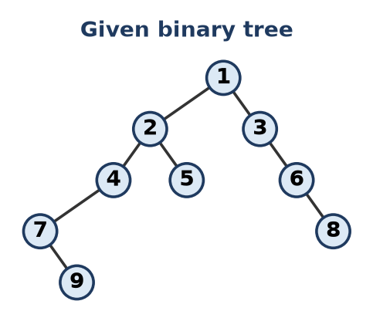
Figure: Given binary tree (9 is the right child of 7; 8 is the right child of 6)
Traversal | Order rule | Output
Preorder | Root, Left, Right | 1 2 4 7 9 5 3 6 8
Inorder | Left, Root, Right | 7 9 4 2 5 1 3 6 8
Postorder | Left, Right, Root | 9 7 4 5 2 8 6 3 1

Recursive postorder:
void postorder(Node* r) {
if (r == nullptr) return; // empty subtree
postorder(r->left); // 1. left subtree
postorder(r->right); // 2. right subtree
cout << r->data << " "; // 3. root last
}
- Check: preorder starts with the root (1), postorder ends with the root (1).
Remember: Postorder = "children before parent" (used to delete a tree).

Q27. Recursive and non-recursive traversals. A file-explorer tool keeps folder IDs in the BST: 40, 20, 60, 10, 30, 50, 70, 5, 15. (a) Write the inorder, preorder and postorder traversals. (b) Write recursive pseudocode for inorder traversal. (c) Write a non-recursive inorder using an explicit stack, and trace the stack contents at every step. (d) Which traversal displays the IDs in sorted order, and why?
Apply • Moderate
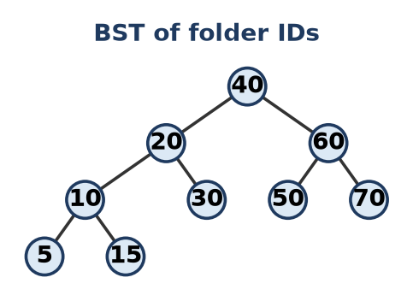
Figure: BST of folder IDs
(a)
Traversal | Output
Inorder | 5 10 15 20 30 40 50 60 70
Preorder | 40 20 10 5 15 30 60 50 70
Postorder | 5 15 10 30 20 50 70 60 40

(b) and (c)
void inorder(Node* r) { // (b) recursive
if (r == nullptr) return;
inorder(r->left);
cout << r->data << " ";
inorder(r->right);
}
void inorderStack(Node* root) { // (c) explicit stack
stack<Node*> s; Node* cur = root;
while (cur || !s.empty()) {
while (cur) { s.push(cur); cur = cur->left; }
cur = s.top(); s.pop();
cout << cur->data << " ";
cur = cur->right;
}
}
Step | Action | Stack (top at right) | Printed
1 | push 40, 20, 10, 5 | 40 20 10 5 | –
2 | pop 5 | 40 20 10 | 5
3 | pop 10; push 15 | 40 20 15 | 10
4 | pop 15 | 40 20 | 15
5 | pop 20; push 30 | 40 30 | 20
6 | pop 30 | 40 | 30
7 | pop 40; push 60, 50 | 60 50 | 40
8 | pop 50 | 60 | 50
9 | pop 60; push 70 | 70 | 60
10 | pop 70; empty → stop | empty | 70

(d) Inorder gives the IDs in sorted order, because it visits the left subtree (smaller IDs), then the node, then the right subtree (larger IDs).
Remember: Folder IDs in order? Use inorder.

Q28. Which of the binary trees (A)-(D) shown has inorder traversal B C A D and preorder traversal A B C D? Justify by constructing the tree from the two traversals and also write its postorder traversal.
Apply • Moderate • CO1, CO3
Construction:
1. Preorder first = A → root. Inorder: (B C) A (D).
2. Left part {B, C}: preorder order B, C → B is the root of the left subtree. In inorder, C comes after B → C is the right child of B.
3. Right part {D} → D is the right child of A.
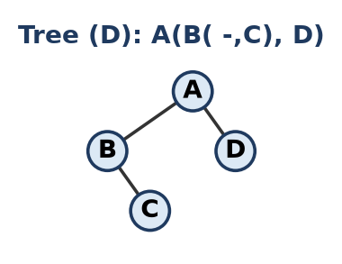
Figure: Constructed tree = option (D)
Answer: tree (D) – A with left child B (B has right child C) and right child D.
- (A) gives inorder B A D C; (B) gives B C A D but preorder A C B D; (C) gives A C B D. Only (D) matches both.
Postorder = C B D A
Remember: Preorder finds the root, inorder decides left or right.

Q29. The postorder traversal of a binary tree is 8, 9, 6, 7, 4, 5, 2, 3, 1 and its inorder traversal is 8, 6, 9, 4, 7, 2, 5, 1, 3. Construct the tree and find its height. Explain why the inorder traversal is required to reconstruct a tree uniquely.
Analyze • HOTS • CO1, CO3
Rule: the last node of postorder is the root; its position in inorder splits left and right subtrees.
Step | Postorder part | Root | Inorder left | Inorder right
1 | 8 9 6 7 4 5 2 3 1 | 1 | 8 6 9 4 7 2 5 | 3
2 | 8 9 6 7 4 5 2 | 2 | 8 6 9 4 7 | 5
3 | 8 9 6 7 4 | 4 | 8 6 9 | 7
4 | 8 9 6 | 6 | 8 | 9

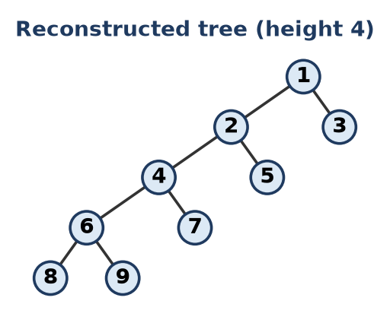
Figure: Reconstructed tree
Tree: 1 (2 (4 (6 (8, 9), 7), 5), 3). Height = 4 (edges on the longest path 1 → 2 → 4 → 6 → 8; 5 levels). Check: preorder = 1 2 4 6 8 9 7 5 3.
Why inorder is needed:
- Preorder or postorder only tells which node is the root; it does not tell where the left subtree ends and the right begins.
- Inorder places the root between its left and right subtrees, so it fixes the split.
- Example: preorder A B fits both "B is left child of A" and "B is right child of A"; inorder B A or A B decides it. Hence (pre + in) or (post + in) give a unique tree, but (pre + post) may not.
Remember: Pre/Post find the root; In finds the sides.

Q30. Construct a hash table of size 10 using linear probing for the keys {31, 3, 4, 21, 61, 6, 71, 8, 9, 25} with h(k) = k mod 10 (one record per slot). Count the collisions and the total number of probes, evaluate the suitability of this hash function for the given keys, and propose an improvement with justification.
Evaluating • HOTS • CO1, CO3
Key | h(k) | Slots tried | Placed | Probes
31 | 1 | 1 | 1 | 1
3 | 3 | 3 | 3 | 1
4 | 4 | 4 | 4 | 1
21 | 1 | 1, 2 | 2 | 2
61 | 1 | 1, 2, 3, 4, 5 | 5 | 5
6 | 6 | 6 | 6 | 1
71 | 1 | 1 to 7 | 7 | 7
8 | 8 | 8 | 8 | 1
9 | 9 | 9 | 9 | 1
25 | 5 | 5, 6, 7, 8, 9, 0 | 0 | 6

Index | 0 | 1 | 2 | 3 | 4 | 5 | 6 | 7 | 8 | 9
Key | 25 | 31 | 21 | 3 | 4 | 61 | 6 | 71 | 8 | 9

- Total probes = 26 (average 2.6 per key).
- Collisions: 4 keys (21, 61, 71, 25) did not get their home slot; they hit 16 occupied slots in all (26 − 10).
Evaluation:
1. k mod 10 uses only the last digit; four keys end in 1, so they all map to slot 1.
2. Linear probing then builds a primary cluster (slots 1–9), which even hurts 25.
3. Load factor = 10 ÷ 10 = 1.0 – the table is completely full, so any new insert fails.
Improvement:
- Use a prime table size about 2n, e.g. m = 19: homes are 12, 3, 4, 2, 4, 6, 14, 8, 9, 6 → only 61 and 25 collide, 12 probes in total (load factor 0.53).
- Or use double hashing / separate chaining to break clusters.
Conclusion: k mod 10 is unsuitable for these keys; a prime modulus with a lower load factor is much better.
Remember: Mod 10 looks only at the last digit; pick a prime size and keep the table half empty.

Quick Revision – Unit 3
Term | Key fact
Full binary tree | Every node has 0 or 2 children
Complete binary tree | All levels full, last filled left to right
Perfect binary tree | 2^(h+1) − 1 nodes, all leaves on one level
BST property | Left < root < right; inorder gives sorted order
Traversals | Pre = Root L R, In = L Root R, Post = L R Root
Tree from traversals | Need inorder + (pre or post) for a unique tree
BST delete (2 children) | Replace with inorder successor (min of right subtree)
Balance factor | h(left) − h(right), must be −1, 0, +1 in AVL
AVL rotations | LL → right, RR → left, LR → left then right, RL → right then left
Red-Black tree | Root black, no red-red, equal black height, height ≤ 2 log2(n+1)
LC-RS conversion | Left = first child, right = next sibling
Static vs dynamic symbol table | Search only vs search + insert + delete
Hash methods | Division (k mod m), mid-square, folding
Collision handling | Linear, quadratic probing, double hashing, chaining
Primary clustering | Long runs of filled slots in linear probing

Unit 4: Graphs

Q1. Explain depth first search with a suitable example.
Understand • Low • CO1, CO4
DFS visits a vertex, then goes as deep as possible along one unvisited neighbour before backtracking. It uses a stack (or recursion) and a visited[] array.
Steps: visit start vertex → push/recurse to an unvisited neighbour → when a vertex has no unvisited neighbour, backtrack (pop).
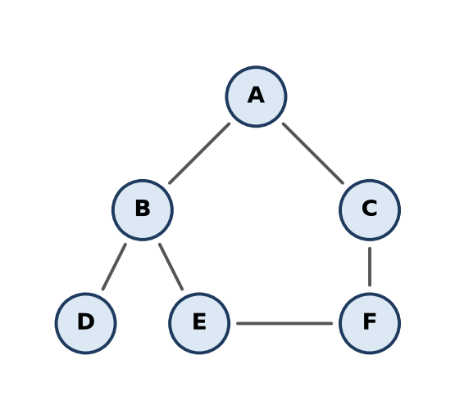
Figure: Example graph
Example (neighbours in alphabetical order), start A: A → B → D (dead end, back to B) → E → F → C. DFS order: A B D E F C. Time O(V + E) with an adjacency list.
Remember: DFS = "go deep, then back up" (stack).

Q2. Explain breadth first search with a suitable example.
Understand • Low • CO1, CO4
BFS visits the start vertex, then all its neighbours, then their neighbours – level by level. It uses a queue and a visited[] array.
Steps: enqueue start and mark it → dequeue a vertex, visit it → enqueue all its unvisited neighbours → repeat until the queue is empty.
Example (same graph as Q1), start A:
Dequeued | Enqueued | Queue
A | B, C | B C
B | D, E | C D E
C | F | D E F
D, E, F | – | empty

BFS order: A B C D E F. Time O(V + E); BFS finds the fewest-edge path.
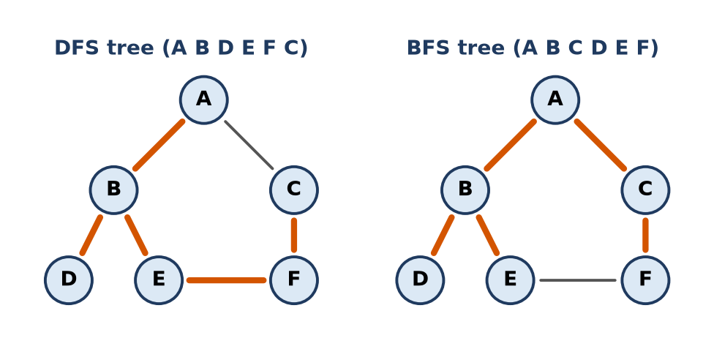
Figure: DFS tree and BFS tree of the example
Remember: BFS = "ripples in water" (queue, level by level).

Q3. Define a spanning tree and a minimum cost spanning tree with an example.
Understand • Low • CO1, CO4
- Spanning tree: a subgraph of a connected graph that contains all V vertices and exactly V − 1 edges with no cycle.
- Minimum cost spanning tree (MST): among all spanning trees of a weighted graph, the one with the smallest total edge weight. Found by Prim's or Kruskal's algorithm.
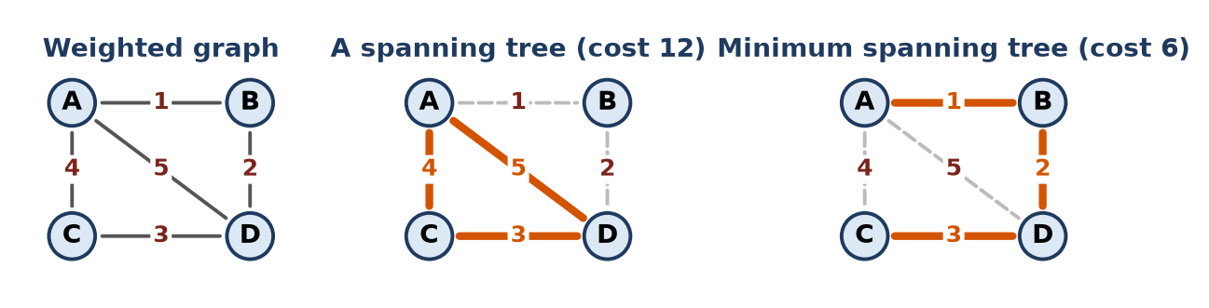
Figure: Graph, a spanning tree and the MST
Example: graph with 4 vertices and edges AB 1, AC 4, BD 2, CD 3, AD 5.
- Spanning tree {AC, CD, AD} has cost 4 + 3 + 5 = 12.
- MST {AB, BD, CD} has cost 1 + 2 + 3 = 6.
Remember: Spanning tree = all vertices, V − 1 edges, no cycle; MST = the cheapest one.

Q4. Differentiate between a tree and a graph.
Understand • Low • CO1, CO4
Point | Tree | Graph
Cycles | No cycles | Cycles allowed
Edges | Exactly n − 1 for n nodes | Any number (0 to n(n−1)/2 undirected)
Root | Has one root; parent–child relation | No root, no hierarchy
Path | Exactly one path between two nodes | Zero, one or many paths
Connectivity | Always connected | May be disconnected
Traversal | Pre/in/post/level order | DFS, BFS (needs visited[])

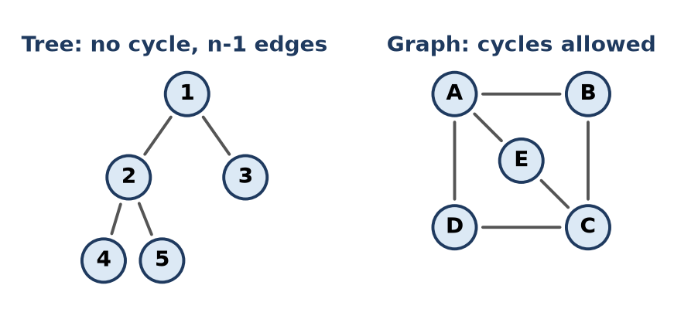
Figure: Tree vs graph
Every tree is a graph, but not every graph is a tree.
Remember: Tree = connected graph with no cycle.

Q5. Represent the undirected graph with V={A,B,C,D,E,F} and E={AB,AC,BD,CD,CE,DF,EF} using an adjacency matrix & an adjacency list.
Apply • Moderate • CO1, CO4
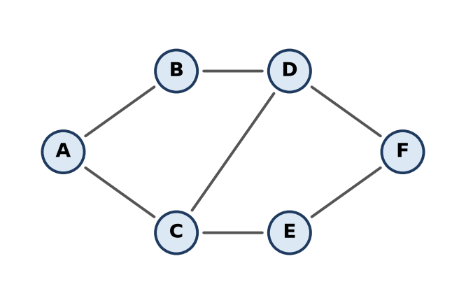
Figure: Given graph
Adjacency matrix: adj[i][j] = 1 if an edge joins i and j, else 0. For an undirected graph it is symmetric.
 | A | B | C | D | E | F
A | 0 | 1 | 1 | 0 | 0 | 0
B | 1 | 0 | 0 | 1 | 0 | 0
C | 1 | 0 | 0 | 1 | 1 | 0
D | 0 | 1 | 1 | 0 | 0 | 1
E | 0 | 0 | 1 | 0 | 0 | 1
F | 0 | 0 | 0 | 1 | 1 | 0

Adjacency list: each vertex has a linked list of its neighbours.
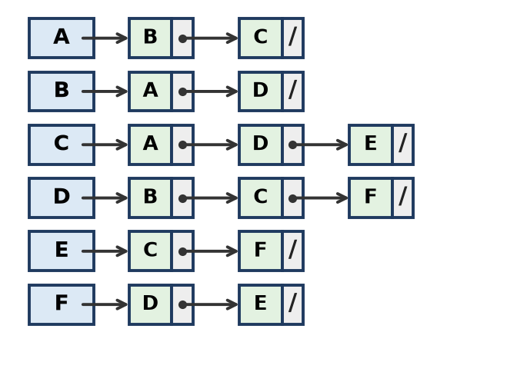
Figure: Adjacency list
- Matrix: O(V²) space = 36 cells; sum of 1s = 2 × 7 = 14.
- List: O(V + E) space = 14 list nodes; better for sparse graphs.
Remember: Matrix = V × V grid of 0/1; list = neighbours chained to each vertex.

Q6. Draw the adjacency matrix and adjacency list for the directed graph with edges A->B(4), A->C(2), B->D(5), C->B(1), C->D(8), D->E(3).
Apply • Moderate • CO1, CO4
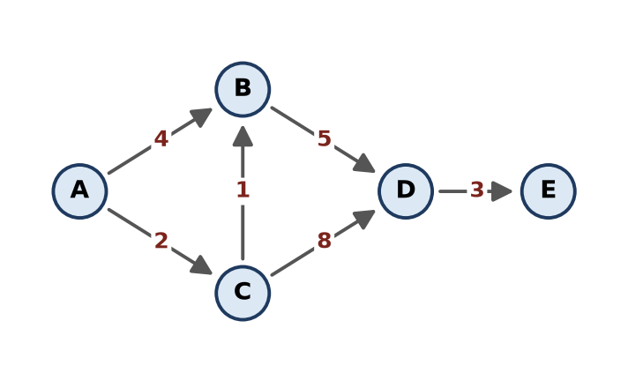
Figure: Directed weighted graph
Cost matrix: cost[i][j] = weight of edge i → j, 0 (or ∞) if no edge. Not symmetric because edges have direction.
From \ To | A | B | C | D | E
A | 0 | 4 | 2 | 0 | 0
B | 0 | 0 | 0 | 5 | 0
C | 0 | 1 | 0 | 8 | 0
D | 0 | 0 | 0 | 0 | 3
E | 0 | 0 | 0 | 0 | 0

Adjacency list: each node stores (destination, weight, next).
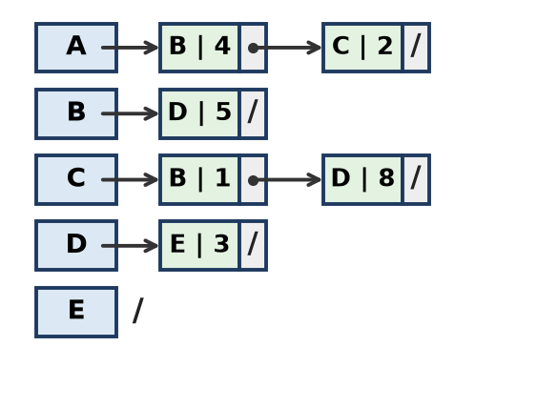
Figure: Adjacency list (vertex and weight)
- Out-degree = number of nodes in a vertex's list (A: 2, E: 0).
- In-degree = number of non-zero entries in a column (B: 2, D: 2).
Remember: Directed: row = from, column = to; only one entry per edge.

Q7. Write pseudocode to create a graph using an adjacency matrix, adjacency list and display it.
Apply • Moderate • CO1, CO4
#include <iostream>
#include <vector>
using namespace std;
int main() {
int n, e; // vertices 0..n-1, number of edges
cin >> n >> e;
vector<vector<int>> mat(n, vector<int>(n, 0)); // adjacency matrix
vector<vector<int>> lst(n); // adjacency list
for (int i = 0; i < e; i++) { // read each undirected edge u v
int u, v;
cin >> u >> v;
mat[u][v] = mat[v][u] = 1; // matrix: mark both cells
lst[u].push_back(v); // list: add to both lists
lst[v].push_back(u);
}
cout << "Adjacency matrix:\n"; // display matrix
for (int i = 0; i < n; i++) {
for (int j = 0; j < n; j++) cout << mat[i][j] << " ";
cout << "\n";
}
cout << "Adjacency list:\n"; // display list
for (int i = 0; i < n; i++) {
cout << i << " -> ";
for (int v : lst[i]) cout << v << " ";
cout << "\n";
}
}
Sample: n = 3, edges (0,1), (1,2) → matrix rows 0 1 0 / 1 0 1 / 0 1 0; list 0 -> 1, 1 -> 0 2, 2 -> 1.
- Matrix: O(V²) space, edge check O(1). List: O(V + E) space, good for sparse graphs.
Remember: For a directed graph, set only mat[u][v] and add v to u's list.

Q8. Write a recursive DFS algorithm. Apply it to the graph V={1..6}, E={12,13,24,25,36,56} starting at 1.
Apply • Moderate • CO1, CO4
vector<int> adj[7]; // adjacency list, neighbours sorted
bool visited[7];
void dfs(int u) {
visited[u] = true;
cout << u << " "; // visit
for (int v : adj[u]) // each neighbour
if (!visited[v]) dfs(v); // go deeper
}
Adjacency: 1: 2, 3; 2: 1, 4, 5; 3: 1, 6; 4: 2; 5: 2, 6; 6: 3, 5.
Call | Unvisited neighbour taken | Note
dfs(1) | 2
dfs(2) | 4
dfs(4) | – | dead end, return to 2
dfs(2) | 5
dfs(5) | 6
dfs(6) | 3
dfs(3) | – | return all the way back

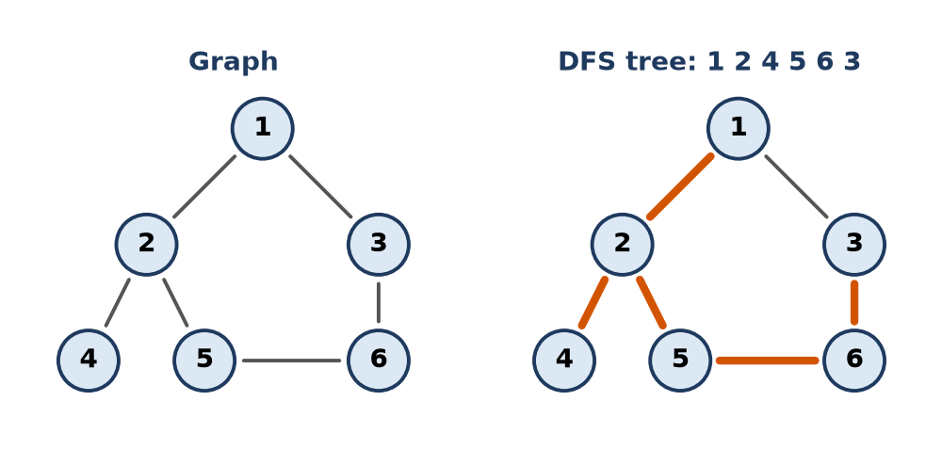
Figure: Graph and DFS tree
DFS order: 1 2 4 5 6 3. Time O(V + E).
Remember: Recursion stack = DFS stack.

Q9. Write a non-recursive DFS using a stack and trace it on the graph of the previous question.
Apply • Moderate • CO1, CO4
void dfsStack(int s) {
stack<int> st;
st.push(s);
while (!st.empty()) {
int u = st.top(); st.pop();
if (visited[u]) continue; // already done, skip
visited[u] = true;
cout << u << " ";
for (int i = adj[u].size() - 1; i >= 0; i--) // push in reverse
if (!visited[adj[u][i]]) st.push(adj[u][i]); // so smallest is on top
}
}
Step | Action | Stack (top at right) | Visited order
1 | push 1 | 1 | –
2 | pop 1, visit; push 3, 2 | 3 2 | 1
3 | pop 2, visit; push 5, 4 | 3 5 4 | 1 2
4 | pop 4, visit; nothing new | 3 5 | 1 2 4
5 | pop 5, visit; push 6 | 3 6 | 1 2 4 5
6 | pop 6, visit; push 3 | 3 3 | 1 2 4 5 6
7 | pop 3, visit | 3 | 1 2 4 5 6 3
8 | pop 3 (visited, skip) | empty | done

DFS order: 1 2 4 5 6 3 – same as the recursive version.
Remember: Pop, mark, push neighbours in reverse.

Q10. Write the BFS algorithm using a queue. State its time complexity.
Apply • Moderate • CO1, CO4
Algorithm:
1. Mark all vertices unvisited. Enqueue start s and mark it visited.
2. While queue not empty: u = dequeue; print u.
3. For each neighbour v of u: if v not visited, mark v and enqueue v.
void bfs(int s, vector<int> adj[], int n) {
vector<bool> visited(n, false);
queue<int> q;
visited[s] = true;
q.push(s);
while (!q.empty()) {
int u = q.front(); q.pop();
cout << u << " "; // visit
for (int v : adj[u])
if (!visited[v]) { // mark when enqueued
visited[v] = true;
q.push(v);
}
}
}
Time complexity:
- Adjacency list: each vertex enqueued once, each edge checked twice → O(V + E).
- Adjacency matrix: scanning a full row for each vertex → O(V²).
- Space: O(V) for queue and visited[].
Remember: BFS cost = every vertex once + every edge once.

Q11. Apply BFS to the graph with edges AB,AC,BD,BE,CF,EF,FG starting from A. Show the queue and visited order.
Apply • Moderate • CO1, CO4
Adjacency (alphabetical): A: B, C; B: A, D, E; C: A, F; D: B; E: B, F; F: C, E, G; G: F.
Step | Dequeue | Enqueue (new) | Queue after | Visited order
0 | – | A | A | –
1 | A | B, C | B C | A
2 | B | D, E | C D E | A B
3 | C | F | D E F | A B C
4 | D | – | E F | A B C D
5 | E | – (F already visited) | F | A B C D E
6 | F | G | G | A B C D E F
7 | G | – | empty | A B C D E F G

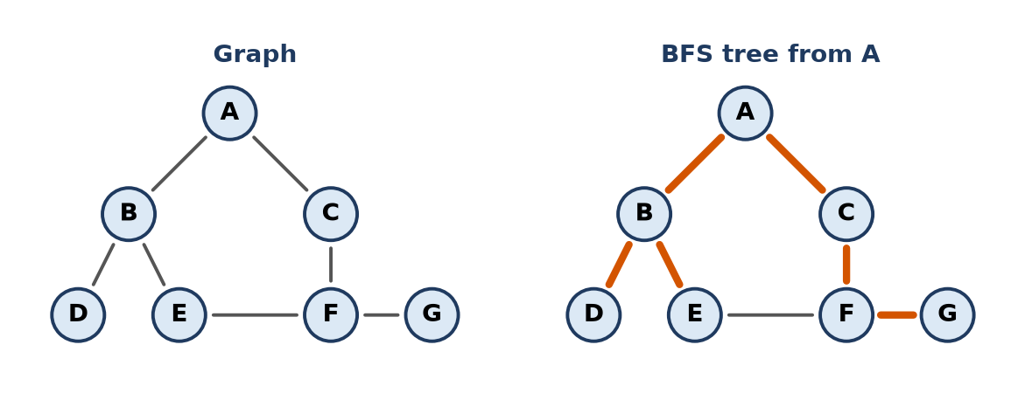
Figure: Graph and BFS tree
BFS order: A B C D E F G. Levels: {A}, {B, C}, {D, E, F}, {G}.
Remember: Mark a vertex when it enters the queue, so it never enters twice.

Q12. For the graph with 8 vertices and edges 12,13,24,25,36,37,48,58,67, give the DFS and BFS orders from vertex 1 and draw the spanning trees.
Apply • Moderate • CO1, CO4
Adjacency: 1: 2, 3; 2: 1, 4, 5; 3: 1, 6, 7; 4: 2, 8; 5: 2, 8; 6: 3, 7; 7: 3, 6; 8: 4, 5.
DFS (smallest neighbour first): 1 → 2 → 4 → 8 → 5 (back to 1) → 3 → 6 → 7. DFS order: 1 2 4 8 5 3 6 7
BFS (queue):
Dequeue | Enqueue | Queue
1 | 2, 3 | 2 3
2 | 4, 5 | 3 4 5
3 | 6, 7 | 4 5 6 7
4 | 8 | 5 6 7 8
5, 6, 7, 8 | – | empty

BFS order: 1 2 3 4 5 6 7 8
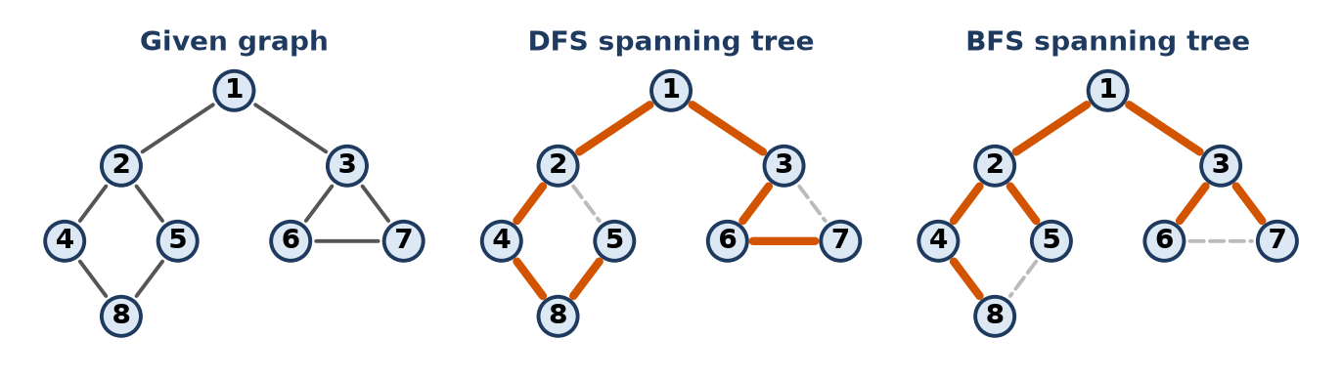
Figure: DFS and BFS spanning trees (thick edges)
- DFS tree edges: 1-2, 2-4, 4-8, 8-5, 1-3, 3-6, 6-7.
- BFS tree edges: 1-2, 1-3, 2-4, 2-5, 3-6, 3-7, 4-8.
- Each tree has 8 − 1 = 7 edges; the unused edges (dashed) would form cycles.
Remember: DFS tree is tall and thin; BFS tree is short and wide.

Q13. Apply Prim's algorithm to the graph with edges AB(4),AC(3),BC(1),BD(2),CD(4),DE(2),CE(5) starting at A. Show each step and total cost.
Apply • Moderate • CO1, CO4
Prim's rule: start from one vertex; at each step add the cheapest edge joining a visited vertex to an unvisited vertex.
Step | Visited set | Candidate edges | Selected | Cost so far
1 | {A} | AB 4, AC 3 | AC 3 | 3
2 | {A, C} | AB 4, BC 1, CD 4, CE 5 | BC 1 | 4
3 | {A, B, C} | BD 2, CD 4, CE 5 | BD 2 | 6
4 | {A, B, C, D} | DE 2, CE 5 | DE 2 | 8
5 | {A, B, C, D, E} | – | stop (V − 1 = 4 edges) | 8

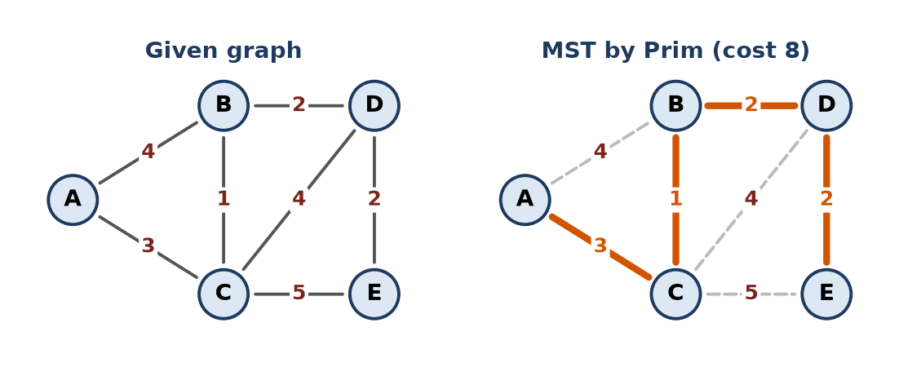
Figure: Graph and MST by Prim
MST edges: AC, BC, BD, DE. Total cost = 3 + 1 + 2 + 2 = 8.
Remember: Prim grows one tree, always by the cheapest edge leaving it.

Q14. Write Prim's algorithm using an adjacency (cost) matrix and trace it for a 5-vertex graph.
Apply • Moderate • CO1, CO4
dist[v] = cheapest edge from the tree to v, parent[v] = tree end of that edge.
const int INF = 1e9;
int prim(int cost[][5], int n) { // cost = 0 means no edge
int dist[5], parent[5]; bool inTree[5];
for (int i = 0; i < n; i++) { dist[i] = INF; inTree[i] = false; }
dist[0] = 0; parent[0] = -1; // start at vertex 0
int total = 0;
for (int k = 0; k < n; k++) {
int u = -1; // pick nearest vertex not in tree
for (int i = 0; i < n; i++)
if (!inTree[i] && (u == -1 || dist[i] < dist[u])) u = i;
inTree[u] = true; total += dist[u];
for (int v = 0; v < n; v++) // update neighbours of u
if (cost[u][v] && !inTree[v] && cost[u][v] < dist[v]) {
dist[v] = cost[u][v]; parent[v] = u;
}
}
return total; // O(V²)
}
Trace on the Q13 graph (A to E = 0 to 4), start A ("–" = already in tree):
Step | Vertex added | dist B | dist C | dist D | dist E
init | A | 4 (A) | 3 (A) | ∞ | ∞
1 | C (3) | 1 (C) | – | 4 (C) | 5 (C)
2 | B (1) | – | – | 2 (B) | 5 (C)
3 | D (2) | – | – | – | 2 (D)
4 | E (2) | – | – | – | –

MST: A-C, C-B, B-D, D-E, total cost = 8. Time O(V²).
Remember: Pick the smallest dist, add it, then lower the dist of its neighbours.

Q15. Write the find and union functions used by Kruskal's algorithm for cycle detection. Trace for edges AB, BC, AC.
Apply • Moderate • CO1, CO4
Kruskal keeps vertices in disjoint sets. An edge (u, v) makes a cycle if u and v are already in the same set, i.e. find(u) == find(v).
int parent[26]; // parent[x] == x means x is a root
int find(int x) { // root of x's set
while (parent[x] != x)
x = parent[x];
return x;
}
bool unite(int u, int v) { // union; false if it would form a cycle
int a = find(u), b = find(v);
if (a == b) return false; // same set -> cycle, reject edge
parent[b] = a; // join the two trees
return true;
}
Initially parent[A] = A, parent[B] = B, parent[C] = C.
Edge | find(u) | find(v) | Same set? | Action | Sets after
AB | A | B | No | accept, parent[B] = A | {A, B}, {C}
BC | A | C | No | accept, parent[C] = A | {A, B, C}
AC | A | A | Yes | reject – cycle A-B-C-A | {A, B, C}

Remember: Same root = same set = cycle.

Q16. Apply Dijkstra's algorithm on the graph with edges AB(7),AC(9),AF(14),BC(10),BD(15),CD(11),CF(2),DE(6),EF(9) from A.
Apply • Moderate • CO1, CO4
Rule: pick the unvisited vertex with the smallest distance, mark it final, and relax its edges: if d[u] + w < d[v] then d[v] = d[u] + w.
Step | Vertex fixed | A | B | C | D | E | F
0 | – | 0 | ∞ | ∞ | ∞ | ∞ | ∞
1 | A (0) | 0 | 7 | 9 | ∞ | ∞ | 14
2 | B (7) |  | 7 | 9 | 22 | ∞ | 14
3 | C (9) |  |  | 9 | 20 | ∞ | 11
4 | F (11) |  |  |  | 20 | 20 | 11
5 | D (20) |  |  |  | 20 | 20
6 | E (20) |  |  |  |  | 20

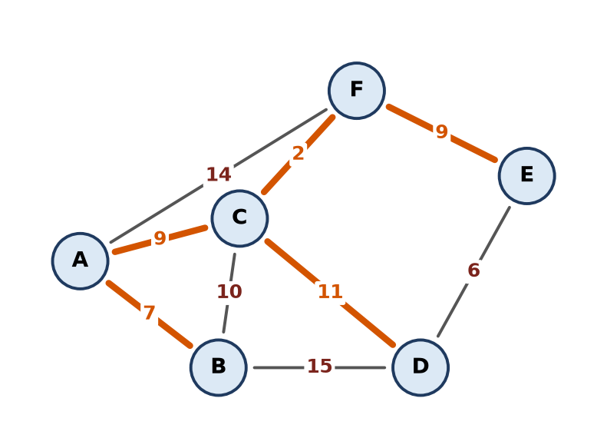
Figure: Shortest-path tree from A (thick edges)
Vertex | Distance | Path
B | 7 | A-B
C | 9 | A-C
F | 11 | A-C-F
D | 20 | A-C-D
E | 20 | A-C-F-E

Remember: Dijkstra = Prim-like greedy, but it adds distances from the source.

Q17. Write a DFS-based algorithm to print all paths between two vertices. Apply it for A to D in edges AB,AC,BD,CD,BC.
Apply • Moderate • CO1, CO4
Idea: DFS from the source keeping the current path; when the target is reached print the path; on return, unmark the vertex (backtrack) so it can be used in other paths.
vector<int> adj[26]; bool onPath[26]; vector<int> path;
void allPaths(int u, int t) {
onPath[u] = true; path.push_back(u);
if (u == t) { // reached target: print
for (int x : path) cout << char('A' + x) << " ";
cout << "\n";
} else {
for (int v : adj[u])
if (!onPath[v]) allPaths(v, t); // extend path
}
onPath[u] = false; path.pop_back(); // backtrack
}
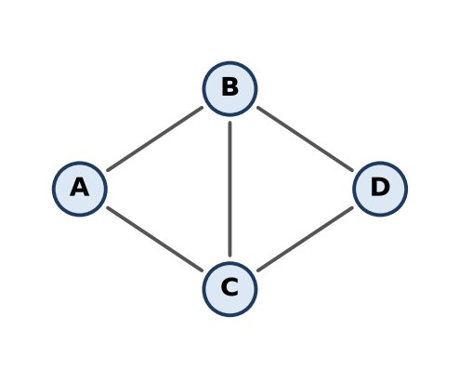
Figure: Graph
Adjacency: A: B, C; B: A, C, D; C: A, B, D; D: B, C. Trace from A:
1. A → B → C → D ⇒ print A B C D
2. back to B → D ⇒ print A B D
3. back to A → C → B → D ⇒ print A C B D
4. back to C → D ⇒ print A C D
4 paths in total.
Remember: Mark on the way in, unmark on the way out.

Q18. Design a graph model for a city road network. Choose the representation, and explain how you would find the shortest route and the cheapest cable layout.
Create • HOTS • CO1, CO4
Situation: a city needs (1) the fastest route between two places and (2) the cheapest way to lay cable to all places.
Graph model:
1. Vertices = junctions or places (station, market, hospital …).
2. Edges = roads; weight = distance or travel time (for routing) and digging cost (for cable).
3. One-way roads → directed edges; two-way roads → undirected.
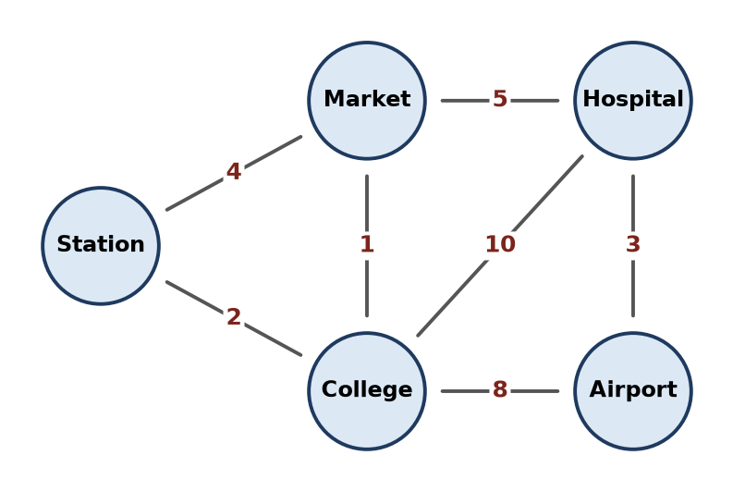
Figure: City network example
Representation: adjacency list. A road network is sparse (each junction has 3–4 roads), so a list needs O(V + E) memory, while a matrix needs O(V²) and is mostly zeros.
Shortest route: Dijkstra's algorithm with a min-heap, O((V + E) log V), since road weights are non-negative. Example: Station → Hospital = Station-College (2) + College-Market (1) + Market-Hospital (5) = 8, better than Station-Market-Hospital = 9.
Cheapest cable layout: a minimum spanning tree (Kruskal or Prim) connects all places with least total cost and no loops. Example MST: Station-College 2, College-Market 1, Hospital-Airport 3, Market-Hospital 5 → cost 11.
Need | Algorithm | Reason
Fastest route A to B | Dijkstra | Single-source shortest path, weights ≥ 0
Cable to all places | Kruskal / Prim | Connect all vertices at least cost
Reachability check | BFS / DFS | O(V + E)

Conclusion: model the city as a weighted graph in an adjacency list; use Dijkstra for routes and an MST for cabling.
Remember: Route = shortest path (Dijkstra); cable = spanning tree (Prim/Kruskal).

Q19. Evaluate whether Dijkstra's algorithm works with negative edge weights. Give a counter example and suggest an alternative.
Evaluate • HOTS • CO1, CO4
No. Dijkstra assumes that once the nearest vertex is fixed, no later path can make it shorter. A negative edge found later can break this, so the result may be wrong.
Counter example (directed): A→B 2, A→C 3, C→B −2, B→D 1.
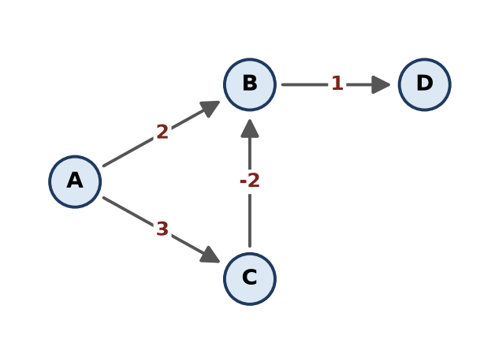
Figure: Graph with a negative edge
Step | Fixed | d(B) | d(C) | d(D)
1 | A (0) | 2 | 3 | ∞
2 | B (2) | 2 (final) | 3 | 3
3 | C (3) | C→B gives 1, but B is already final | 3 | 3
4 | D (3) |  |  | 3

- Dijkstra answer: d(B) = 2, d(D) = 3.
- Correct answer: A→C→B = 3 − 2 = 1, A→C→B→D = 2. Dijkstra is wrong.
Alternative: Bellman-Ford algorithm
1. Relax all edges V − 1 times; it does not depend on the order of fixing vertices.
2. Handles negative weights; time O(V × E).
3. One extra pass detects a negative cycle (then no shortest path exists).
Conclusion: use Dijkstra only for non-negative weights; use Bellman-Ford when negative edges are present.
Remember: Dijkstra never looks back; a negative edge needs looking back (Bellman-Ford).

Q20. Define the following with a small example graph (drawing) for each: (a) Directed Acyclic Graph (DAG), (b) Spanning tree, (c) Degree of a vertex in an undirected graph and in-degree / out-degree in a directed graph.
Understand • Low • CO1, CO4
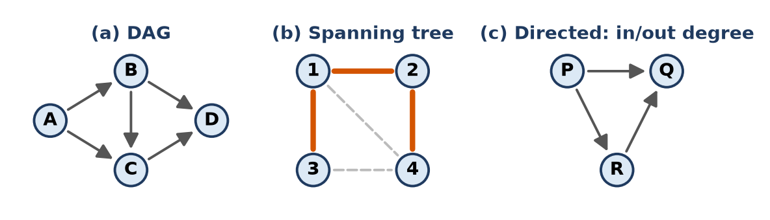
Figure: Examples for (a), (b) and (c)
- (a) DAG: a directed graph with no directed cycle. Example: A→B, A→C, B→C, B→D, C→D. Used for task scheduling and topological sort.
- (b) Spanning tree: a subgraph with all vertices, V − 1 edges and no cycle. Example: graph 1-2, 1-3, 2-4, 3-4, 1-4 → spanning tree {1-2, 1-3, 2-4} (thick).
- (c) Degree: in an undirected graph, degree = number of edges at a vertex. In graph (b): deg(1) = 3, deg(2) = 2, deg(3) = 2, deg(4) = 3 (sum 10 = 2 × 5 edges).
- Directed graph: in-degree = edges coming in, out-degree = edges going out. In (c): P in 0 / out 2, Q in 2 / out 0, R in 1 / out 1.
Remember: Sum of degrees = 2 × edges (handshake rule).

Q21. Find the minimum cost spanning tree of the graph shown using Kruskal's algorithm. The graph contains a self-loop and parallel edges; explain how the algorithm handles them. Show the sorted edge list with accept/reject decisions and the total cost.
Apply • Moderate • CO1, CO4
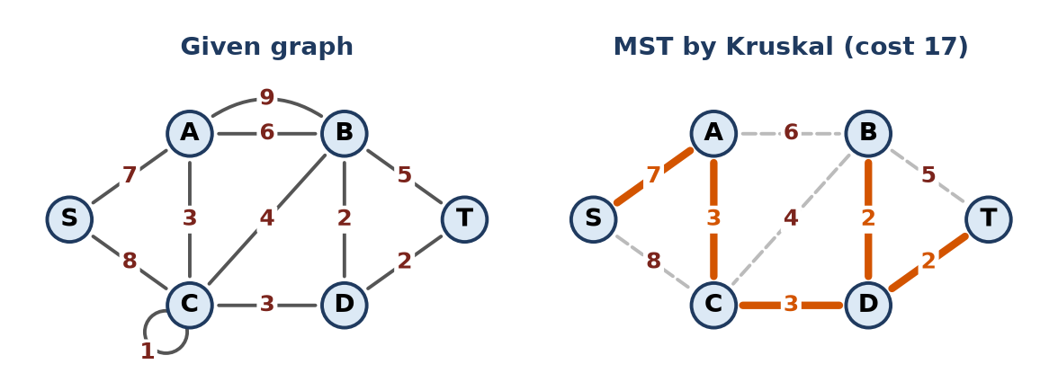
Figure: Given graph and its MST
Handling special edges:
- Self-loop (C-C, 1): joins a vertex to itself, so it always forms a cycle → removed / rejected.
- Parallel edges (A-B 6 and A-B 9): keep only the cheaper one (6); the costlier one can never be in an MST (it is rejected anyway).
Kruskal: sort edges by weight; accept an edge if it joins two different sets (no cycle).
Edge | Weight | Decision
C-C | 1 | Reject (self-loop)
B-D | 2 | Accept
D-T | 2 | Accept
A-C | 3 | Accept
C-D | 3 | Accept
B-C | 4 | Reject (cycle B-D-C)
B-T | 5 | Reject (cycle)
A-B | 6 | Reject (cycle)
S-A | 7 | Accept (5th edge, stop)
S-C | 8 | Reject (not needed)
A-B | 9 | Reject (parallel, costlier)

MST: BD, DT, AC, CD, SA. Total cost = 2 + 2 + 3 + 3 + 7 = 17.
Remember: Kruskal: sort, pick cheapest, skip if cycle; loops and costly duplicates are skipped.

Q22. Find a minimum cost spanning tree of the graph shown using Prim's algorithm, starting from vertex 1. Show the selected edge and the set of visited vertices at each step and give the total cost.
Apply • Moderate • CO1, CO4
Edges: 1-4 (1), 1-2 (2), 1-5 (4), 4-2 (3), 3-2 (3), 4-3 (5), 2-6 (7), 3-6 (8), 4-5 (9).
Step | Visited set | Cheapest edge leaving the set | Selected | Cost so far
1 | {1} | 1-4 (1), 1-2 (2), 1-5 (4) | 1-4 (1) | 1
2 | {1, 4} | 1-2 (2), 4-2 (3), 1-5 (4), 4-3 (5) | 1-2 (2) | 3
3 | {1, 2, 4} | 2-3 (3), 1-5 (4), 2-6 (7) | 2-3 (3) | 6
4 | {1, 2, 3, 4} | 1-5 (4), 2-6 (7), 3-6 (8) | 1-5 (4) | 10
5 | {1, 2, 3, 4, 5} | 2-6 (7), 3-6 (8) | 2-6 (7) | 17

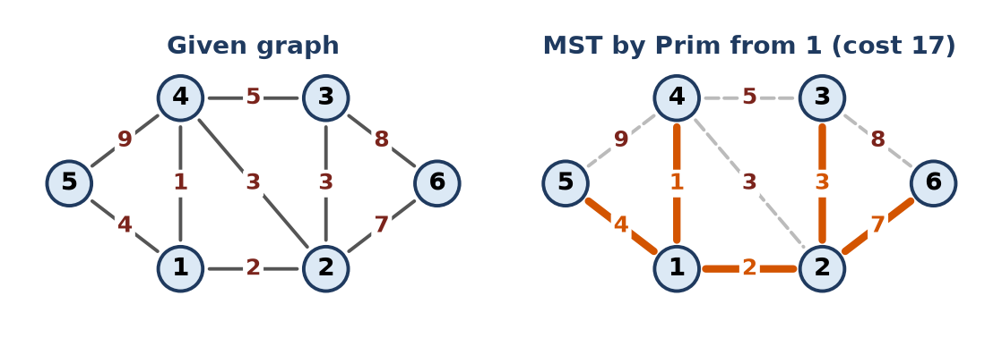
Figure: Graph and MST by Prim
MST edges: 1-4, 1-2, 2-3, 1-5, 2-6. Total cost = 1 + 2 + 3 + 4 + 7 = 17.
Remember: Visited set grows by one vertex per step; stop at n − 1 edges.

Q23. A telecom company must connect 6 towns (P, Q, R, S, T, U) with fibre cable at minimum cost. The possible links and their costs (in lakhs) are P–Q 4, P–R 3, Q–R 5, Q–S 2, R–S 7, R–T 8, S–T 6, S–U 9, T–U 3. (a) Apply Prim's algorithm from P. Show the edge selected and the set of visited towns at each step. (b) Apply Kruskal's algorithm and show the sorted edge list with accept or reject for each edge. (c) Show that both give the same total cost, and state that cost. (d) The link T–U is damaged and unavailable. Find the new minimum cost network, and say whether the spanning tree is still unique.
Apply • Moderate • CO1, CO4
(a) Prim from P
Step | Visited towns | Selected edge | Cost
1 | {P, R} | P-R 3 | 3
2 | {P, Q, R} | P-Q 4 | 7
3 | {P, Q, R, S} | Q-S 2 | 9
4 | {P, Q, R, S, T} | S-T 6 | 15
5 | {P, Q, R, S, T, U} | T-U 3 | 18

(b) Kruskal
Edge | Cost | Decision
Q-S | 2 | Accept
P-R | 3 | Accept
T-U | 3 | Accept
P-Q | 4 | Accept
Q-R | 5 | Reject (cycle P-Q-R)
S-T | 6 | Accept (5 edges, done)
R-S | 7 | Reject
R-T | 8 | Reject
S-U | 9 | Reject

(c) Both choose the same 5 edges {QS, PR, TU, PQ, ST}: 2 + 3 + 3 + 4 + 6 = 18 lakh.
Figure: MST and the network without T-U
(d) Without T–U: Kruskal on the remaining edges: QS 2 accept, PR 3 accept, PQ 4 accept, QR 5 reject, ST 6 accept, RS 7 reject, RT 8 reject, SU 9 accept (only link left to U). New network: QS, PR, PQ, ST, SU = 2 + 3 + 4 + 6 + 9 = 24 lakh. Unique? Yes – all remaining edge costs are distinct, so the MST is unique (and SU is forced because it is U's only link).
Remember: Prim and Kruskal may pick edges in a different order, but the MST cost is always the same.

Q24. A delivery company models 8 warehouses (W1 to W8) as a graph. The roads are W1–W2, W1–W3, W2–W4, W2–W5, W3–W6, W3–W7, W5–W8 and W6–W8. (a) Starting at W1, and visiting neighbours in ascending order, write the BFS and DFS visiting sequences. (b) Show the queue contents for BFS and the stack contents for DFS at each step. (c) Write pseudocode for BFS using an adjacency list. (d) The company wants the route with the fewest road segments from W1 to W8. Say which traversal to use and give the route it finds, with a reason.
Apply • Moderate • CO1, CO4
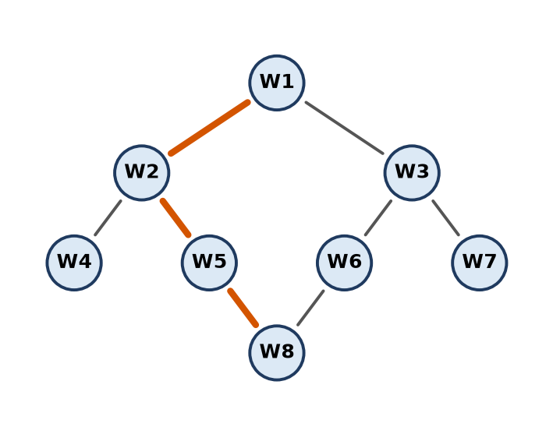
Figure: Warehouse graph (BFS shortest route W1-W2-W5-W8 thick)
(a) BFS: W1 W2 W3 W4 W5 W6 W7 W8 ; DFS: W1 W2 W4 W5 W8 W6 W3 W7
(b) BFS queue
Dequeue | Enqueue | Queue after
– | W1 | W1
W1 | W2, W3 | W2 W3
W2 | W4, W5 | W3 W4 W5
W3 | W6, W7 | W4 W5 W6 W7
W4 | – | W5 W6 W7
W5 | W8 | W6 W7 W8
W6, W7, W8 | – | empty

DFS stack (pop, visit, push unvisited neighbours in reverse; top at right)
Pop / visit | Push | Stack after
– | W1 | W1
W1 | W3, W2 | W3 W2
W2 | W5, W4 | W3 W5 W4
W4 | – | W3 W5
W5 | W8 | W3 W8
W8 | W6 | W3 W6
W6 | W3 | W3 W3
W3 | W7 | W3 W7
W7 | – | W3
W3 (already visited, skip) | – | empty

(c)
void bfs(int s, vector<int> adj[], int n) {
vector<bool> vis(n + 1, false);
queue<int> q; q.push(s); vis[s] = true;
while (!q.empty()) {
int u = q.front(); q.pop();
cout << "W" << u << " ";
for (int v : adj[u]) // neighbours in ascending order
if (!vis[v]) { vis[v] = true; q.push(v); }
}
}
(d) Use BFS: it explores level by level, so the first time it reaches a vertex is by the fewest edges. W8 is discovered from W5, so the route is W1 → W2 → W5 → W8 (3 road segments). DFS gives no such guarantee (its path W1-W2-W5-W8 here is only by luck).
Remember: Fewest hops = BFS.

Q25. List all possible spanning trees of the graph shown in the figure and state how many there are. Justify, by reasoning on the cycles of the graph, that no spanning tree has been missed.
Analyze • HOTS • CO1, CO4
Graph: 5 vertices, 6 edges: AB, AE, BC, BD, CD, DE. A spanning tree needs 5 − 1 = 4 edges, so exactly 2 edges must be removed.
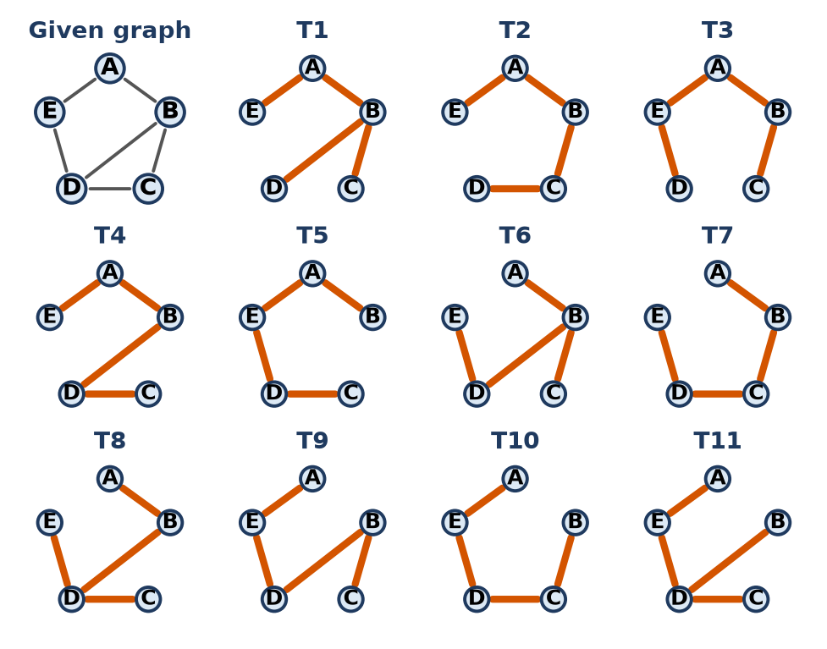
Figure: The graph and its 11 spanning trees
Tree | Edges removed | Edges kept
T1 | CD, DE | AB, AE, BC, BD
T2 | BD, DE | AB, AE, BC, CD
T3 | BD, CD | AB, AE, BC, DE
T4 | BC, DE | AB, AE, BD, CD
T5 | BC, BD | AB, AE, CD, DE
T6 | AE, CD | AB, BC, BD, DE
T7 | AE, BD | AB, BC, CD, DE
T8 | AE, BC | AB, BD, CD, DE
T9 | AB, CD | AE, BC, BD, DE
T10 | AB, BD | AE, BC, CD, DE
T11 | AB, BC | AE, BD, CD, DE

Number of spanning trees = 11.
Justification using cycles:
1. Ways to remove 2 of 6 edges = 6C2 = 15.
2. The graph has three cycles: C1 = B-C-D (BC, CD, BD), C2 = A-B-D-E (AB, BD, DE, EA), and the outer C3 = A-B-C-D-E (AB, BC, CD, DE, EA).
3. The removed pair must break every cycle. A pair fails if both edges lie only on one side:
- both from {BC, CD} → C2 stays: 1 pair;
- both from {AB, DE, EA} → C1 stays: 3 pairs.
4. Valid pairs = 15 − 4 = 11: 5 pairs containing BD (BD breaks C1 and C2; the other edge breaks C3) + 2 × 3 = 6 pairs with one edge from each side.
5. Each valid removal leaves 4 edges, connected and acyclic, so all 11 are listed and none is missed.
Remember: Spanning trees = remove just enough edges to break every cycle.

Q26. A social network is a graph in which each node is a person and each edge means that two people are friends. A friendship circle is a connected group of people who are directly or indirectly friends. Write an algorithm to find all friendship circles. Justify the graph representation you choose and analyze the time complexity.
Create • HOTS • CO1, CO4
Analysis: a friendship circle is a connected component of an undirected graph. Run BFS/DFS from every person not yet visited; all people reached form one circle.
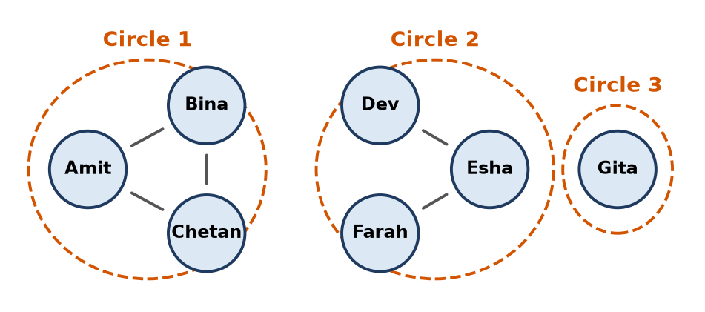
Figure: Three friendship circles
Algorithm:
1. Mark every person unvisited; circle = 0.
2. For each person p: if p is unvisited, circle++ and run BFS from p.
3. Every person dequeued in that BFS gets comp[x] = circle.
4. At the end, circle = number of circles; group people by comp[].
int findCircles(int n, vector<int> adj[], vector<int>& comp) {
comp.assign(n, -1); // -1 = not visited
int circle = 0;
for (int p = 0; p < n; p++) {
if (comp[p] != -1) continue; // already in a circle
queue<int> q; q.push(p); comp[p] = circle;
while (!q.empty()) {
int u = q.front(); q.pop();
for (int v : adj[u])
if (comp[v] == -1) { comp[v] = circle; q.push(v); }
}
circle++; // one BFS = one circle
}
return circle;
}
Representation – adjacency list:
- Social graphs are very sparse (millions of users, a few hundred friends each).
- List memory O(V + E); a matrix would need O(V²) cells, mostly 0.
- Listing a person's friends costs only their degree.
Time complexity: every person is enqueued once and every friendship scanned twice → O(V + E); space O(V). (With a matrix it would be O(V²).) Union-find is an alternative at about O(E α(V)).
Conclusion: circles = connected components, found by repeated BFS on an adjacency list in linear time.
Remember: Number of circles = number of times BFS is started.

Quick Revision – Unit 4
Term | Key fact
Graph | G = (V, E); directed or undirected, weighted or not
Adjacency matrix | V × V array, O(V²) space, edge check O(1), good for dense graphs
Adjacency list | List of neighbours per vertex, O(V + E), good for sparse graphs
DFS | Stack / recursion, goes deep, O(V + E)
BFS | Queue, level by level, fewest-edge path, O(V + E)
Spanning tree | All V vertices, V − 1 edges, no cycle
MST | Spanning tree with minimum total weight
Prim | Grow one tree by the cheapest edge leaving it; O(V²) with matrix
Kruskal | Sort edges, add cheapest that makes no cycle (find/union); O(E log E)
Find / union | Same root = same set = cycle
Dijkstra | Single-source shortest path, non-negative weights only
Bellman-Ford | Handles negative edges, O(V × E), detects negative cycles
Degree | Sum of degrees = 2 × number of edges
DAG | Directed graph with no cycle (scheduling, topological sort)
Connected components | Repeated BFS/DFS from unvisited vertices

